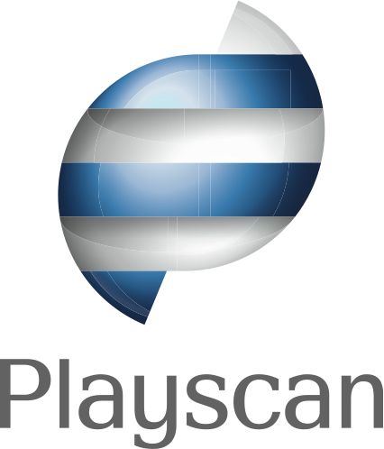

**Playscan – a strong brand for responsible e-gaming**

## Playscan™ is the leading global brand in IT-solutions for responsible e-gaming. Now the company launches its new logotype and brand identity.

   – It is in the interests of our clients that we build a strong brand for responsible gaming that their users recognize, says CEO Ann-Sofie Olsson. We needed a warm, friendly symbol that builds recognition in busy interactive environments with a lot of different visual styles.

The symbol will be used on the web sites of Playscan’s clients as a push button for users to activate the service that helps them make sure that their gaming stays on the  healthy side. The friendly symbol in the logo is designed to communicate to the users that it is a helpful widget and that it’s not about ”big brother is watching you”.

– The users should feel that this is their personal tool, says Ann-Sofie Olsson. The information about the user’s gaming behaviour is only communicated to him or her.

In the B2B-communication the logotype works as a symbol that stand for trust and all competence that lies behind the product. The logotype is developed by the Stockholm based design agency Silver, with a client lists that includes both international brands such as H&M and Kraft as well as leading Swedish B2C and B2B brands.

**For more information, contact:**  
Sara Larsson, CMO Playscan AB, telephone +46-706-378939  
[www.playscan.com](http://www.playscan.com/)  
Ulf Berlin, CEO, Silver, telephone +46-708-462 277  
[www.silver.se](http://www.silver.se/)

## About Playscan:

Playscan AB delivers unique specialised customer made solutions in the field of problem gambling and CSR tools towards the international and national e-gaming market. Playscan AB combines cutting edge technologies with the expert knowledge and experience of gaming behaviour, problem gambling and CSR. Playscan™ is developed in cooperation with the Spelistitutet and launched for the first time at s[venskaspel.se](http://SvenskaSpel.se/) in June 2007.

Playscan™ gives the player an accurate analysis of their gaming behaviour based on mental, cognitive and predictive data. The tool provides a safety net for the player and increases the player’s awareness of their gaming, giving the operator a channel to communicate directly with the customer.

Playscan™ is licensed to other gaming operators with strong involvement within responsible gaming. Today, Svenska Spel, Française des Jeux and Swedish Millionlotteriet offers Playscan™ to their customers. Recently an agreement was signed with Finnish RAY.