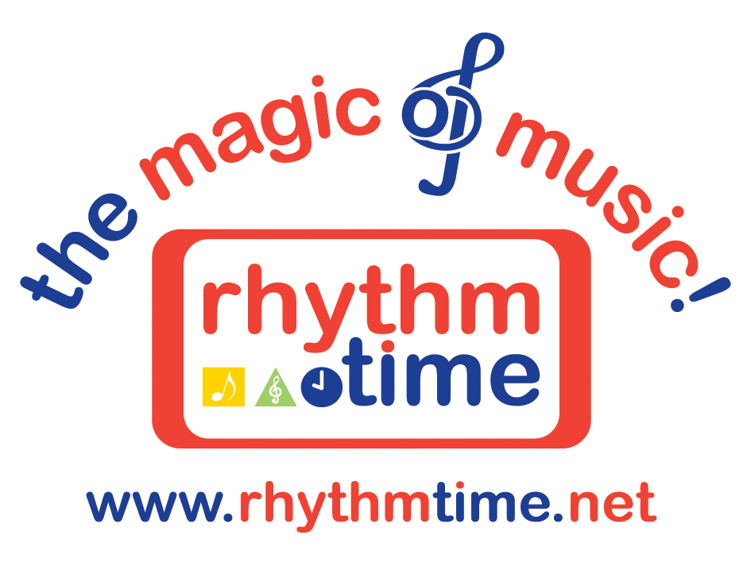

PRESS RELEASE

(children’s music franchise)
15th March 2012

CHILDREN’S MUSIC FRANCHISE GROUP, RHYTHM TIME, THROUGH TO FINAL STAGES OF NATIONAL AWARD
Rhythm Time, the popular children’s music franchise group that provides baby music classes, toddler music classes and pre-school music classes, are proud to announce that they are through to the final voting stages of a national awards scheme that recognises the best activities for children.

Rhythm Time has been nominated for several categories within the prestigious What’s On 4 2012 Junior Awards including Best National Baby & Toddler Development Activity and Best National Pre-Schooler Development Activity. They have also received a number of local nominations for Most Outstanding Activity Leader for the Under 5s across the UK.

The awards, now in their 6th year, celebrate the best activities, classes and individuals throughout the UK as nominated by the experts – the parents themselves. A record 4,200 nominations have been received, 30% more than last year.

Rhythm Time was started in Solihull in 1995 by mum and music teacher, Kathy Doolan. The company then offered children’s music franchise opportunities in 2000 and they now have 36 franchises throughout the UK.

Kathy is delighted with the company’s nominations. “I’m thrilled and flattered that the parents and carers who come to our classes with their little ones have nominated Rhythm Time for these prestigious awards” she says. “It’s wonderful to see how the babies and young children in our classes genuinely benefit from music, and how it can enhance their development. The fact that the parents really value what we do is so rewarding. It’s also down to the fabulous teaching staff at Rhythm Time who help to make our classes so enjoyable,” she adds.

Parents can log on to www.whatson4littleones.co.uk to vote for Rhythm Time, or their favourite Rhythm Time teacher if they have been nominated. Voting closes on 6th May and finalists will be invited to attend the awards presentation on the 15th June 2012 at the Hilton Avisford Park, Arundel.

For more information about Rhythm Time’s children’s music franchise opportunities as well as their music classes for babies, toddlers and pre-schoolers, or to book a free trial, call 0121 711 4224 or visit www.rhythmtime.net

ENDS

Word Count 326

Information for Editors

www.rhythmtime.net

Rhythm Time
76 Beechwood Park Road
Solihull
B91 1ES
Telephone 0121 711 4224
Email: marketing@rtfg.co.uk

Rhythm Time was started in the Midlands in 1995 by Kathy Doolan who is a firm believer in the power and importance of music for babies, toddlers and pre-school children.

Kathy graduated from the Royal Scottish Academy of Music & Drama in Glasgow and was also Head of Music at a Scottish school. Kathy sold her first franchise in 2000 and now has 36 franchises across the UK. Country-wide, approximately 9500 children enjoy Rhythm Time’s music classes in over 300 venues.

Rhythm Time offers three age-appropriate classes for babies (birth to 15 months), toddlers (15 months to three years) and pre-schoolers (three to school age). Children enjoy an early introduction to music and all classes are in line with the Early Learning Goals and Key Stage 1.

These are the sixth National Annual Awards run by www.whatson4littleones.co.uk in association with Konfidence and they were created to reward and recognise those companies, organisations and individuals who provide the very best activities for children across the UK.

