**iotty, “made in Italy” smart home is coming to Northern Europe**

*100% Italian design, the smart switch that brings a new lighting experience, continues to conquer Europe and arrives to Scandinavia and the Baltics.*

Pordenone - ITALY, xx April 2019 – Italian design meets smart home. Now it happens in Northern Europe. Success stories are never prosaic, and the [**iotty**](https://iotty.com)’s one is no exception. It comes from Italy, so there is a pinch of genius and a touch of great style. The company from Porcia (Pordenone) has been founded in 2017. Its path has started with a crowdfunding campaign on Indiegogo that gathered 200% of the requested investments. Before long, iotty has become noticeable in the crowded Smart Home market.

Persistency, commitment, devotion and decision to start from USA market, which is more ready to incorporate the product and the company philosophy, has allowed iotty to rapidly grow at the global level. Now it starts an active expansion in Europe, including the entire Scandinavia and the Baltic regions which have always been great admirers of what is "Made in Italy". Created by two Italian entrepreneurs, already committed to other technology companies, **Edoardo Cesari** and **Alberto Bacchin**, iotty is totally focused on innovation and design when creating an original and highly distinctive WiFi switch.

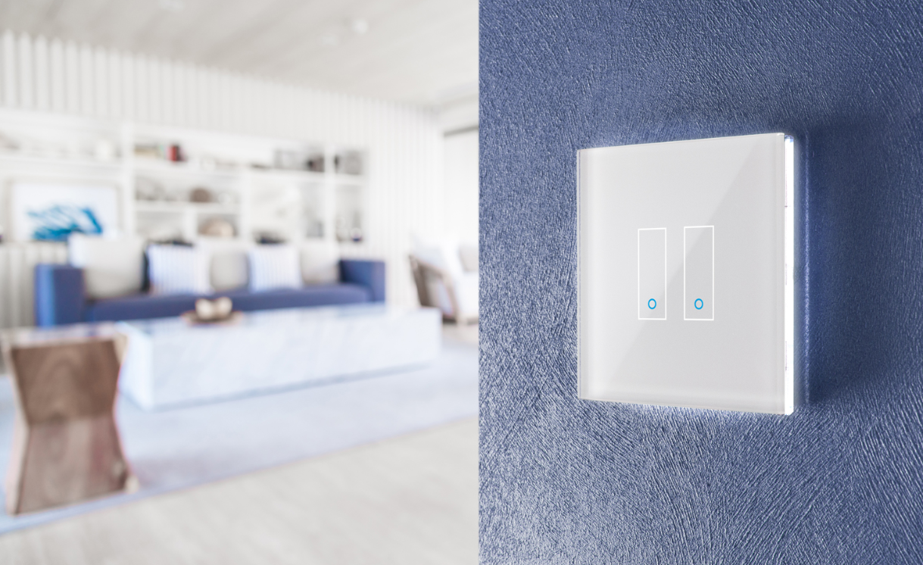

*“When we were working on our product, the main principle was that smart home should be accessible for everyone, easy to install and manage, can be integrated with other solutions and have an accessible and competitive price. At a first glance, other products on the market can seem similar, but they are far from quality and design standards we offer. We decided to focus on Northern Europe because we are sure that users will particularly appreciate our design solution,” comments* **Edoardo Cesari**, **iotty co-CEO**.

The device stands out for its advanced features, like integrated WiFi that does not require any use of auxiliary systems or control units, customization possibility and management through an app and Google Assistant and Amazon Alexa voice commands integration. Another characteristic that makes iotty unique is its elegant design made with attention to every detail. The device is made of the best materials that increase its aesthetic value and durability.

Watch [VIDEO](https://youtu.be/WReO78BZkuk)

To wrap up, it is “100% Italian product”, well known for its quality and innovation with an intrinsic international mission. There is no coincidence that in addition to the HQ in Italy, iotty is already present in North America (Las Vegas), has a branch in Germany (Hamburg), while the opening in France is in a foreseeable future. The industrial department is in Shenzhen in China. This arrangement allows designing a product ready to be distributed and installed in 90% of markets thanks to the numerous certifications already acquired in various countries such as Brazil, Thailand and the UK.

For more information: [www.iotty.com](http://www.iotty.com)

**About iotty**

Founded in 2017, the company is based in Porcia (PN). It is willing to offer users smart products with an excellent quality / price ratio, innovative and easy to use, thanks to the compatibility with the main home automation platforms. Today iotty has more than 25 employees and collaborators, 3 offices in Italy, USA, a branch in Germany and an industrial department in Shenzhen, China. The company’s goal is to become a world-class reference for home automation products with Italian design.

**Press contacts:**

**iotty**

Maria Elena Loria – Communications coordinator - [press@iotty.it](mailto:press@iotty.it)