**Cycling and sustainable mobility in focus for the first Sustainable Mobility Summer Academy at TH Wildau**

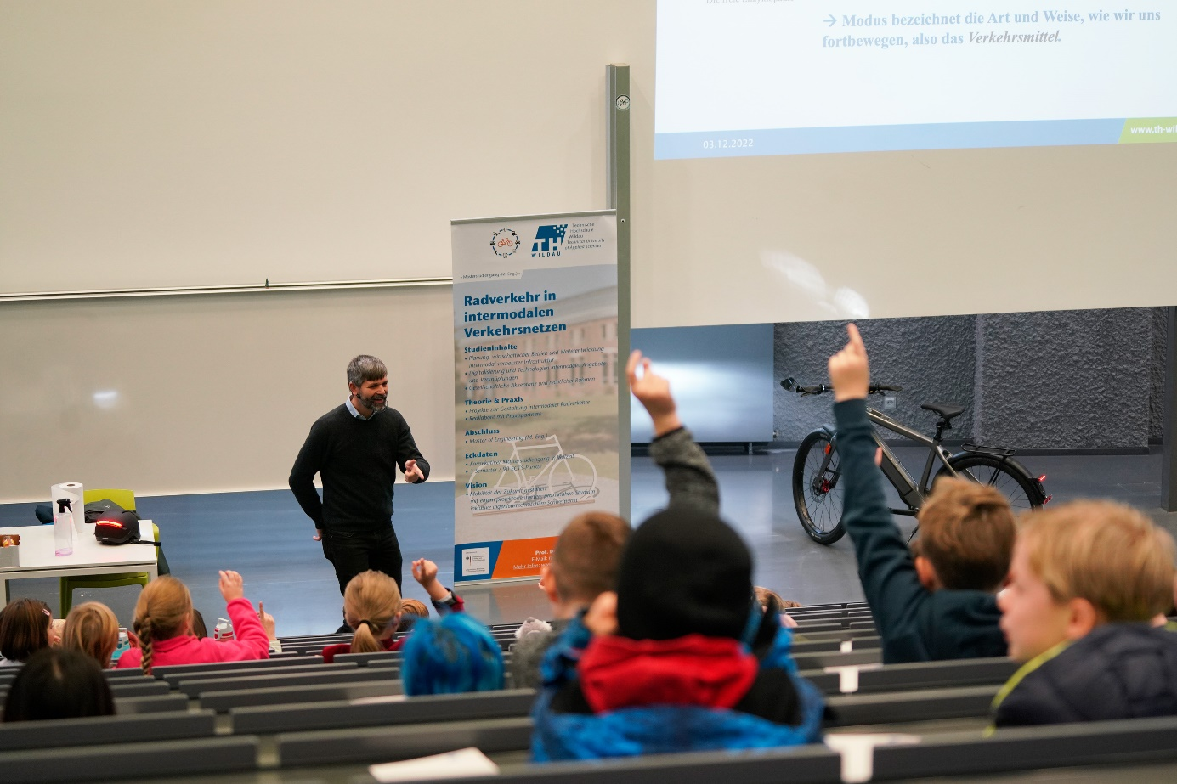

**Caption:** Cycling and sustainable mobility play a major role in teaching, research and transfer at TH Wildau - the Sustainable Mobility Summer Academy on the topic is now taking place from 4 to 15 September.

**Picture:** Mareike Rammelt / TH Wildau

**Subheadline:** Sustainable mobility

**Teaser:**

**The Sustainable Mobility Summer Academy will take place at TH Wildau from 4 to 15 September 2023. The theme of the two-week event is "The Role of Cycling and other Modes of Transport" and focuses on cycling and sustainable mobility. 17 lecturers and 19 participants from Germany and abroad will come together in lectures, seminars, workshops and excursions, develop concepts and exchange ideas on the topic.**

**Text:**

The topic of sustainable mobility is increasingly in the focus of public interest and is also an important component in teaching, research and transfer at the Technical University of Applied Sciences Wildau (TH Wildau), among other things within the Master's degree programme Cycling Intermodal Transport Networks. In addition, the "TH Wildau Sustainable Mobility Academy" project has been approved for the years 2023 and 2024 as part of the HAW.International programme funded by the German Academic Exchange Service (DAAD). As one component of the project, the Sustainable Mobility Summer Academy will take place at TH Wildau from 4 to 15 September 2023. The summer academy, which will focus on "The Role of Cycling and other Modes of Transport", brings together professors, students and researchers from TH Wildau and international partner universities, as well as representatives from practical partners in the region.

**Who is the Summer Academy aimed at?**

17 lecturers and 19 students from Germany and abroad - from bachelor students to doctoral students - will come together in lectures, seminars, workshops and excursions, develop concepts and exchange ideas on the topic. The planned lectures and workshops are not limited to the role of cycling, however. There are additional lectures, for instance, on ‘Drones and Smart Mobility Strategy in the EU’, ‘Use of Hydrogen in Modes of Transport’, ‘Sustainability in Air Transport’, and the ‘Ecological Environment of Markets’.

"We’ve discovered a lively interest in this important set of topics connected to sustainable mobility, not only from members of the TH Wildau community, but also from our international partners and local partners in the region. Participating lecturers not only come from TH Wildau, but also the Technical University of Liberec in the Czech Republic, FH Salzburg in Austria, VIVES University of Applied Sciences in Belgium and HAN University of Applied Sciences and FH Amsterdam in the Netherlands. Our student participants come from an even wider geographical area. In addition to TH Wildau students, our international participants originate from as far away as the west coast of Canada, Cuba, Ghana, Uganda, and various European countries. So we expect a multi-faceted view of the topic of sustainable mobility and interesting field reports on opportunities, challenges and perspectives from the different countries," says Dr. Jeffrey Wolf, project manager of the event.

**What exactly is on the agenda?**

The main highlights of the Summer Academy, beyond the lectures and workshops themselves, include:

1. Team Project Work, aka the ‘Planspiel’

Participants will be divided into small teams and develop a transport concept which they will present on the last day of the academy. This transport concept will confront them with a real-life case study of sustainable mobility: The city of Eichwalde wants to become climate neutral by 2045. Specifically, the participants will develop a transport concept to strengthen intermodal transport in Eichwalde, based on their own research and reading as well as interviews with stakeholders from the region. The ‘simulation game’ is intended to strengthen communication skills in the group and familiarise the participants with all aspects of sustainable mobility in the "real world".

2. Roundtable Discussion

On 12 September 2023, the team will organise a roundtable discussion on the role of active forms of mobility in the sustainability transition, involving various experts, moderated by Prof. Dr. Christian Rudolph, endowed chair and speaker for the degree programme Cycling in Intermodal Transport Networks at TH Wildau. Participants of the Summer Academy will engage directly with the keynote speakers and take part in the discussion.

3. Bike tour through Potsdam with use of rental bikes

A special highlight will be a cycling tour of many of the historic sites in Potsdam on Saturday, 9 September, led by a member of the Allgemeine Deutsche Fahrrad-Club e.V. Brandenburg (ADFC Brandenburg). Students participating in the Summer Academy will receive rental bicycles for a large part of the Summer Academy, which they can use for trips around the campus and into the region.

Other programme highlights and excursions include visits to the local company ‘Business auf Rädern’ in Lok21, as well as the battery-sharing startup, Swobbee, in Adlershof. Additional excursions include visits to the Mayor’s office in Eichwalde, the Kiezblocks project in Pankow, and a guided tour of cycling infrastructure in Friedrichshain-Kreuzberg.

**Further information**

Information on the Sustainable Mobility Summer Academy: [www.th-wildau.de/sma2023](http://www.th-wildau.de/sma2023) and <https://en.th-wildau.de/sma2023>

Information on the project Sustainable Mobility Academy: [www.th-wildau.de/sma](http://www.th-wildau.de/sma) and <https://en.th-wildau.de/sma>

**Project contact at TH Wildau:**

Dr. Jeffrey Wolf  
Project management Sustainable Mobility Academy  
TH Wildau  
Hochschulring 1, 15745 Wildau  
Phone: +49 (0)3375 508 390  
E-mail: smacademy @th-wildau.de

**Contact person external communication TH Wildau:**

Mike Lange / Mareike Rammelt  
TH Wildau  
Hochschulring 1, 15745 Wildau  
Phone: +49 (0)3375 508 211 / -669  
E-mail: presse@th-wildau.de