MAKING YOUR 2014 RESOLUTION COME TRUE:
NEW MOBILE APP MAKES QUITTING SMOKING FUN AND EASY

Smoking cessation coach QUIT PRO now available for Android and iOS

SINGAPORE, 1 January 2013 – At the end of each year, people make resolutions to try and be better, either by starting to do something good or stop doing something harmful. With 2014 just starting, why not resolve to kick a bad habit and usher in a smoke-free new year in a smart(phone) way?

Quit Pro is a mobile-based app that helps monitor an individual’s journey and progression towards their goal of quitting smoking. This week, Singapore-based mobile apps factory Bitsmedia introduced the Android version one year after launching in the Apple Store.

Since being launched first for iOS a year ago, Quit Pro has already helped more than 130,000 smokers kick the habit: “Great app to help you quit smoking and track your progress. Would highly recommend it for anyone who is trying to quit”, shared one user.

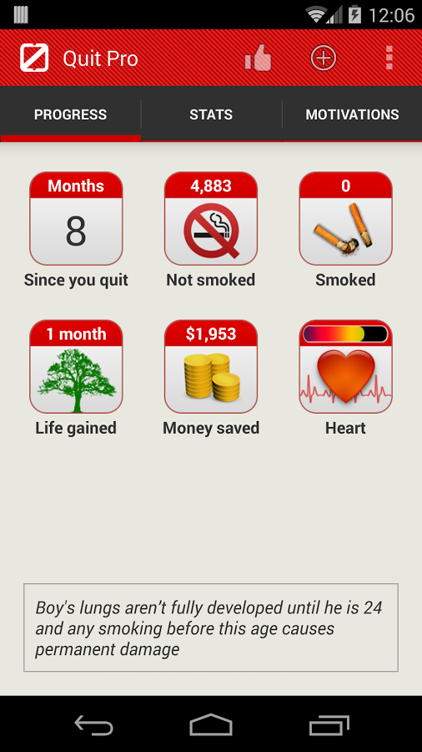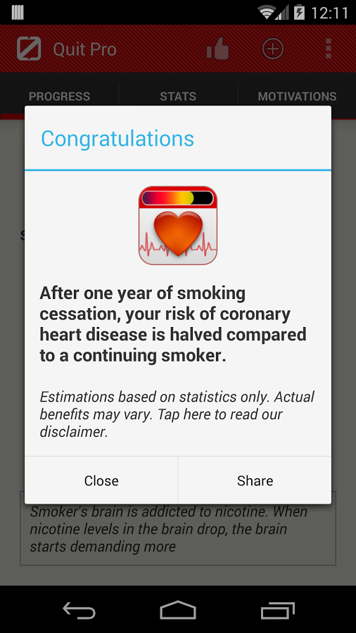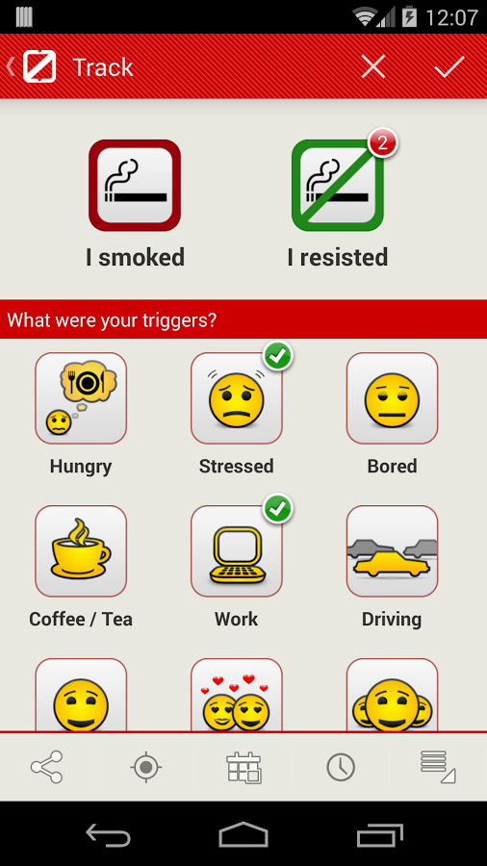
Screenshots from the Quit Pro app: Smart, easy to follow and helpful
Through its user-friendly interface, Quit Pro helps to easily track and tabulate information about when smokers crave for a cigarette, along with what moods or emotional triggers might lead to smoking.

Quit Pro also has a social feature that allows sharing your progress with friends, monitoring either how long a person has quit for or how much money has been saved not buying cigarettes.

Another Quit Pro user commented: “This app has helped me a lot! When I have a craving I look at my counter & think ok I've made it this long I can make it 5 more minutes! I'm 9 days in with no relapse! My family has been great too!”

Other features of Quit Pro include identifying places that users smoke most at and also highlighting the benefits that quitting smoking has in terms of financial and health impact. You can find out more about the functionalities of Quit Pro on http://www.quit-pro.com/video

Quit Pro is available on Google Play and Apple App Store for free with an optional premium version to access additional content. Bitsmedia will give 5% of the proceeds of this app to cancer research.

###

About Bitsmedia
Founded in 2009 by Erwan Macé, Bitsmedia Pte Ltd is a Singapore based Mobile Apps Factory specializing in the development of mobile applications.
http://www.bitsmedia.com/

MEDIA Contacts

PRecious Communications for Bitsmedia Pte Ltd
Debbie Beins
Mobile: +65 9180 7924
Email: debbie@preciouscomms.com

