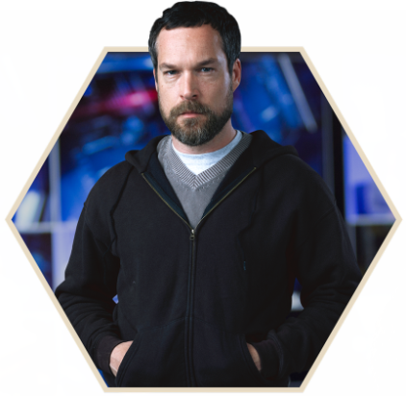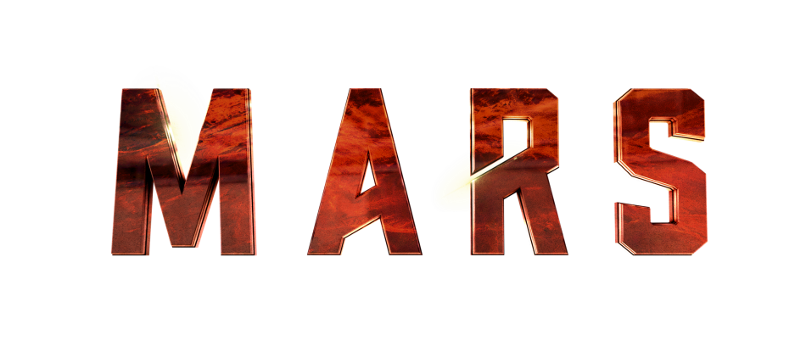

CREW MEMBER: Dr. Paul Richardson

ASSIGNMENT: Exobotonist

NATIONALITY: British

NOTES: A brilliant experimental botanist who has worked in many of Earth’s most extreme environments, Dr. Richardson developed a series of plant hybrids specifically engineered to function in the extreme conditions of Martian greenhouses.

ACTOR BIO: John Light

Actor John Light plays British exobotonist Dr. Paul Richardson. Light trained at the London Academy of Music and Dramatic Arts. In 1997 and 2001, he was nominated for a Sunday Times Ian Charleson Award. His other nominations include an American Film Institute Award for Motion Pictures in 2002 for HBO’s “Band of Brothers” and an Olivier award for best actor in a supporting role in 2015 for his work in the play “Taken at Midnight.” Light has appeared in many BBC television productions, including “North and South,” “Silk,” “Endeavour,” “Atlantis,” “Father Brown,” “Love in a Cold Climate,” “A Rather English Marriage” and the BAFTA-winning drama “Holding On.” He played British pilot Robert Newman in the German film “Dresden” and played Geoffrey, Duke of Brittany, in “The Lion in Winter” alongside Patrick Stewart and Glenn Close.

