Balance Salad Servers by Magisso are nominated for the German Design Award 2019

Press Release • May 24, 2018 15:48 EEST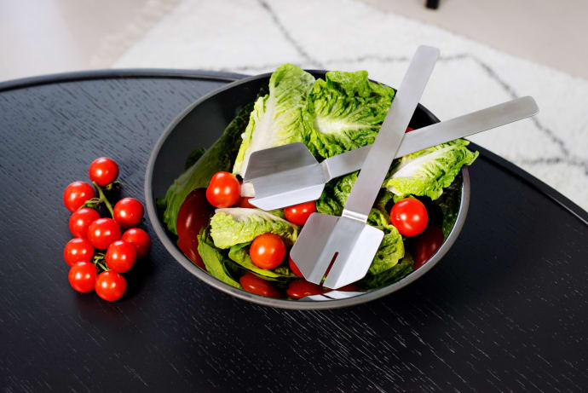

Balance Salad Servers
New Balance Salad Servers by Finnish design lab Magisso, are nominated for German Design Award 2019. The award identifies unique design trends, which represent German and international design landscape.
Stainless steel salad servers, designed by Johannes Lindner, offer maximum convenience with the minimum use of storage space. Lindner is inspired by the simplicity and functionality of the Scandinavian design tradition. He believes in the importance of every detail and timeless design.
Magisso creates meaningful, function-driven design products that solve everyday problems at home. Visit our website and find our whole collection: www.magisso.com

MAGISSO is a fast-moving and forward-thinking design lab from Finland. Magisso’s mission is simple - we want to make life at home smarter, better and easier - to be a part of your journey for a better living. Magisso creates meaningful, function-driven design products that solve everyday problems at home. Magisso is one of the most awarded Nordic design companies with over 30 international design awards.
The German Design Award directly contributes to the overall commercial success. Prizes will only be awarded to projects that truly represent pioneering contributions to the German and international design landscape. The German Design Award identifies and presents unique design trends: a competition that advances the design-oriented scene.

