 |  | Press Update  May 2021
May 2021 - Prime Gaming Monthly Update
This month, Prime Gaming is offering a diverse library of games and in-game content for top titles, including:

- Exclusive content for League of Legends, Rainbow Six Siege and FIFA 21
- The May Games with Prime lineup, featuring Yoku’s Island Express, Healer’s Quest Beholder, The Blind Prophet and A Blind Legend

Prime members can claim these offers at gaming.amazon.com. As a reminder, Prime Gaming offers are available for a limited time, so be sure to act fast before they disappear!

Read on below for a look at all of the great content and games coming in May, including a brand new Prime Gaming sizzle showcasing this month’s biggest offers.

Information on this month’s lineup, as well as the latest and greatest Prime Gaming news, can be found on the Prime Gaming blog. Download assets here.

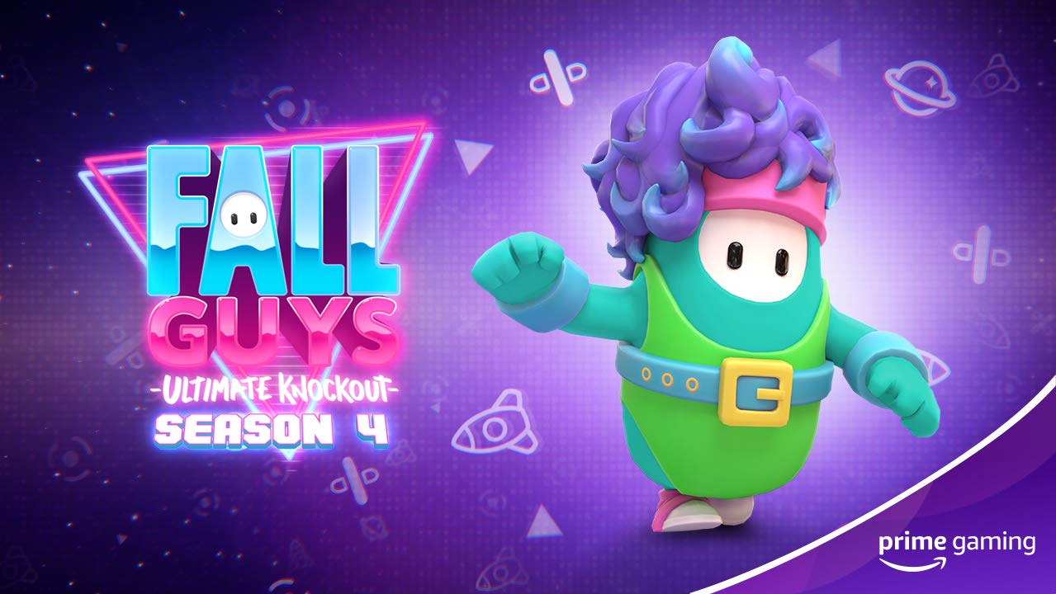
A Sneak Peek of Prime Gaming’s May Offerings
Catch the newest sizzle reel featuring this month’s biggest offerings for Prime members! May features a new selection of Games with Prime, in-game content for Red Dead Online, Fall Guys, Destiny 2, and much more. You can view the latest video here.
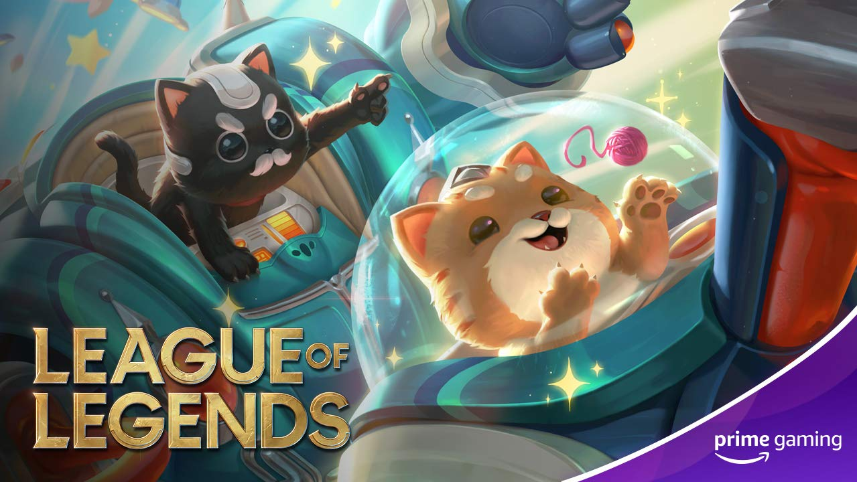
Claim Up to Five Mystery Skin Shards in League of Legends
Outplay & Out-think! Members can claim up to five mystery skin shards for the wildly popular team-based strategy game, League of Legends!
- Drops 10 - 12 - Mystery Skin Shard: Available Now - May 10
- Drop 13 - Mystery Skin Shard: May 10 - June 11
- Drop 14 - Mystery Skin Shard: May 21 - June 11
Drops 10-14 of 36
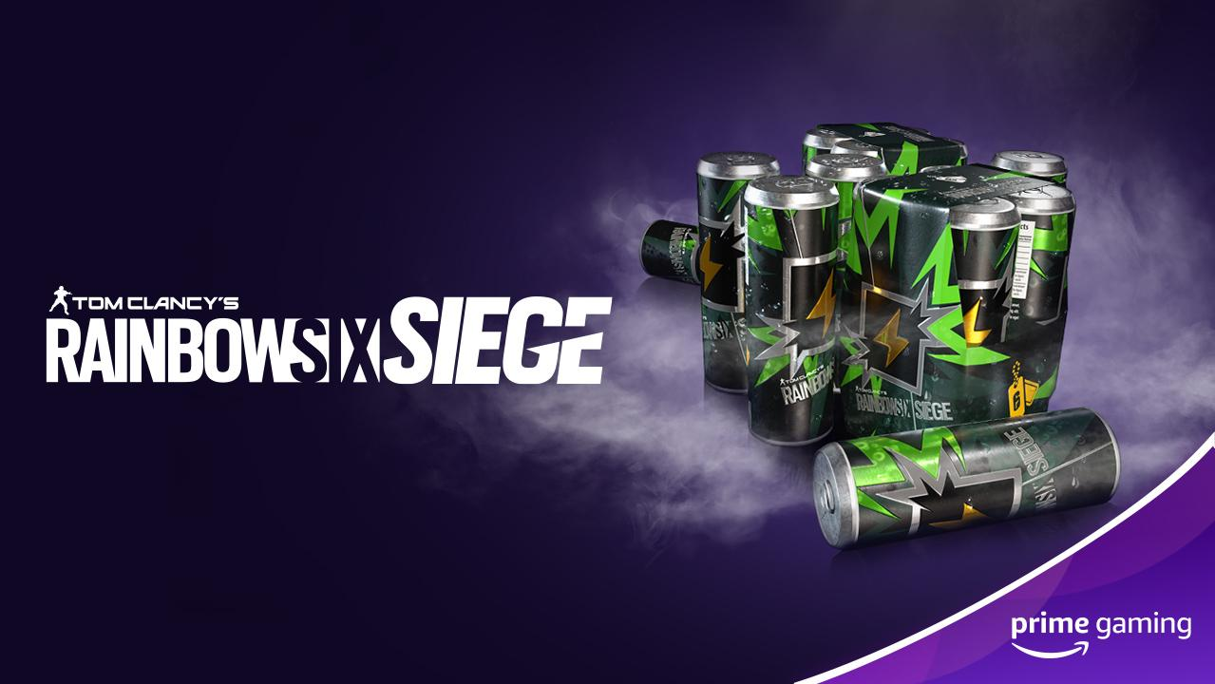
Get seven days’ worth of Renown Boosters in Rainbow Six Siege!
Available Now Prime Gaming has more on the way for Ubisoft’s online tactical shooter video game this May. This month, grab up to a week’s worth of Renown Boosters for Rainbow Six Siege gameplay before it expires on May 20.
Drop 5 of 12
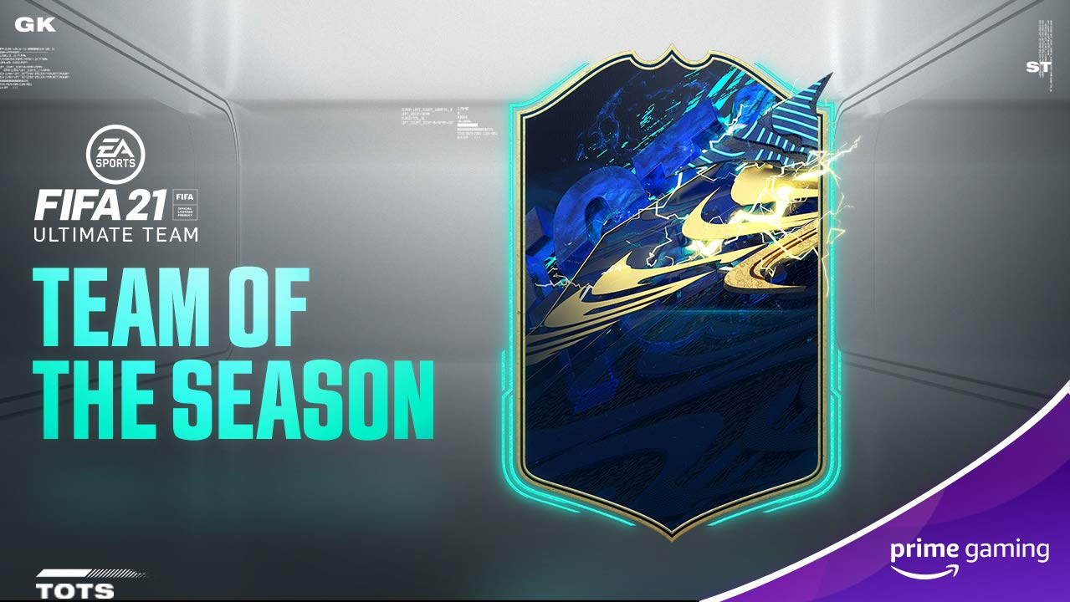
Leave It All Out on the Pitch With FIFA Loot
Available Now Players can let their competitive side take over this month in FIFA 21 and build out their dream squad with the latest Prime Gaming FIFA 21 loot. Claim the Exclusive Prime Gaming 81+ OVR Player Pack including: 1x guaranteed 81+ OVR Item and 4x rare gold player items.
Drop 4 of 9
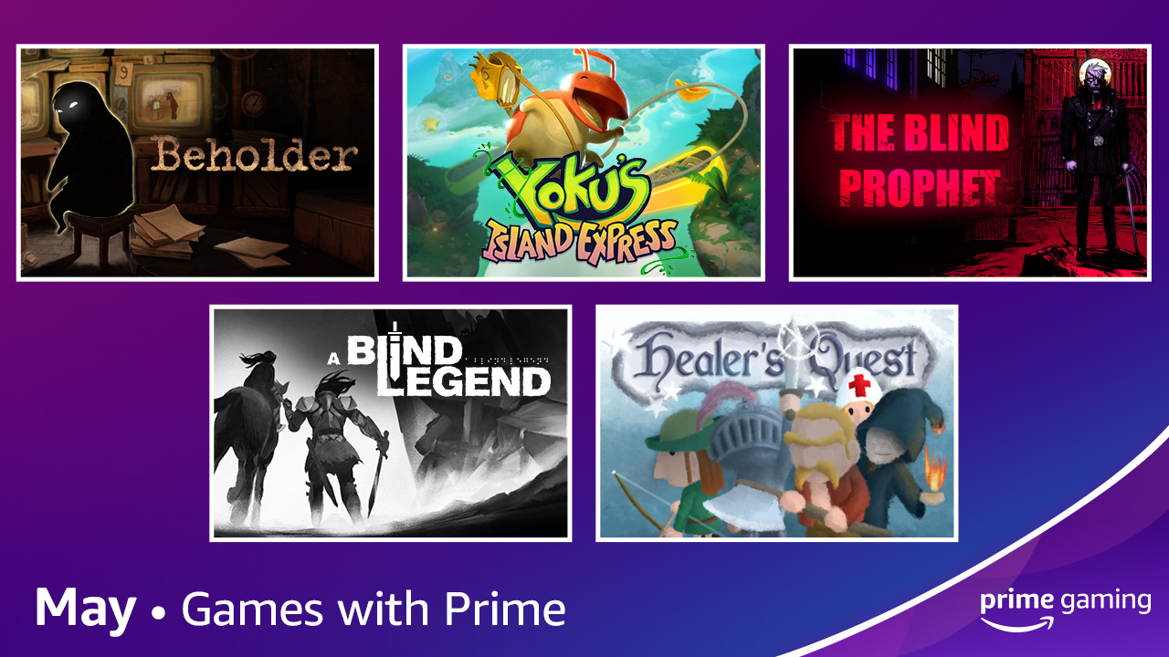
Level Up this May with Five New Games!
Available May 3 Prime Gaming is excited to bring five new titles to your library starting May 3! This month’s collection has something for everyone, from Yoku’s Island Express, a platforming pinball adventure game, to comedy RPG Healer’s Quest.
- Yoku’s Island Express - Explore a unique blend of pinball mechanics, platforming and open world exploration to unlock the secrets of Mokumana Island, help the locals, awaken ancient deities and more in this tropical adventure!
- Healer’s Quest - In this game, take on the role of the most underappreciated party member in any fantasy realm: the Healer.
- Beholder - Jump into this narrative award-winning dark dystopian adventure, where players are tasked to uncover and report anyone capable of plotting against the state.
- The Blind Prophet - Play apostle Bartholomeus in his divine mission: liberate the corrupted city of Rotbork, and brave the Great Evil that lurks within.
- A Blind Legend - The first-ever action-adventure game without video – where ears replace eyes! Discover the original, innovative sensory experience of binaural 3D sound.
 | 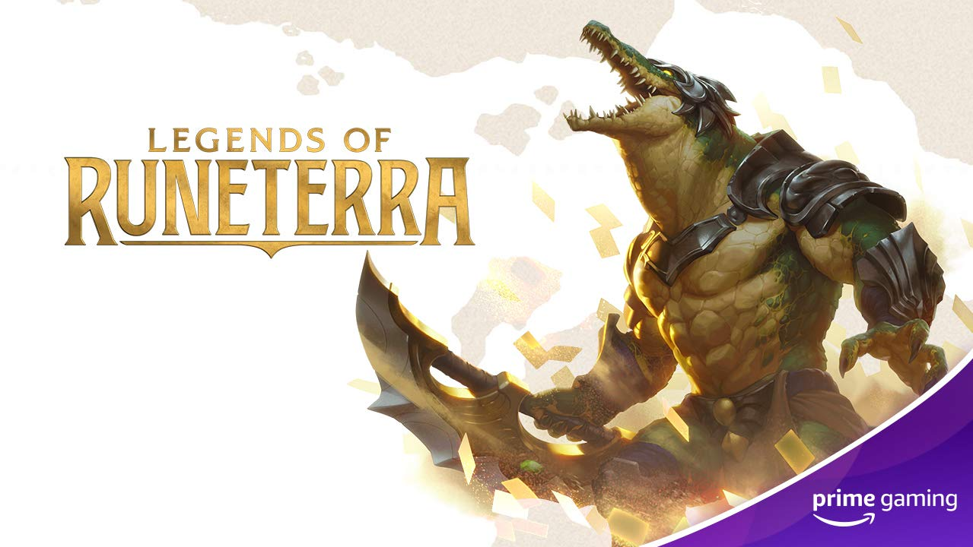 | 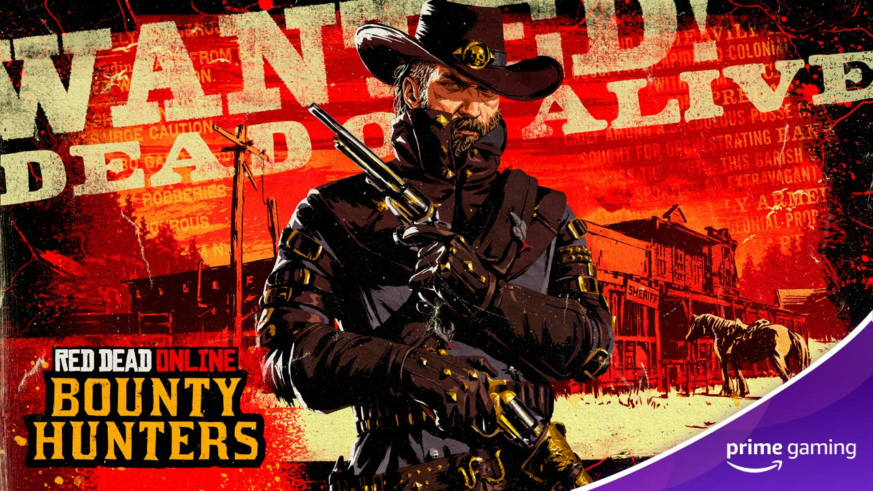
Fall Guys  Available Now  Pick up the Fitness Fiesta Costume + 3 Crowns, available until May 20.  Drop 5 of 6 | Legends of Runeterra  Available Now  Grab an Epic Wildcard this month!  Drop 4 of 12 | Red Dead Online  Available Now  Throughout the month of May, Prime Members can claim a Bounty Hunter License, Purple Bounty Wagon Tint, Varmint Rifle and other content/rewards.
 | 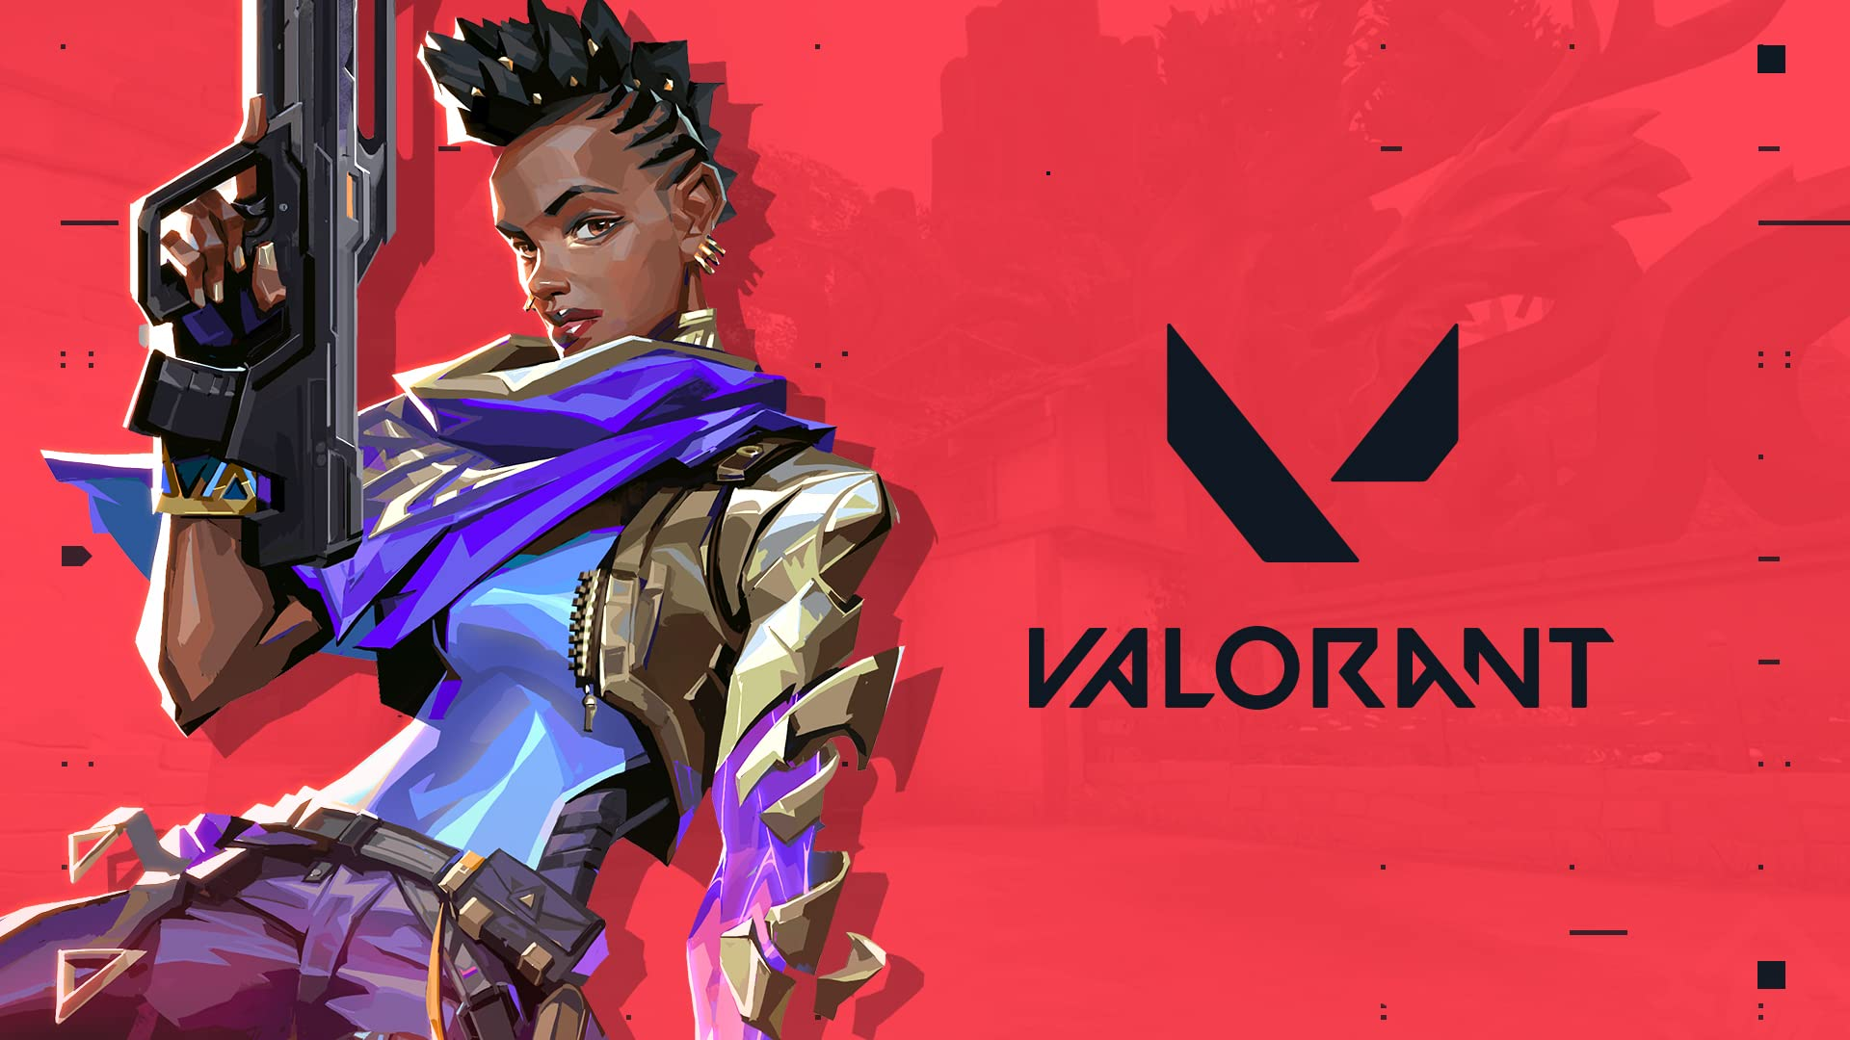 | 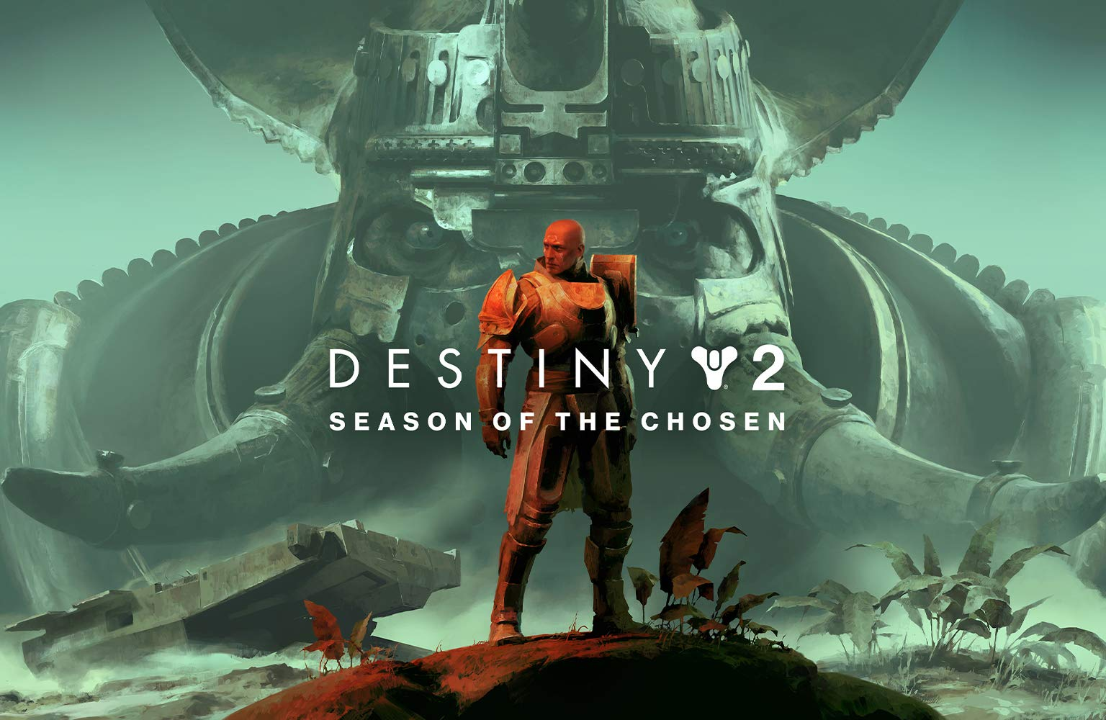
Grand Theft Auto Online  Available Now  May brings a ton of Grand Theft Auto Online content, with various GTA$ offers, a Submarine Sonar Station, discounts on a number of vehicles, weapons and more! | VALORANT  Available Now  Prime Members can level up this month with a 200 IQ Spray in the popular free-to-play hero shooter.  Drop 3 of 10 | Destiny 2  Available Now  Improve your arsenal with May’s offerings, including a Spicy Ramen Exotic Emote, Ikora's Resolve Exotic Ship, Future Perfect Exotic Ghost Shell and a Jagged Darksum Legendary Sparrow.  Drop 6 of 12
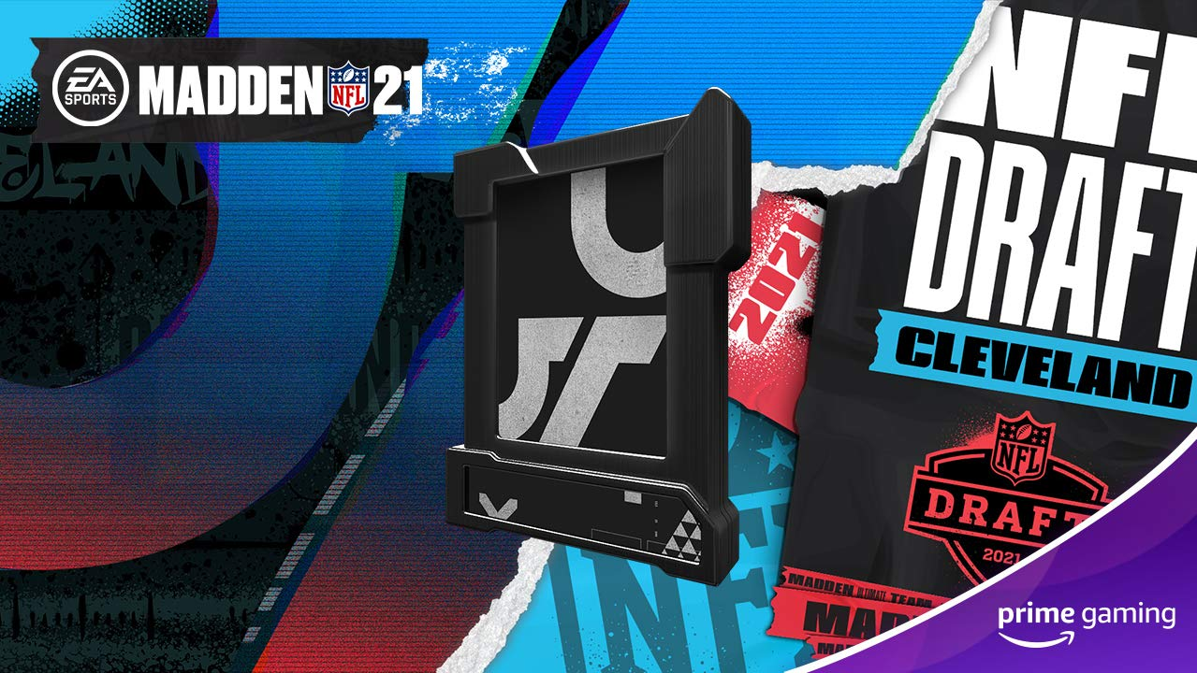 | 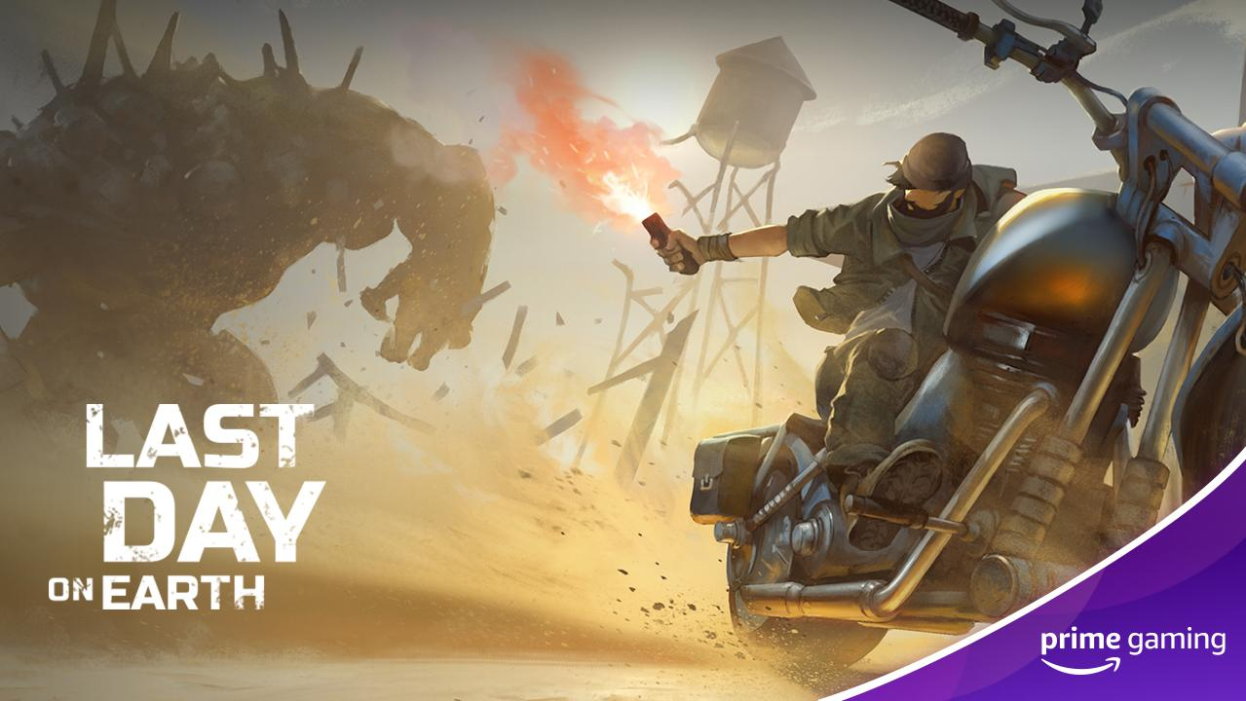 | 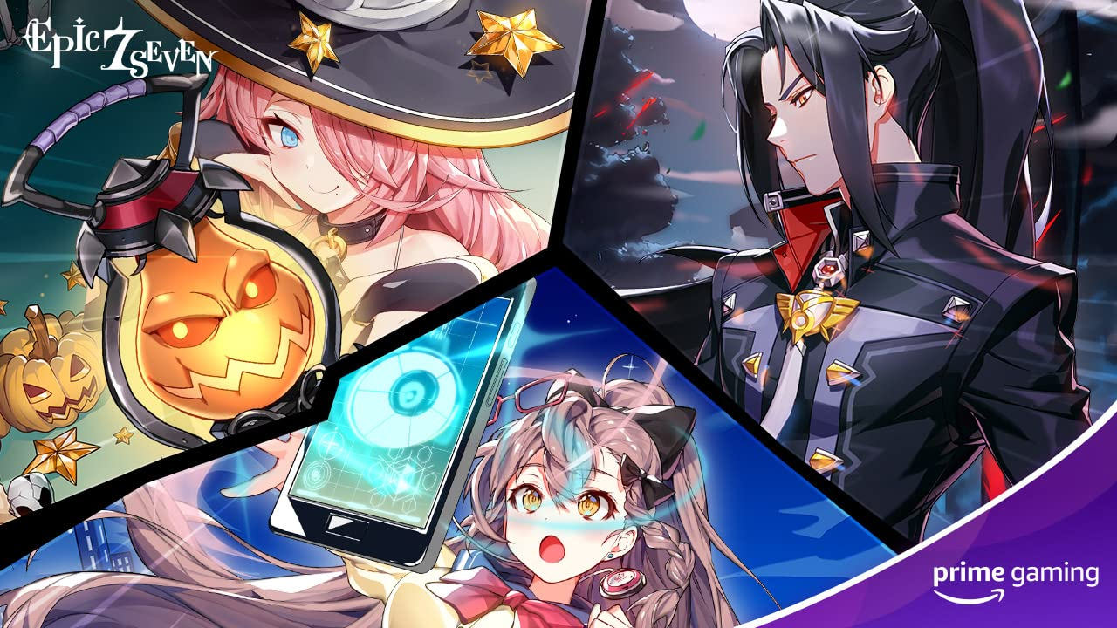
Madden NFL 21  Coming in May  Just in time for the 2021 NFL draft, be sure to grab 1x 89-95 OVR NAT Past Draft Player.  Drop 9 of 11 | Last Day on Earth  Available Now  Grab the Rank III Husky Puppy to assist you in the survival shooter set in the post apocalyptic world.  Drop 2 of 16 | Epic Seven  Drop 8: Now Available  Drop 9: May 5  Drop 10: May 19  Prevent the destruction of the 7th world with help from:  - Drop 8 - 20 x Leif through May 5  - Drop 9 - 5x Greater Equipment Charms, 500,000 Gold by May 19  - Drop 10 - 1 x Tera - Phantasma, 6 x Giga - Phantasma, 300,000 Gold before June 2  Drop 8-10 of 18
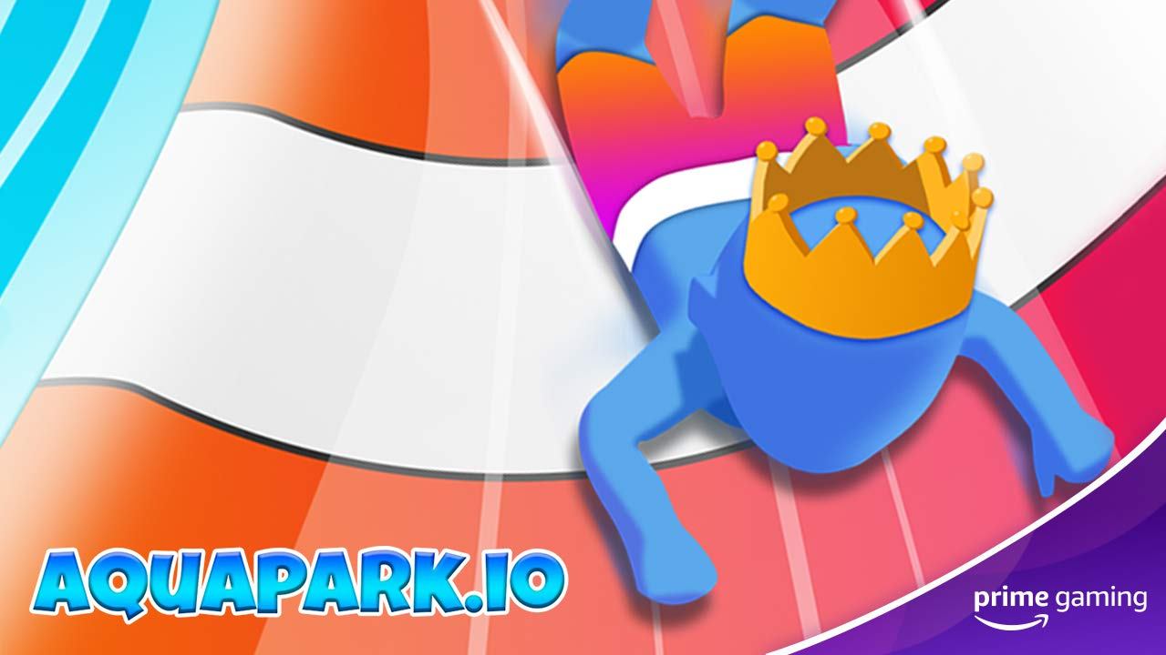 | 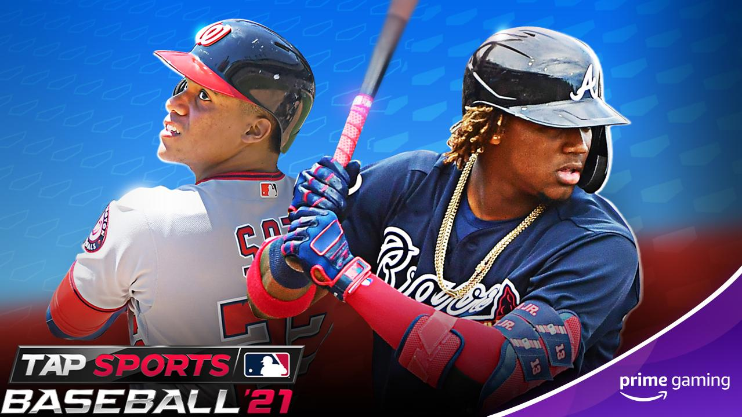 | 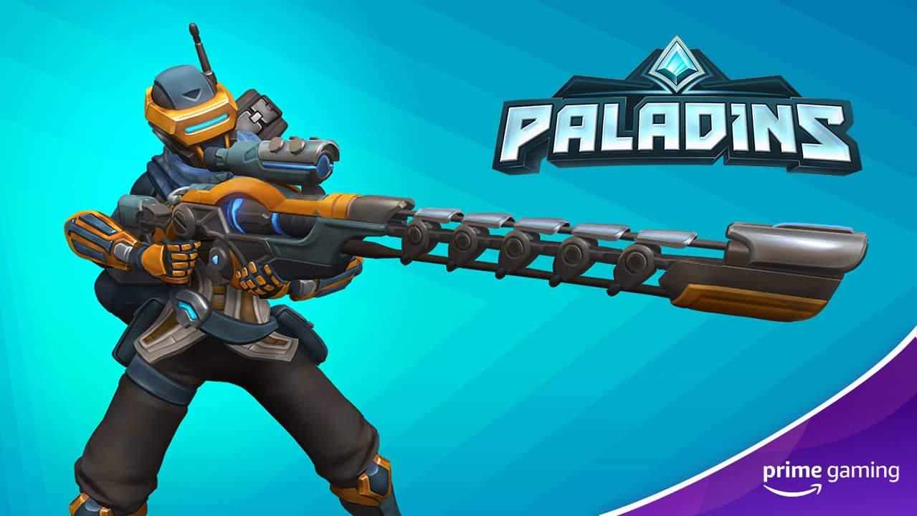
Voodoo mobile games  Enjoy ad-free play in some of Voodoo’s popular and addicting mobile titles.  - Available May 3 – 7 ad-free days in Aquapark.io  - Available May 6 – 14 ad-free days for Cube Surfer  - Available May 13 – 7 days of ad-free play in Helix Jump | MLB Tap Sports Baseball  Drop 3: Now Available  Drop 4: May 12  Drop 5: May 25  In conjunction with the resumption of the MLB season, Prime Gaming is pleased to give its members Daily Box and In-game Currency for mobile gameplay.  Drops 3-5 of 16 | Paladins  Now Available  Unlock an exclusive Nova Strike Kinessa skin available to Prime members.  Drop 8 of 9
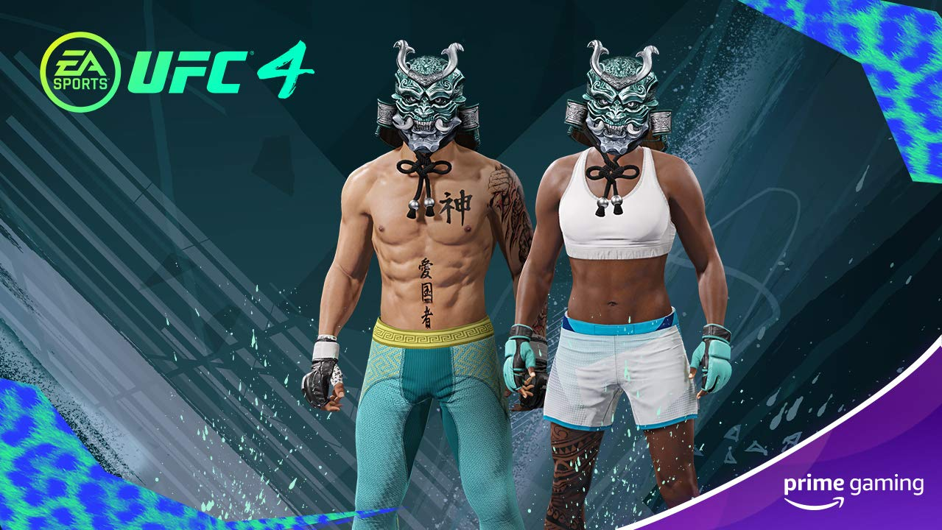 | 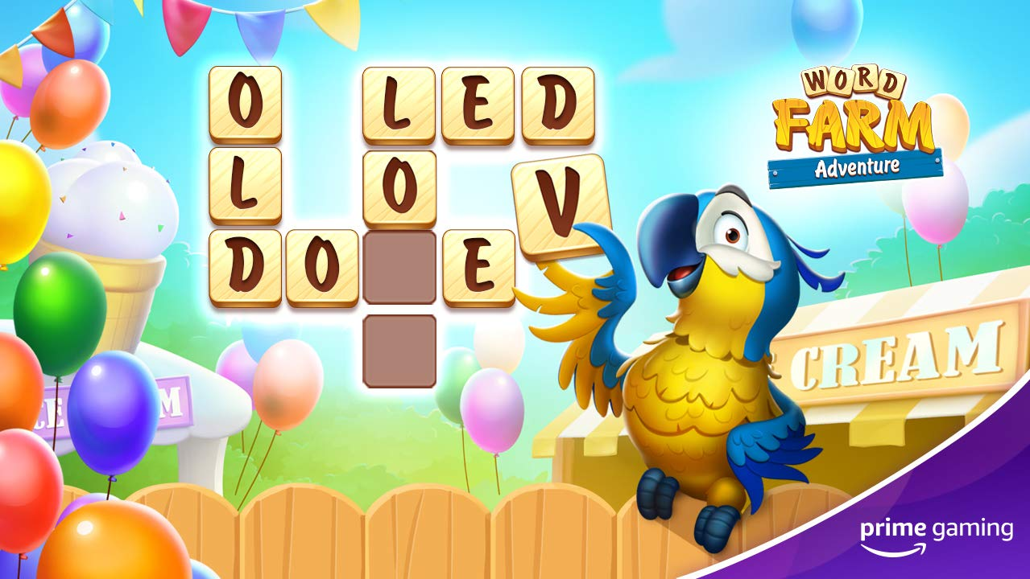 | 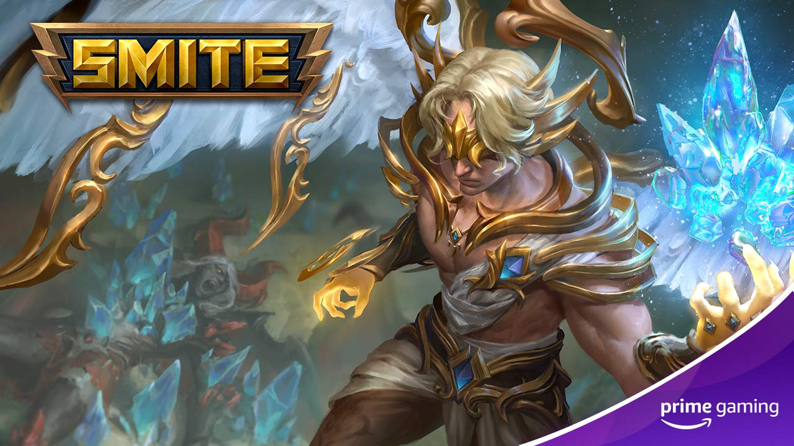
UFC 4  Now Available  Pick up your very own Blue Samurai Mask and other Playercard Items, Blue Samurai Mask, Unique Player card and Picture Unique Playercard Background.  Drop 4 of 6 | World Farm Adventure  Now Available  Players can collect the Booster Pack, which includes a number of loot such as hammer, hbomb, vbomb, fireworks, timer, magic wand, level reveal, ant and woodpecker.  Drop 1 of 4 | SMITE  Now Available  Calling all SMITE fans: Snag an exclusive Archangel Chernobog skin while you can!  Drop 8 of 9
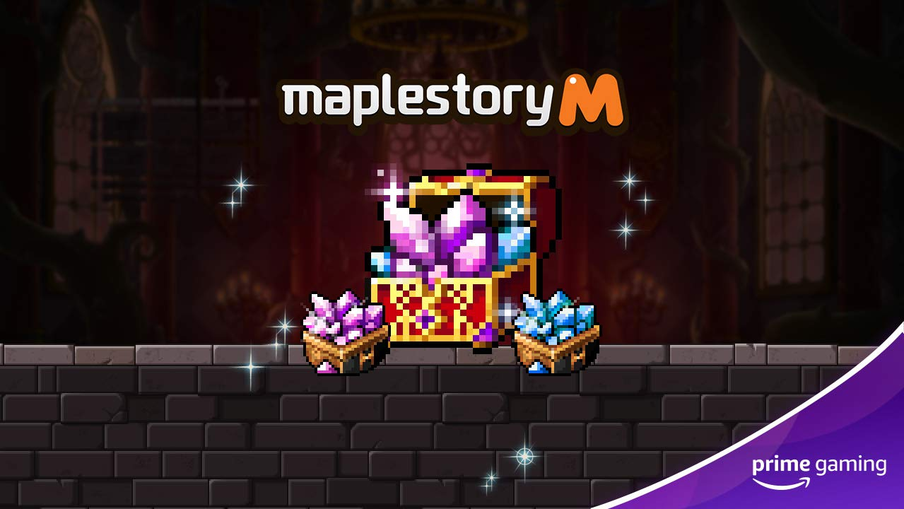 | 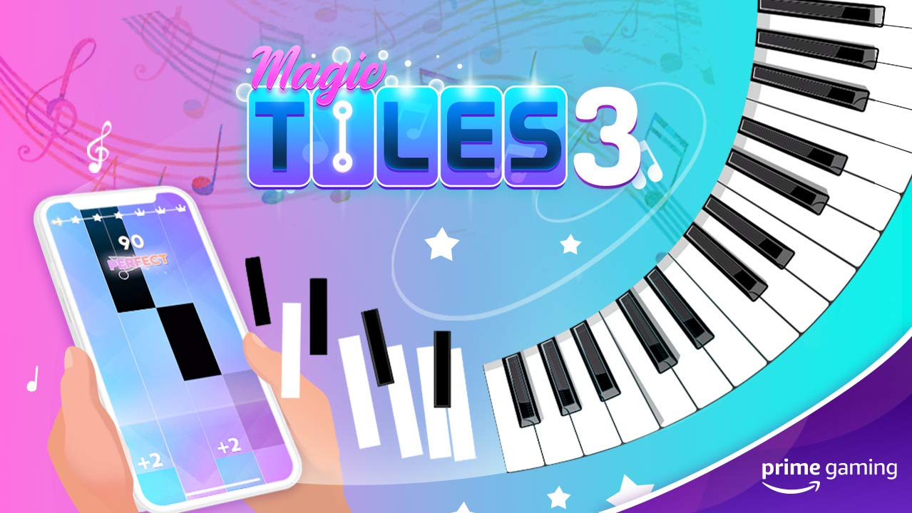 | 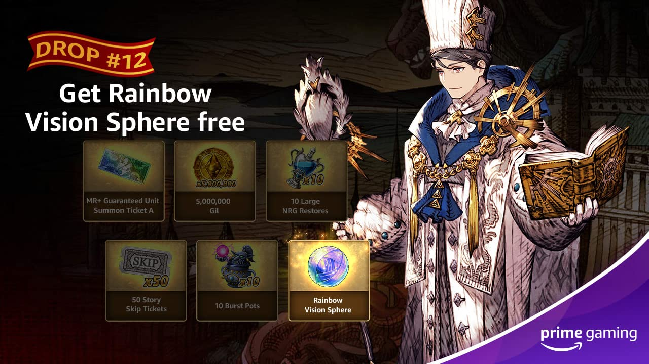
MapleStory M  Drop 7: May 5  May 5 through May 19, Prime Members can claim the Legendary Whetstone Box, containing Mysterious Weapon Whetstone Legendary x50, and Mysterious Armor Whetstone Legendary x100.  Drop 7 of 12 | Magic Tiles 3  May 6  This month, players can unlock a OneDay VIP pass and 5 additional songs, every week!  Drop 22 | WAR OF THE VISIONS FINAL FANTASY BRAVE EXVIUS  Now Available  Prime members can claim the Rainbow Vision Sphere x1 until May 12.  Drop 12 of 12
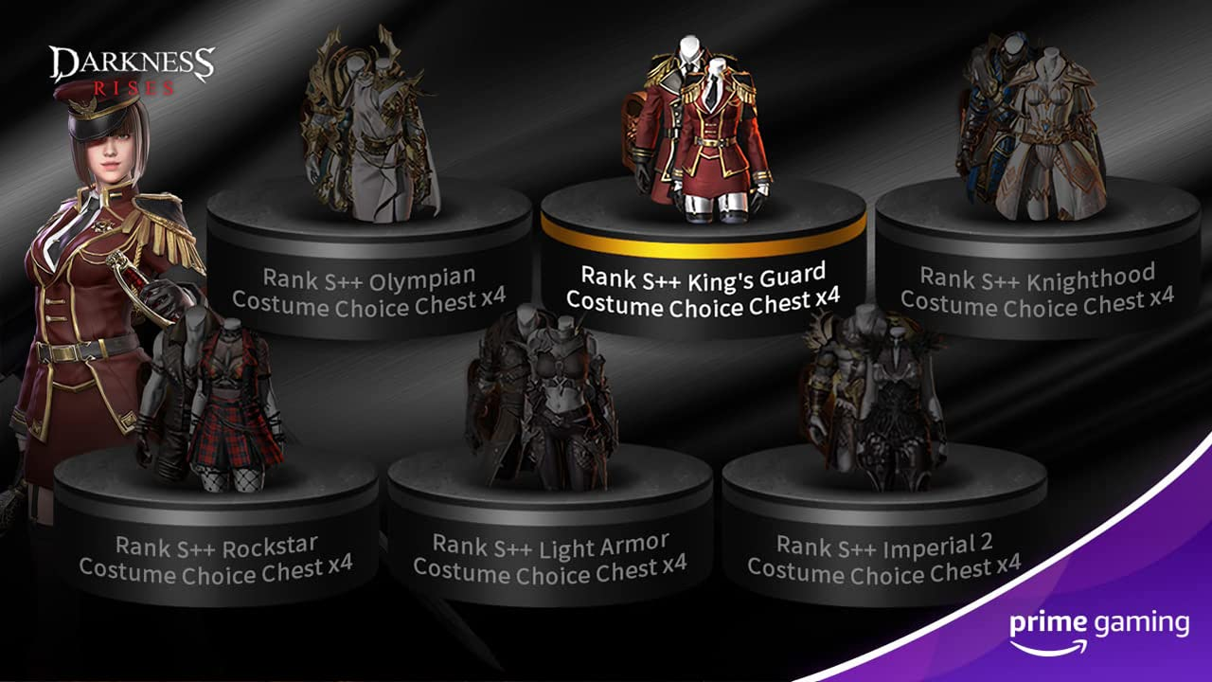 | 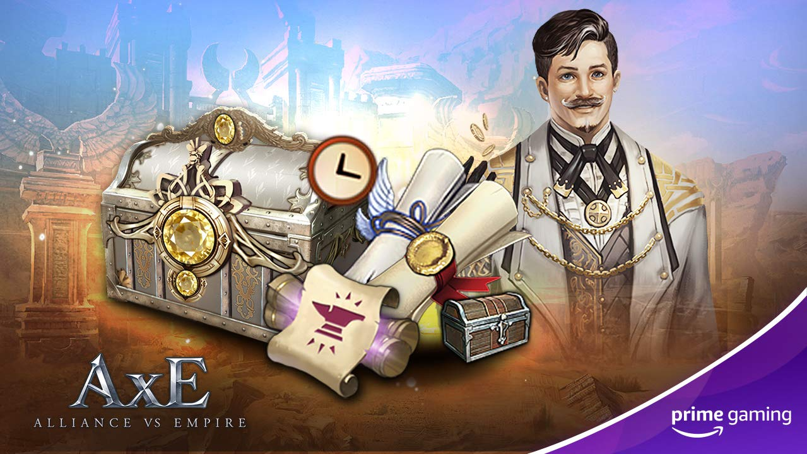
Darkness Rises  Drop 8: May 6  Drop 9: May 20  Players can look forward to redeeming the following items:  - Drop 8: Rank S++ Costume Choice Box x4: King’s Guard Costumes  - Drop 9: Rank S++ Costume Choice Box x4: Knighthood Costumes  Drop 8-9 of 12 | Alliance vs. Empire  Drop 6: May 12  Beginning May 12, Prime members can claim content including White Diamond x500, Enhancement Guard Ticket x50, Hero’s Blessing x1, and Treasure’s Blessing x1.  Drop 6 of 12
Calendar May 2021
Now Available Destiny 2 Drop 6
Now Available Epic Seven Drop 8
Now Available Fall Guys Drop 5
Now Available FIFA Drop 4
Now Available Last Day on Earth Drop 2
Now Available League of Legends Drops 10 - 12
Now Available Legends of Runeterra Drop 4
Now Available MLB Tap Sports Baseball Drop 3
Now Available Mobile Legends Bang Bang Drop 2
Now available Paladins Drop 8
Now Available Rainbow Siege Six Drop 5
Now available Red Dead Online content
Now available SMITE Drop 8
Now available UFC Drop 4
Now Available VALORANT Drop 3
Now Available WAR OF THE VISIONS FINAL FANTASY BRAVE EXVIUS Drop 12
Now available World Farm Adventure Drop 1
May 3 Games With Prime - Yoku’s Island Express, Healer’s Quest Beholder, The Blind Prophet and A Blind Legend
May 3 Last Chance to Claim Move or Die Couch Party Edition, The Escapists, Moving Out, Aces of the Luftwaffe - Squadron and Before I Forget
May 5 Epic Seven Drop 9
May 5 MapleStory M Drop 7
May 6 Magic Tiles 3 Drop 22
May 6 Darkness Rises Drop 8
May 10 League of Legends Drop 13
May 12 MLB Tap Sports Baseball Drop 4
May 12 Alliance vs. Empire Drop 6
May 13 Grand Theft Auto Online Content
May 19 Epic Seven Drop 10
May 20 Darkness Rises Drop 9
May 21 League of Legends Drop 14
May 25 MLB Tap Sports Baseball Drop 5
Coming in May Madden Drop 9

For the latest on content, offers and sweepstakes, follow Prime Gaming on the official Prime Gaming blog, Twitter, Facebook and Instagram.

About Prime Gaming

With Prime Gaming, Amazon Prime members enjoy tons of, exclusive content for their favorite PC, console, and mobile games. Plus, they can claim a collection of PC games every month that are theirs to keep forever, and a monthly Twitch channel subscription. Prime Gaming’s selection of in-game content and PC games is always growing and rotating to stay fresh, with new items and games added every month.

This is in addition to the many other benefits available with Prime, including the best of shopping and entertainment from Amazon, including fast, free delivery, along with exclusive savings, early access to deals, Prime Day, and so much more. Members enjoy unlimited streaming access to a vast collection of TV shows, movies, sports and more with Prime Video, ad-free listening of 2 million songs plus thousands of stations and playlists with Amazon Music, unlimited access to a rotating selection of more than 1,000 books and magazines with Prime Reading, and unlimited photo storage with Amazon Photos.

