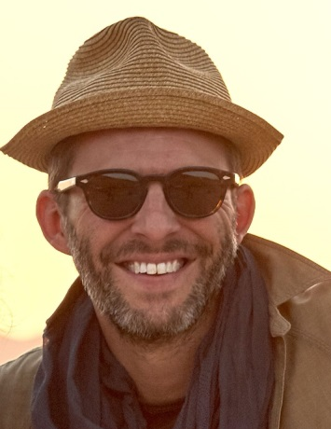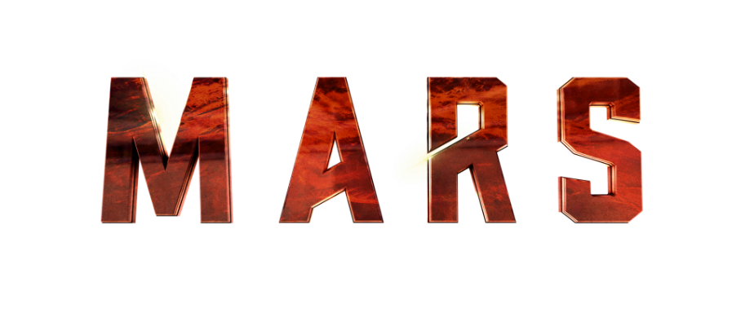

PRODUCTION: Justin Wilkes

ASSIGNMENT: Executive Producer

BIO: As the President of Media & Entertainment for RadicalMedia, Justin Wilkes leads a team of producers, directors, writers, editors and artists in creating, developing and producing a wide range entertainment programming. Under his leadership and sixteen-year history with the company, RadicalMedia has pushed the art of storytelling across multiple forms of media in collaboration with talent, networks and studios.
An accomplished producer himself, Justin has extensive experience in film and television production, live entertainment and digital platforms. He has been the recipient of numerous accolades, including an Academy Award nomination, Grammy nomination, Emmy Award, Peabody Award, two NAACP Image Awards, multiple Cannes Lions and two recent Primetime Emmy-nominations for the documentary What Happened, Miss Simone? and Steve Buscemi’s Park Bench.
Recent Executive Producer/Producer credits include: the Oscar®, Grammy®, and Emmy®-nominated Nina Simone documentary, What Happened, Miss Simone? and the critically acclaimed Keith Richards documentary, Keith Richards: Under The Influence, both for Netflix; the Oscar® and Emmy®-nominated documentary, Paradise Lost 3: Purgatory for HBO; the Emmy Award®-winning documentary, Paul Simon’s Graceland Journey, Under African Skies for A&E; the Jay Z/Ron Howard documentary, Made In America for Showtime; ESPN’s 30 for 30 documentary about sports legend, Bo Jackson, You Don’t Know Bo and the recent Doc & Darryl; five seasons of the Emmy®-nominated OWN series, Oprah’s Master Class; six seasons of Iconoclasts for the Sundance Channel; David Blaine: Real or Magic for ABC; the Emmy®-nominated AOL series, Park Bench with Steve Buscemi; Hello World! for Discovery Channel; and the Fall 2016 television projects, Hamilton’s America for PBS, about Lin-Manuel Miranda’s Tony®, Grammy®, and Pulitzer Prize®-winning Broadway hip-hop phenomenon, America Divided for Epix and the highly anticipated six-part mini-series event, Mars for Nat Geo with Ron Howard and Brian Grazer.

