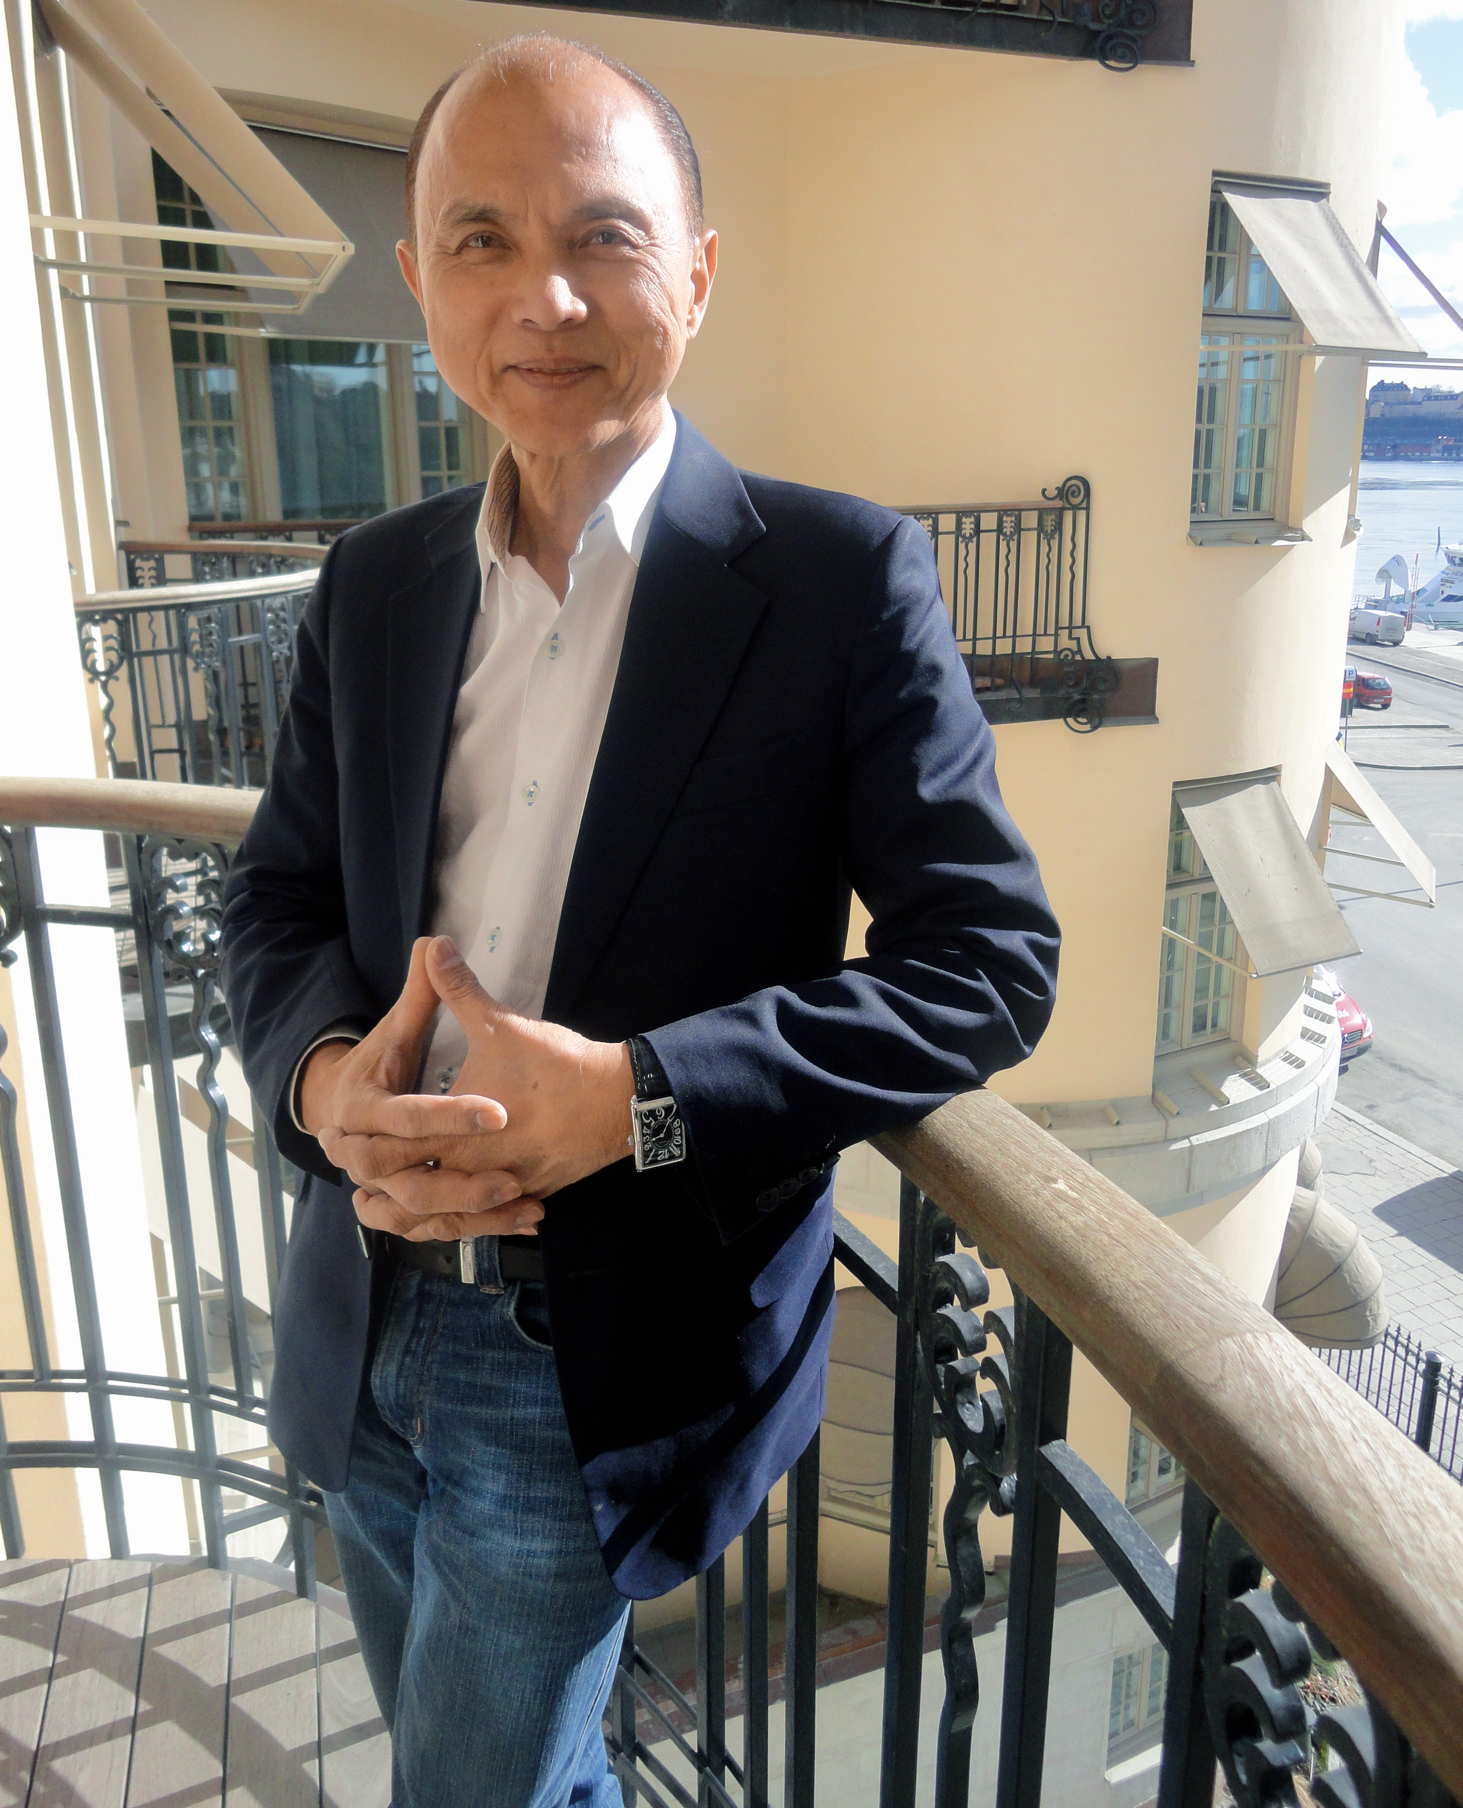

**Dato´ Professor Jimmy Choo OBE invited by H.M. King Carl XVI Gustaf**

**At lunchtime today Wednesday March 30 Dato´ Professor Jimmy Choo OBE arrived in Stockholm Sweden for a four day visit. In the evening Mr. Jimmy Choo OBE was invited by H.M. King Carl XVI Gustaf to the Royal Palace in Stockholm, at a dinner for the World Scout Foundation.**

The World Scout Foundation Board is composed of volunteers committed to Scouting, who are successful in their respective fields of endeavour. The board meets twice a year, with the active participation of its Honorary Chairman, His Majesty the King of Sweden.

The World Scout Foundation CEO Mr. John Geoghegan, Ireland, who attended the dinner, said: *”In his speech the King welcomed Mr. Jimmy Choo OBE as an ambassador for the World Scout Foundation and asked him to work for peace and understanding of different cultures, in business as well as in arts, design and fashion. ”*

Dato´ Professor Jimmy Choo OBE was honoured to be invited and said:  
*”The young people is our future. To me, education is everything. We need to devote and commit ourselves to inspiring young people. I'm honoured to be invited by his Majesty the King of Sweden and look forward to work for this good cause.”*

In addition to the royal dinner, Dato Jimmy Choo OBE will meet with business associates, Swedish friends and attend the Vanadis milano fashion show by Ida Lundberg on March 31 at Grand Hotel.

**PR/Special interview** with Dato' Professor Jimmy Choo OBE please contact:   
[annette@tgim.se](mailto:annette@tgim.se) or + 46 70 777 91 00

**Dato´ Professor Jimmy Choo OBE**

Dato' Jimmy Choo OBE, born Choo Yeang Keat, is a Malaysian fashion designer based in London, United Kingdom. He is best known for founding Jimmy Choo Ltd that became known for its hand-made women's shoes. Choo was born in Penang, Malaysia into a family of shoemakers. He made his first shoe when he was 11 years old. He is perhaps the most notable of students of Cordwainers Technical College in Hackney. The college is now part of the London College of Fashion.

**The World Scout Foundation**

Information:

<http://scout.org/en>

Why support Scouting, Mr. John Geoghegan, CEO, The World Scout Foundation:   
<http://www.youtube.com/watch?v=J99x6Q3iOMY>

Report of the World Scout Foundation:

<http://www.youtube.com/watch?v=tuEbD0LZp74>