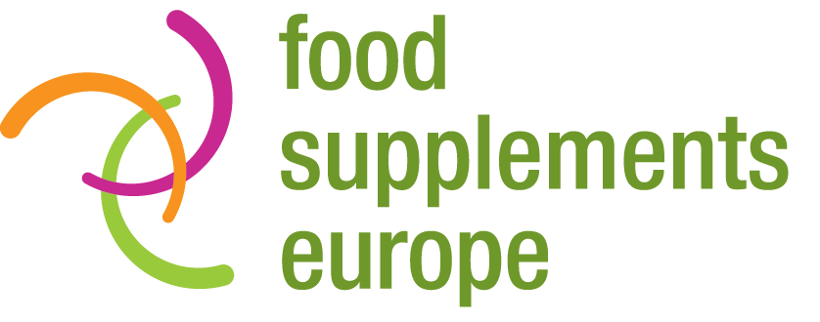

Under embargo until:
10am CET Tuesday 9 May 2017
PRESS RELEASE
Phytosterols study strengthens case for healthcare
cost savings through supplementation

There is mounting evidence that billions of euros worth of healthcare costs associated with cardiovascular disease (CVD) could be avoided through more widespread food supplementation among target populations across the EU.

A new study commissioned by Food Supplements Europe has found that savings of €5.3 billion a year could be generated through the daily consumption of 1.7g of phytosterols by the millions of adults aged 55 and over in the EU with severe hypercholesterolemia.

Hypercholesterolemia is the presence of high levels of LDL cholesterol in the blood, which is strongly associated with a higher risk of CVD. Across the EU, 31.1 million over-55s are living with severe hypercholesterolemia. They have an estimated 24.3% risk of experiencing a CVD-attributed hospital event as a result.

Independent researchers from Frost & Sullivan calculated the economic burden of addressing cases of CVD linked to hypercholesterolemia among this population and discovered it is set to cost EU healthcare systems and providers €1.328 trillion between 2016 and 2020 – €266 billion a year, and equivalent to €34,637 per event.

Phytosterols are proven to reduce levels of LDL cholesterol. Following an analysis of the available science, Frost & Sullivan’s research team concluded that consumption of just 1.7g of phytosterols a day by EU adults aged 55+ with severe hypercholesterolemia would cut their risk of experiencing a CVD-attributed hospital event associated with their condition by 2.3% basis points. In turn, this would result in cost savings of €26.5 bn over five years, or €5.3 bn a year.

The findings of the study are presented in full in a new Frost & Sullivan report: Healthcare Cost Savings of Phytosterol Food Supplements in the European Union.

It is the second study in the space of a year to highlight the huge potential that exists for generating healthcare cost savings in relation to CVD through more widespread food supplementation among target populations in the EU. In 2016, Frost & Sullivan’s researchers reported that €13 bn a year in healthcare cost savings could be generated through daily consumption of 1,000mg of Omega 3 EPA+DHA food supplements.

Food Supplements Europe Chair Ingrid Atteryd said: “A very clear picture is emerging of the significant economic and wellbeing benefits that could be achieved by encouraging more widespread food supplementation among those sections of the EU population at greatest risk of experiencing a CVD-attributed hospital event. Having already demonstrated the cost savings possible through greater supplementation with fish oil, we are now able to see the potential for substantial economies through more widespread consumption of phtyosterols. It’s a clear indication that food supplementation can make a highly positive contribution in the EU both financially and in terms of quality of life.”

The newly published phytosterols report is the third in a series by Frost & Sullivan. The first addressed Omega 3 and CVD, while the second – published in February 2017 – explored the cost saving benefits of Calcium + Vitamin D supplementation in the context of avoiding bone fractures among the 27.8 million people in the EU aged over 55 and living with osteoporosis. It was found that savings of €3.96bn a year were achievable.

Ms Atteryd concluded: “This series of in-depth and rigorous healthcare cost savings reports commissioned by Food Supplements Europe highlights an important opportunity to enhance the health and wellbeing of millions of EU citizens, while also making significant cost savings that could ease the enormous financial pressure on healthcare systems. More than ever, it is now impossible to ignore the fact that supplementation can play an absolutely vital role in the future of how healthcare in the EU is funded, resourced and delivered.”

ENDS

For more information, please contact:
Richard Clarke, Ingredient Communications
Tel: +44 1293 886291 / +44 7766 256176
Email: richard@ingredientcommunications.com
Twitter: @ingredientcomms

About Food Supplements Europe
Based in Brussels, Food Supplements Europe is a not-for-profit trade organisation representing the interests of the European food supplements sector. Its membership includes national associations and companies who are committed to ensuring that future EU legislation and policy reflect the important role that the supplements sector plays in improving the health of consumers. You can find more information about Food Supplements Europe at www.foodsupplementseurope.org

