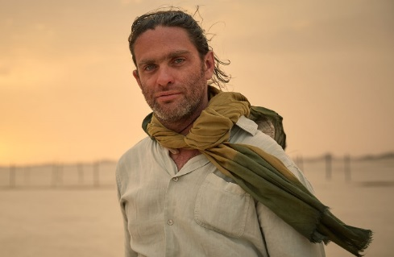

PRODUCTION: Everardo Gout

ASSIGNMENT: Director

BIO: Everardo Gout is a Mexican director, writer and producer. He studied film at Centro Universitario de Estudios Cinematograficos in Mexico City, the New York Film Academy and the Hollywood Film Institute. Gout began his career in television and produced two sessions of “Linea de Tres,” a segment of the popular program “Los Protagonistas,” for TV AZTECA for the 2004 Olympic Games and the 2006 World Cup. He co-produced three documentaries, “XV in Zaachila,” “Tula espejo del cielo” and “Indio,” as well as the Mexican feature films “Matame Amor” and “Piedras Verdes.” Gout’s expertise in storytelling led him into directing many music videos for artists such as Mos Def, Craig David, Morcheeba, The Roots, Ozomatli and will.i.am. In 2007, he was nominated for a Grammy for the Killers’ music video “When You Were Young,” on which he collaborated with Anthony Mandler. In the feature film world, Gout honed his craft by working as Baz Lurhmann’s second assistant director on “Romeo & Juliet,” which led to multiple opportunities in directing various short films. In 2008, he established a company in Mexico City where he developed and directed his first critically acclaimed feature film, “Days of Grace,” which made its premiere at the 2012 Cannes International Film Festival to rave reviews.

