COX POWERTRAIN INTRODUCES NEW DUTCH DISTRIBUTOR AT METSTRADE
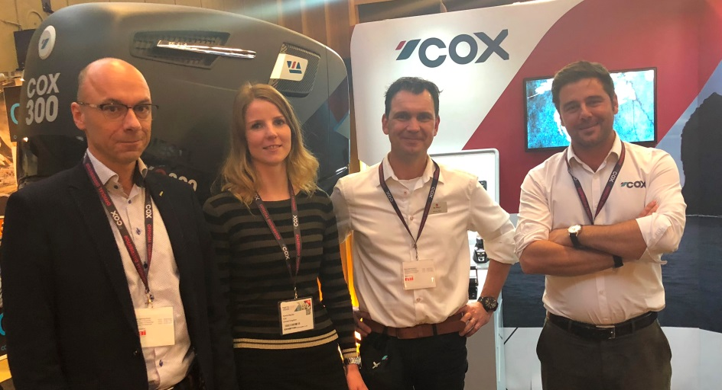
L-R, Piet de Wolf, Laurina van der Maas, Martin Wijs of De Wolf and Joel Reid, Global Sales Director, Cox Powertrain

Cox Powertrain, the British company behind the development of the world’s highest power density diesel outboard engine, the CXO300, has announced De Wolf Maritime Safety as its distributor for the Netherlands and Belgium. The announcement took place during last week’s METSTRADE where the two companies came together for the first time as manufacturer and distributor.

As a supplier of outboard engines and boats to commercial, rescue, military and superyacht vessels, De Wolf Maritime Safety has many years of experience of working with professional maritime applications and provides a dependable servicing and maintenance programme to its customers.

De Wolf Maritime Safety’s joint owner and Technical Director, Piet de Wolf said, “We are very happy to become the official distributor of Cox Powertrain in the Netherlands and Belgium. Our two companies have been working closely together over the last few years to deliver the first high power outboard diesel engine as a new propulsion standard. The signing of this contract underpins our strong relationship.

We know how much military and police organisations, the offshore and superyacht industries, are looking forward to the introduction of this high power diesel outboard engine.
The new diesel technology vastly extends the capabilities of small fast boats and enables new service levels to be introduced to this market.”

Over the last year, Cox Powertrain has been consistently increasing its attendance at key maritime trade and consumer exhibitions ahead of the CXO300 launch in 2018. METSTRADE once again proved a highly successful platform for the Cox brand and product awareness.

Visit www.coxmarine.com for more information and to sign up for regular news updates about the CXO300.

ENDS
About Cox Powertrain

Cox Powertrain is a world-leading British designer and builder of diesel engines developed for worldwide and multi-market applications.

Based on the South Coast of England, Cox Powertrain is backed by the Ministry of Defence and a solid shareholder base of private and institutional investors. As a result, the company has been able to implement a long-term development programme of ground-breaking new products.

Led by ex-Cosworth CEO, Tim Routsis, whose background lies in engine development in global automotive, aerospace and marine markets, the company’s mission is to deliver a completely new concept in diesel engines that has the potential to revolutionise the marine market.

With a strong pedigree in Formula 1 racing and premium automotive design, Cox’s highly skilled team of engineers has decades of experience in combustion engines and understand the many difficulties with which customers are challenged.

Cox’s first ground-breaking diesel outboard engine, the CXO300, is the highest power density diesel outboard engine ever developed. As a low weight, high power, single fuel engine, the CXO300 delivers the same performance and efficiency of an inboard but with the convenience and flexibility of an outboard.

For further information, visit www.coxmarine.com

Media contacts:

Reena Bayley, Global Marketing Manager
Cox Powertrain Limited
Tel: +44 (0) 1273 454 424
E: reena.bayley@coxpwertrain.com

Media information & images:
Karen Bartlett
Saltwater Stone
Tel: +44 (0) 1202 669 244
E: k.bartlett@saltwater-stone.com

