Press release
Norwegian Coastal Administration digitalizes operations
with Kongsberg Digital’s Vessel Insight

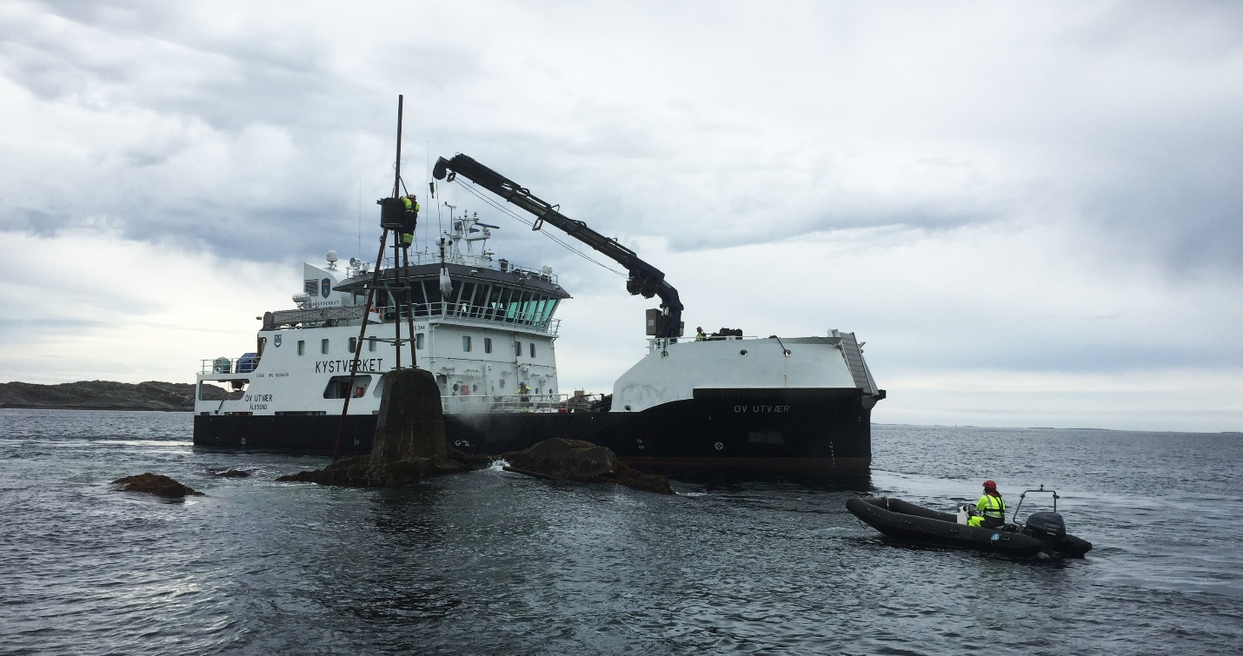
Photo: Anne Grethe Nilsen/Kystverket
The Norwegian Coastal Administration has signed up to Kongsberg Digital’s Vessel Insight data infrastructure service

Kongsberg Digital is pleased to announce that the Norwegian Coastal Administration has taken the next step in its digitalization journey by signing up to Kongsberg Digital’s data infrastructure subscription service, Vessel Insight, and the performance application Vessel Performance.

The Norwegian Coastal Administration is a national agency for coastal management, maritime safety and preparedness against acute pollution. Their vision is to make the Norwegian coast and waters the safest and purest in the world. This includes, among other goals, enabling safe navigation and a clean environment whilst maintaining quality throughout all operations and always being present when needed. Now, they are looking for digital tools to make their operations more data driven.

“Digitalization plays a critical role in transforming the maritime industry towards more sustainable, accurate and efficient operations,” says Andreas Jagtøyen, EVP Digital Ocean, Kongsberg Digital. “The question is not whether there is an increased focus on digitalization, but rather how fast we can enable the transformation towards a more data-driven and sustainable fleet. We are very happy to be working with the Norwegian Coastal Administration to help them achieve their goals.”

Digitalization in the maritime industry will enable increased efficiency, safety and facilitate meeting enhanced environmental standards. Kongsberg Digital’s data infrastructure and subscription-based service, Vessel Insight, gives maritime operators a low-threshold, viable way to start their digitalization journey. The vessel-to-cloud data infrastructure ensures customers can capture and aggregate quality data from their fleet. This data will be used to run applications tailored to various needs and goals, all available in KONGSBERG’s application marketplace. The marketplace hosts KONGSBERG, OEM and third party developed applications.

“In the Norwegian Coastal Administration, we want to achieve the most efficient and environmentally friendly operation of our vessels. With that goal in mind, optimizing energy use and reducing emissions are two important factors. With Kongsberg Digital’s solution, this is what we achieve,” says Kurt-Ivar Gram Franck, Technical Manager in the Norwegian Coastal Administration.

The Norwegian Coastal Administration will install Vessel Insight on their first vessels during Q3 2021.

KONGSBERG DIGITAL
Kongsberg Digital, a subsidiary of KONGSBERG, is a provider of next-generation software and digital solutions, to customers within maritime, oil and gas, and renewables and utilities. The company consists of more than 500 software experts with leading competence within the internet of things, smart data, artificial intelligence, maritime simulation, automation and autonomous operations. Kongsberg Digital is the group-wide center of digital expertise for the KONGSBERG group. www.kongsbergdigital.com
KONGSBERG
KONGSBERG (OSE-ticker: KOG) is an international, leading global technology corporation delivering mission-critical systems and solutions with extreme performance for customers that operate under extremely challenging conditions. We work with nations, businesses and research environments to push the boundaries of technology development in industries such as space, offshore and energy, merchant marine, defense and aerospace, and more. KONGSBERG has about 11,000 employees located in more than 40 countries, creating a total revenue of NOK 25.6bn in 2020.

NCA
The Norwegian Coastal Administration is a national agency for coastal management, maritime safety and preparedness against acute pollution. The Norwegian Coastal Administration is under the Ministry of Transport and Communications. The Norwegian Coastal Administration is both user financed and financed through the state budget. Tasks are assigned to the Norwegian Coastal Administration through the state budget and an annual allocation letter is received from the Norwegian Ministry of Transport.

CONTACT:  Mathilde Magnussen  VP Communication and Marketing  Kongsberg Digital  (+47) 456 78 255  mathilde.magnussen@kdi.kongsberg.com  kongsberg.com | Kurt Ivar Gram Franck  Technical Manager  Norwegian Coastal Administration  (+47) 928 55 069  kurt-ivar.gram.franck@kystverket.no  kystverket.no

