

Press Release

Stockholm, August 25, 2015

**Svenskt Tenn launches Swedish-made textiles**

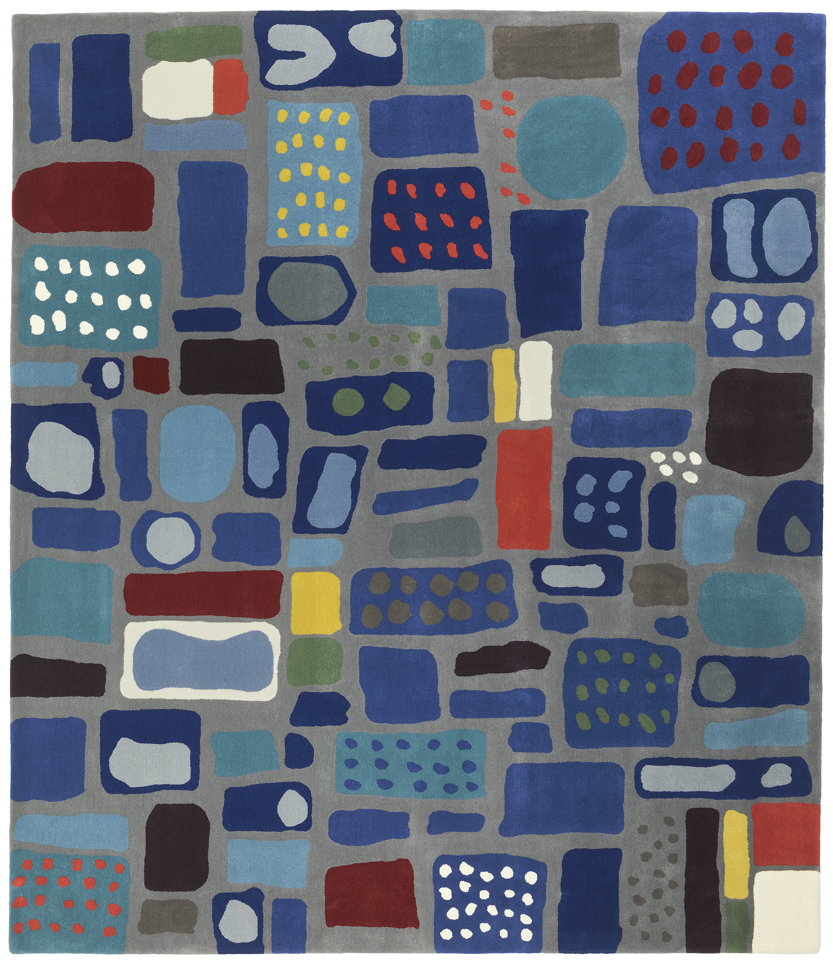**The interior design company Svenskt Tenn introduces an upholstery textile and a carpet, both domestically manufactured. Svenskt Tenn is set on preserving Swedish handicrafts, and the new collaborations with rug producer Kasthall and Ludvig Svensson’s textile weaving is part of that endeavor.**  
Josef Frank designed the *Mosaik* carpet in the late 1940s, but it has, as far as known, never been produced before. Now it is made, from yarn to finished rug, by the Kasthall company, with the attention to quality of materials and craftsmanship that distinguishes Svenskt Tenn and its offering. Similarly, the new *Twist* – a durable textile upholstery fabric – was developed in close collaboration between Svenskt Tenn and textile manufacturer Ludvig Svensson. *Twist* is a wool and linen blend, available in five color combinations.  
  
“Sweden once had a significant textile industry. Today, while only a few manufacturers remain, these combine unique experience and know-how with excellent craftsmanship and quality. Producing most of what we market domestically is one way for Svenskt Tenn to help preserve Swedish quality handicrafts,” said Thommy Bindefeld, Marketing Director at Svenskt Tenn.  
  
The new products are displayed in an exhibition of furnishings opening now at the Svenskt Tenn store in Stockholm. The exhibition is open to everyone and runs through September 27.

Alongside the textile products a new armchair is also featured. This was designed by Björn Trägårdh (1908-1998) during his time at the Svenkt Tenn in the 1930s, and it is now introduced in the company’s line of products.

**For further information, please contact:**

Vicky Nordh, Marketing Assistant: +46 8-670 16 23 or vicky.nordh@svenskttenn.se

Thommy Bindefeld, Marketing Director: +46 8 670 16 02 or thommy.bindefeld@svenskttenn.se

Svenskt Tenn is an interior design company with retail stores at Strandvägen in Stockholm and online. Since 1975, Svenskt Tenn is owned by the Kjell and Märta Beijer Foundation, which provides research grants within ecology, medicine and the preservation of Swedish interior design tradition.