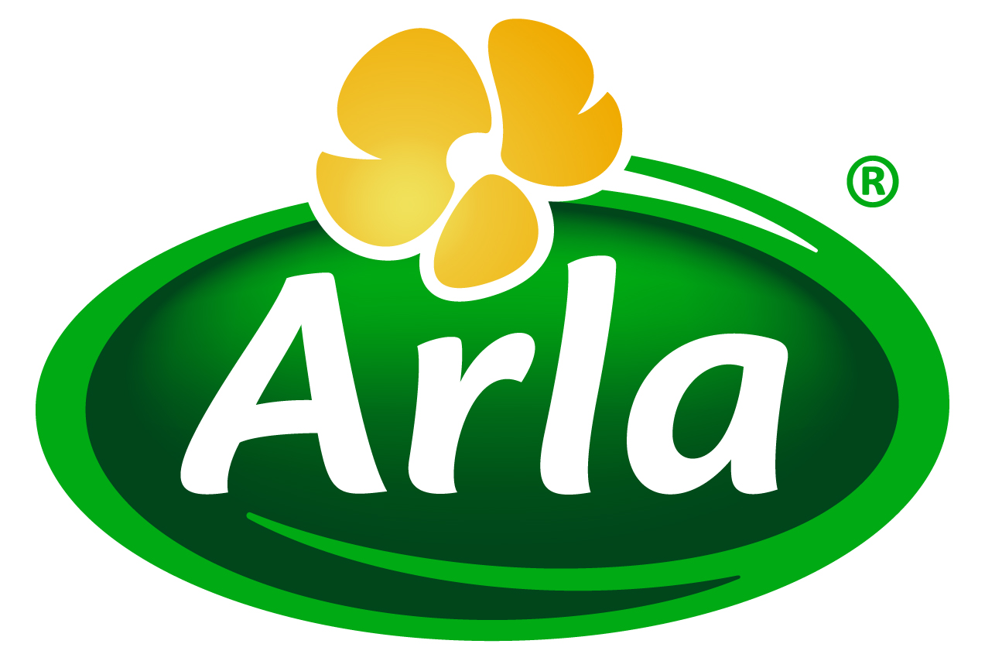
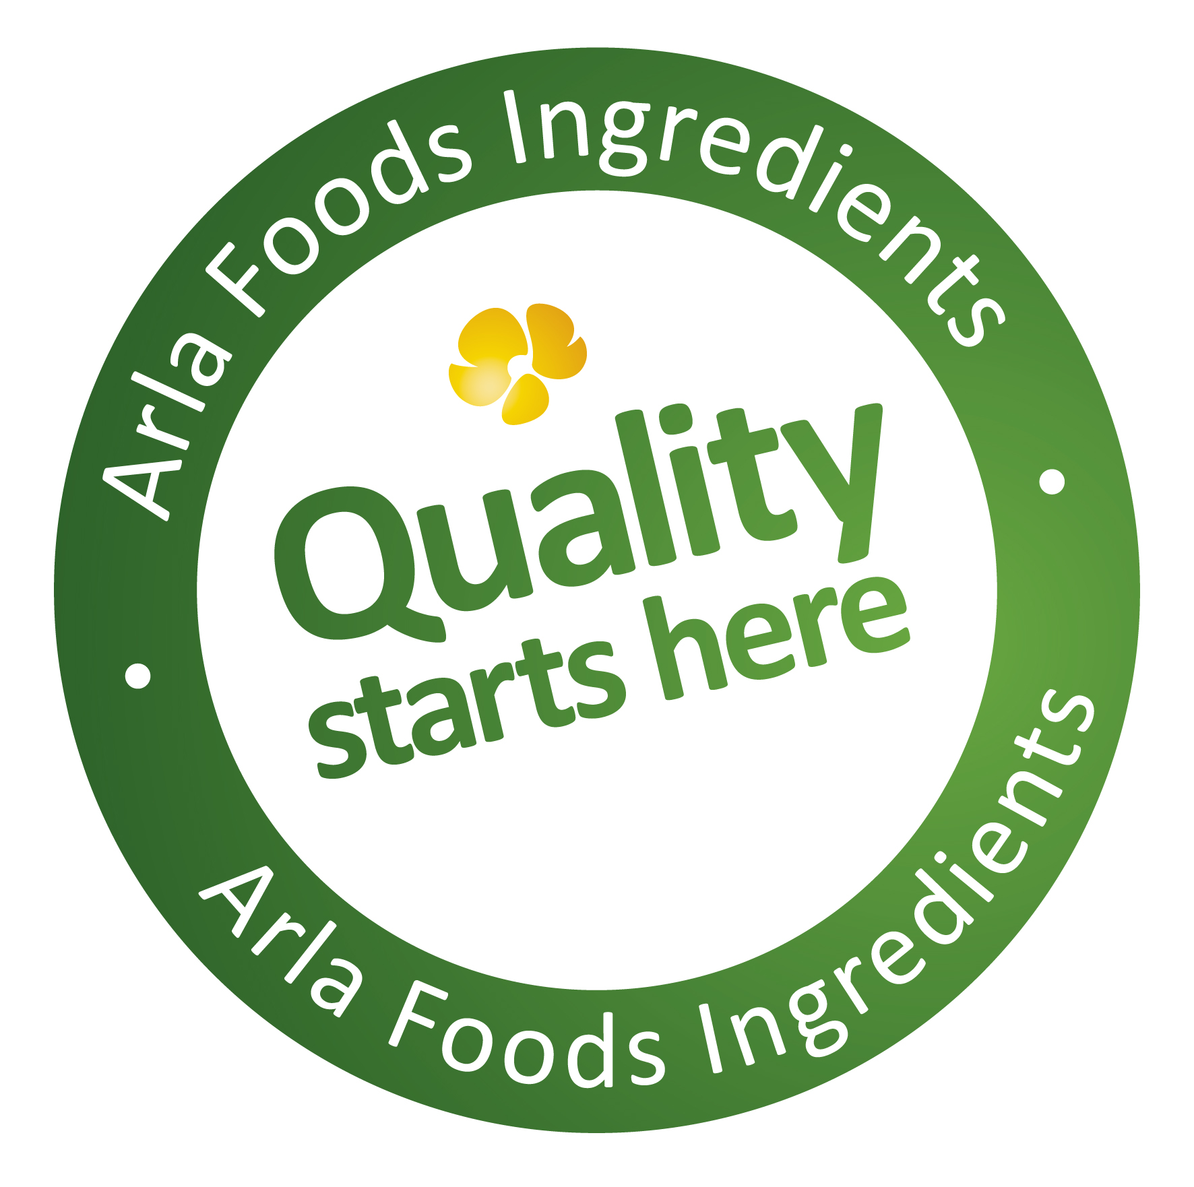

23 September 2014

PRESS RELEASE – HIE 2014 PREVIEW

Cut recovery times from days to hours with
HYDRO.365 whey protein hydrolysate

Lacprodan® HYDRO.365, a whey protein hydrolysate for sports nutrition that reduces recovery times from days to hours, will take centre-stage for Arla Foods Ingredients at Health Ingredients Europe 2014.

Developed for endurance sport enthusiasts – such as runners, cyclists and triathletes – HYDRO.365 offers a particularly high degree of hydrolysis. As a result it is more easily absorbed than intact whey proteins because most of it has already been broken down, or ‘pre-digested’, into amino acids and smaller short-chain peptides. This promotes much faster recovery after a workout in comparison with standard whey proteins.

HYDRO.365 can be used in a wide range of popular sports supplement product applications, including clear beverages, gels, bars, powders and tablets. At HIE, Arla Foods Ingredients will present application concepts that will showcase the commercial potential of HYDRO.365 in today’s booming endurance sports nutrition market.

HIE takes place in Amsterdam from 2-4 December 2014. Arla Foods Ingredients will exhibit on Booth E5. Also on the stand will be an exciting new whey protein concept that addresses glucose control, and a high-protein snacking concept designed specially for weight management and the needs of seniors.

Lindsey Ormond, Business Development Manager for Health & Performance Nutrition at Arla Foods Ingredients, said: “Our high quality whey protein solutions are at the cutting edge of innovation and address a wide range of nutritional needs and health concerns. HIE will offer the perfect forum for us to share these advancements with the industry.”

ENDS

For more information, please contact:

Kine Bjoralt, Ingredient Communications
Tel: +44 141 280 4141
Email: kine@ingredientcommunications.com

About Arla Foods Ingredients
Quality starts here: Arla Foods Ingredients is a global leader in natural whey ingredients for products in a range of categories – from sports nutrition, beverages, bakery, dairy and ice cream to clinical and infant nutrition.
The cornerstones of our business are innovative ingredients, world-class facilities and a staff of dedicated experts. Drawing on our portfolio of functional and nutritional whey proteins, milk minerals, lactose and permeate, our expert team delivers solutions that bring new food products quickly and efficiently to market. Our application centres run hundreds of customer product trials every week. All ingredients are produced using state-of-the-art processing technology at our plant in Denmark, or by one of our joint ventures in Argentina, Germany and the UK.
Arla Foods Ingredients Group P/S is a 100% owned subsidiary of Arla Foods, a global dairy company and cooperative owned by dairy farmers in Denmark, Sweden, the UK, Germany, the Netherlands, Belgium and Luxemburg.

RSS Feed
Visit our website at http://www.mynewsdesk.com/arla-foods-ingredients and sign up to our News RSS feed for all the latest developments – updated regularly.

Twitter
Follow us on twitter for all the latest updates @ArlaIngredients

