Serving customers better and faster—Dentsply Sirona opens new production
facility in Tokyo, Japan
Press Contact
Kerstin Wettby
Senior Manager
Global Communication & PR
Dentsply Sirona Implants
Aminogatan 1
SE-43121 Mölndal, Sweden
Phone: +46 705 16 32 02
kerstin.wettby@dentsplysirona.com

ABOUT DENTSPLY SIRONA IMPLANTS
Dentsply Sirona Implants offers comprehensive solutions for all phases of implant therapy, including
Ankylos®, Astra Tech Implant System™ and Xive® implant lines, digital technologies, such as Atlantis™ patient-specific CAD/CAM solutions and Simplant® guided surgery, Symbios®
regenerative solutions, and professional and business development programs, such as STEPPS™. Dentsply Sirona Implants creates value for dental professionals and allows for predictable and lasting implant treatment outcomes, resulting in enhanced quality of life
for patients.

ABOUT DENTSPLY SIRONA
Dentsply Sirona is the world’s largest manufacturer of professional dental products and technologies, with a 130-year history of innovation and service to the dental industry and patients worldwide. Dentsply Sirona develops, manufactures, and markets a comprehensive solutions offering including dental and oral health products as well as other consumable medical devices under a strong portfolio of world class brands.
As The Dental Solutions CompanyTM, Dentsply Sirona’s products provide innovative, high-quality and effective solutions to advance patient care and deliver better, safer and faster dentistry. Dentsply Sirona’s global headquarters is located in York, Pennsylvania, and the international headquarters is based in Salzburg, Austria. The company’s shares are listed in the United States on NASDAQ under the symbol XRAY.
Visit www.dentsplysirona.com for more information about Dentsply Sirona and its products.
Press Release

Dentsply Sirona’s new world-class manufacturing site for production of Atlantis and Simplant solutions in Tokyo, Japan, opened today.
Tokyo, Japan, February 27, 2017. The new facility is the first to manufacture the complete Dentsply Sirona Implants digital solutions portfolio at one and the same site and is an important step in the effort to provide better and faster service and support for customers.
Ever since the introduction of Atlantis and Simplant in Japan, these digital solutions have been very successful and have grown fast and steadily. In order to continue to efficiently serve the dental community, the new production facility is an important part of the future development.
“We have really built this production facility for the future. We have estimated the production capacity to manage a three- or four-fold increase of current sales. This means that initially we will probably also support other markets in Asia and the Pacific,” says Mitsutoshi Onoda, Vice President, Commercial Lead of Implants, Orthodontics and Prosthetic at Dentsply Sirona Japan.
From the start, the new facility will contain manufacturing equipment for Simplant guided surgery, Atlantis abutments and Atlantis suprastructures. Design and production locally will also shorten the lead times to customers, and thus patients. “Today we have a turn-around-time of about 7 days including design, production, verification and shipping, as we need to use our facilities in Sweden, the United States or Belgium. Now we can offer our customers delivery within 48 hours, and with the same high quality,” says Onoda.
Lars Henrikson, Group Vice President Dentsply Sirona Implants, concurs, “It is very important to us to be able to offer customers our total solutions portfolio, including our implant systems and digital solutions. With this world-class manufacturing facility, we can serve dental professionals and their patients better.”
The opening of the new facility strengthens the Atlantis and Simplant presence in the Asian market in general and the Japanese market in particular.
The opening of the new facility is in conjunction with the World Summit Tour—the scientific congress on implant dentistry. Tokyo is the first stop of the World Summit Tour that will also visit San Diego, Nice and Shanghai during 2017.

IMAGES
Images are available for > Download on the website.
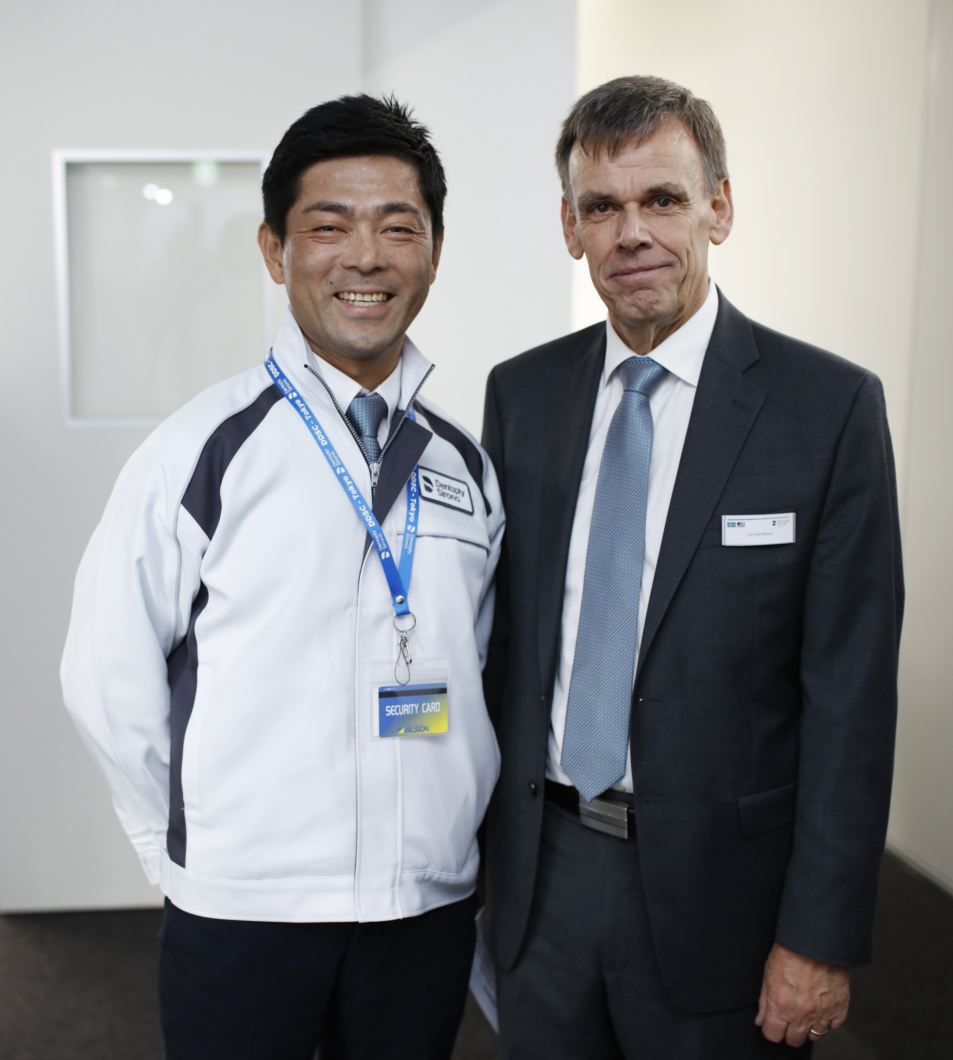 | 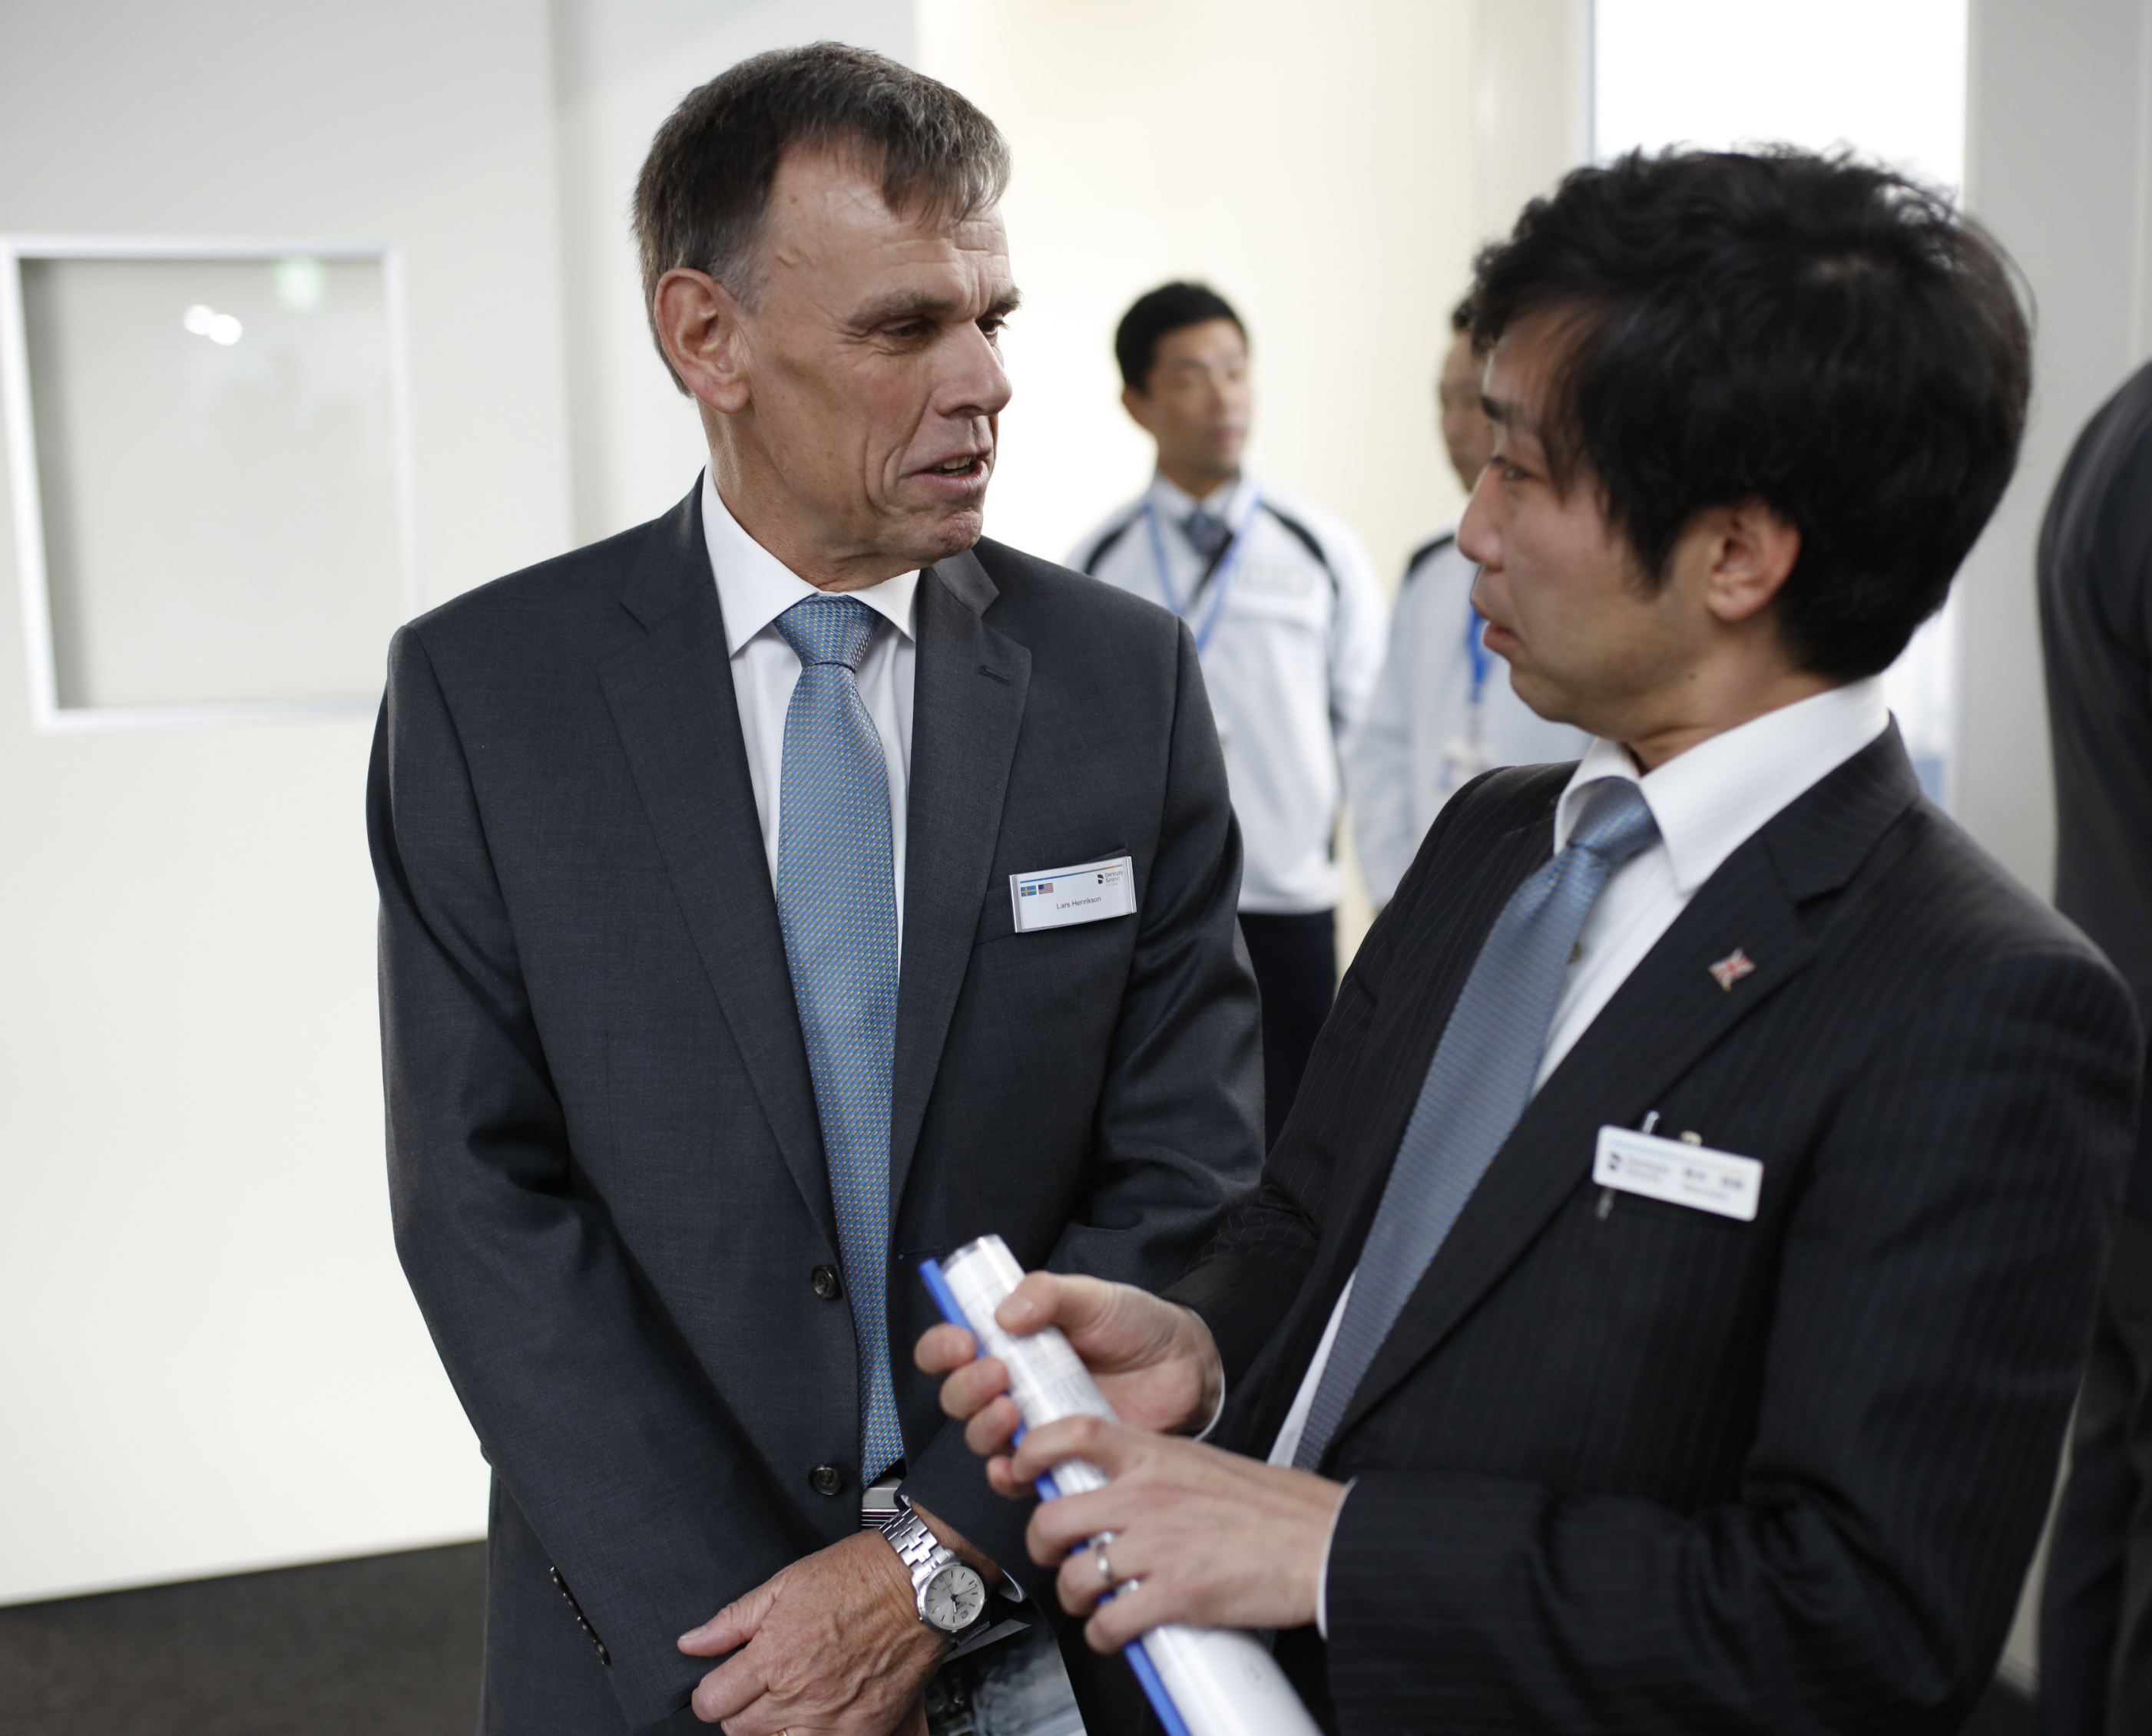
Fig.1: Lars Henrikson, Group Vice President Dentsply Sirona Implants, and Taketo Satu, Manufacturing Lead, Operations & Production at the factory in Tokyo. | Fig.2: Lars Henriksson gets a tour around the site with Tetsuro Suzuki, Implants Product Manager, Product Marketing & Development at Dentsply Sirona Japan.
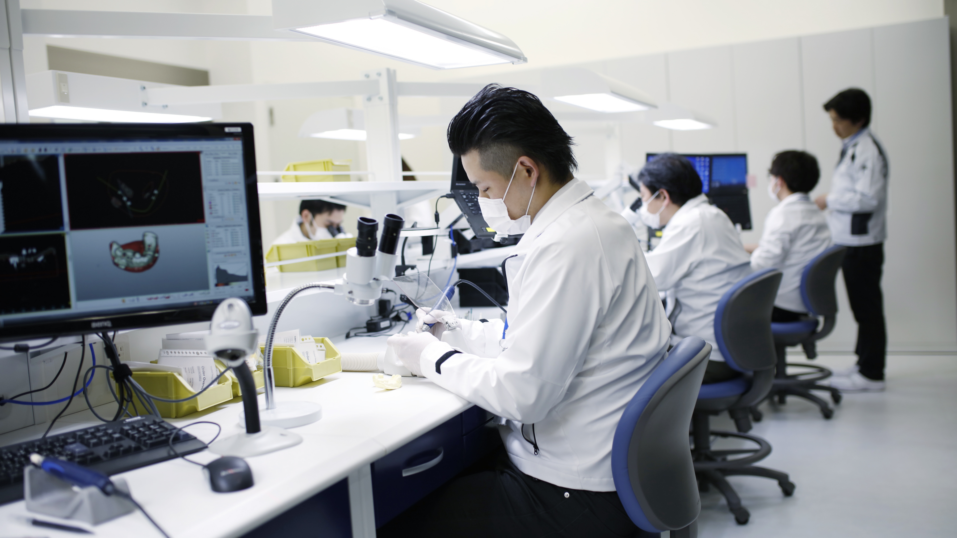
Fig.3: 3D artists immersed in work in the new factory in Tokyo.
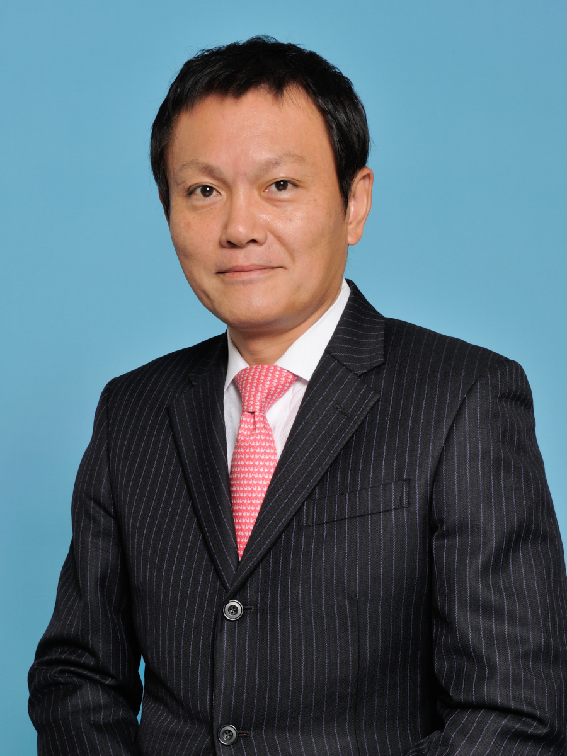
Fig. 4: Mitsutoshi Onoda, Vice President,
Commercial Lead of Implants, Orthodontics
and Prosthetic Dentsply Sirona Japan

