FOR IMMEDIATE RELEASE

YANMAR CONTINUES SUPPORT OF HERO WORLD CHALLENGE, LAUNCHING NEW FLAGSHIP X47 EXPRESS CRUISER YACHT

The 47’ high performance motor yacht is debuting at Albany in The Bahamas during the Hero World Challenge

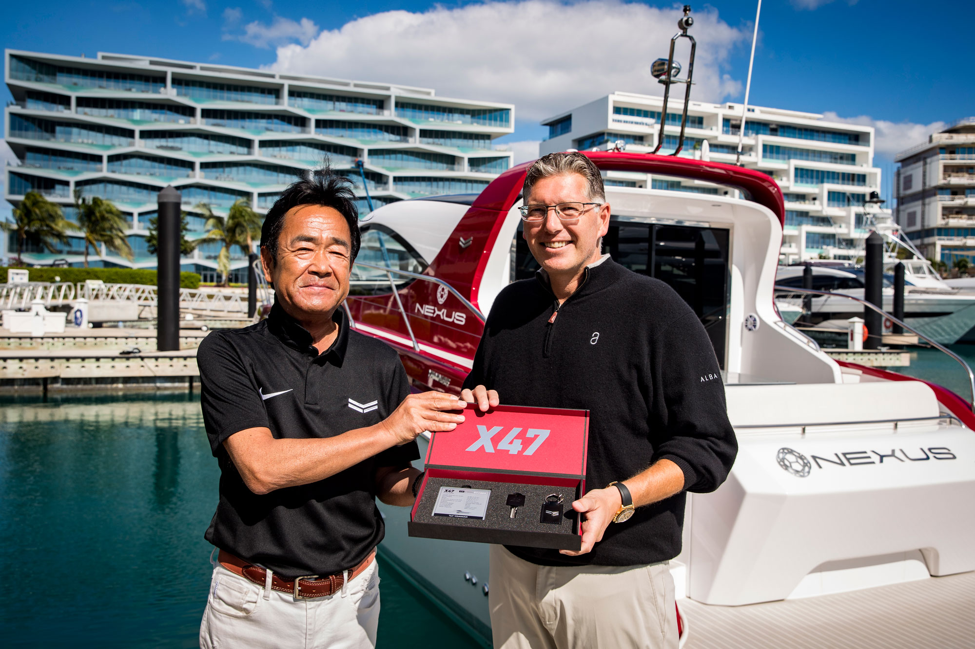
Yanmar’s Ken Araki and Christopher Anand of NEXUS with the X47 Express Cruiser

ALBANY, The Bahamas – December 5, 2019 — Yanmar is proud to unveil the new X47 Express Cruiser motor yacht, built in conjunction with the renowned brand Azimut Yachts, today at the luxury resort community of Albany in The Bahamas during the PGA TOUR’s Hero World Challenge hosted by Tiger Woods, a tournament which Yanmar has supported for five years.

This international collaboration is a combination of strengths, forging together three leading industry brands – Yanmar and its industrial strength and engine expertise, top Italian yacht designer and manufacturer Azimut Yachts, and luxury lifestyle leader NEXUS Luxury Collection – founded by Joe Lewis and his Tavistock Group, golfing greats Tiger Woods and Ernie Els, and actor and musician Justin Timberlake.

“We have been collaborating with NEXUS and its partners for several years to design and build this unique motor yacht,” said Ken Araki, executive officer of Yanmar. “For us to debut the first X47 Express Cruiser during the Hero World Challenge here at Albany is truly special.”

Yanmar has long been a leader in the engine business, perfecting diesel engines for the yachting industry and beyond, and worked alongside renowned designer Ken Okuyama in the design and creation of the X47 Express Cruiser.

“We wanted to help create a motor yacht that would be beautiful in design and also perform brilliantly on all types of waters, especially the shallow waters of The Bahamas,” offered Christopher Anand, managing partner of NEXUS. “Our friends at Yanmar have spent years building incredible engines and industrial equipment, and as they sought a build collaboration with Azimut, we all felt this was an amazing opportunity to bring the extraordinary X47 to life – together.”

For the X47 motor yacht, Yanmar contributes top marine engineering and diesel engines for the high-performance motor yacht while Azimut drives the sleek design, with inputs from NEXUS who brings its global reach and keen understanding of affluent customers from around the world to create a one-of-a-kind motor yacht for the most demanding sporting enthusiast.

“Since the very beginning of this collaboration we wanted to offer Yanmar our top quality building skills and all Azimut Yachts knowledge related to sea performance and luxury appeal,” stated Marco Valle, chief executive officer of Azimut Yachts. “Therefore we are delighted with the innovative and smart X47.”

“The X47 enjoys a symbiotic relationship with our engines and its design guaranteeing one of the surest, most enjoyable water experiences we’ve ever created. Our collaboration on the X47 had the boat enthusiast at the center of every decision we made,” shared Araki.

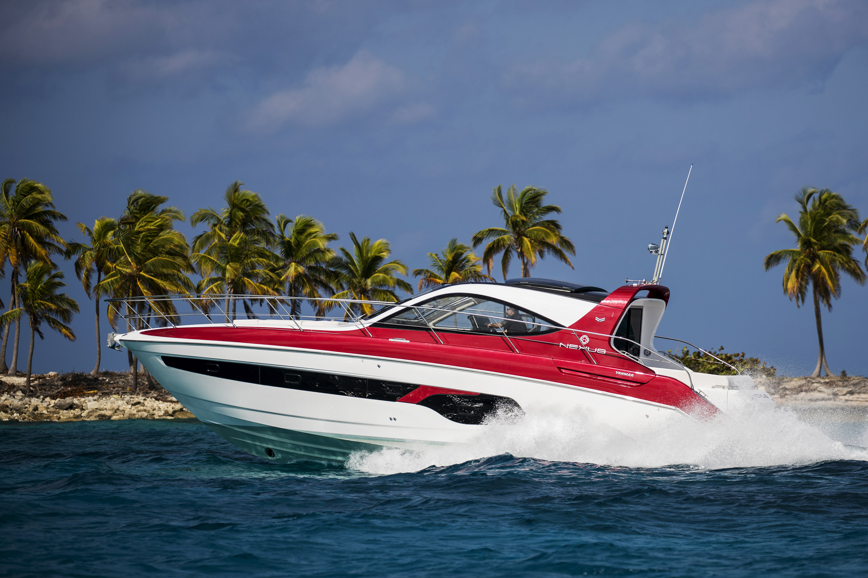
The X47 in the waters of The Bahamas

The Yanmar X47 Express Cruiser
Yanmar’s brand flagship, the Yanmar X47 Express Cruiser leads the company into its second century of business. The 47-foot vessel offers an unprecedented combination of luxury and performance and will serve as the Official VIP Cruiser of the 36th America’s Cup presented by Prada, the oldest trophy in international sport and the pinnacle of yachting.

The vessel is powered by a triple arrangement of Yanmar’s powerful and reliable 8LV marine diesel engines with ZT370 sterndrive. The result is better acceleration and maneuvering performance with a more compact engine bay that maximizes accommodation space. Yanmar’s proprietary joystick maneuvering system takes the stress out of docking the yacht in a marina.
The X47 offers an outstanding level of quality accommodation with two well-appointed en-suites cabins, a convertible sofa bed and an additional third berth, owners and guests will enjoy a luxury stay in living spaces bathed with natural light. Exceptional craftsmanship and selection of refined materials create an atmosphere of beauty and comfort.

The launch of the Yanmar X47 Express Cruiser in The Bahamas:
https://youtu.be/RhOgvSAXsMc

Video of the Yanmar X47 Express Cruiser: https://youtu.be/x7koyfMMk_8

Specifications
Length overall (incl. pulpit) | 14.53m (47’ 8”)
Hull length | 14.25m (46’ 9”)
Beam | 4.25m (13’ 11”)
Draft (incl. props at full load) | 1.13m (3’ 8”)
Displacement (at full load) | 14.7t (32,408lbs)
Engines | Yanmar 8LV-370 x 3
Maximum speed | 40kts
Cruising speed | 33kts
Fuel capacity | 1,200L (317gal)
Exterior design | Ken Okuyama Design  Yanmar
Interior design | Ken Okuyama Design  Yanmar / Azimut
Builder | Azimut Yachts

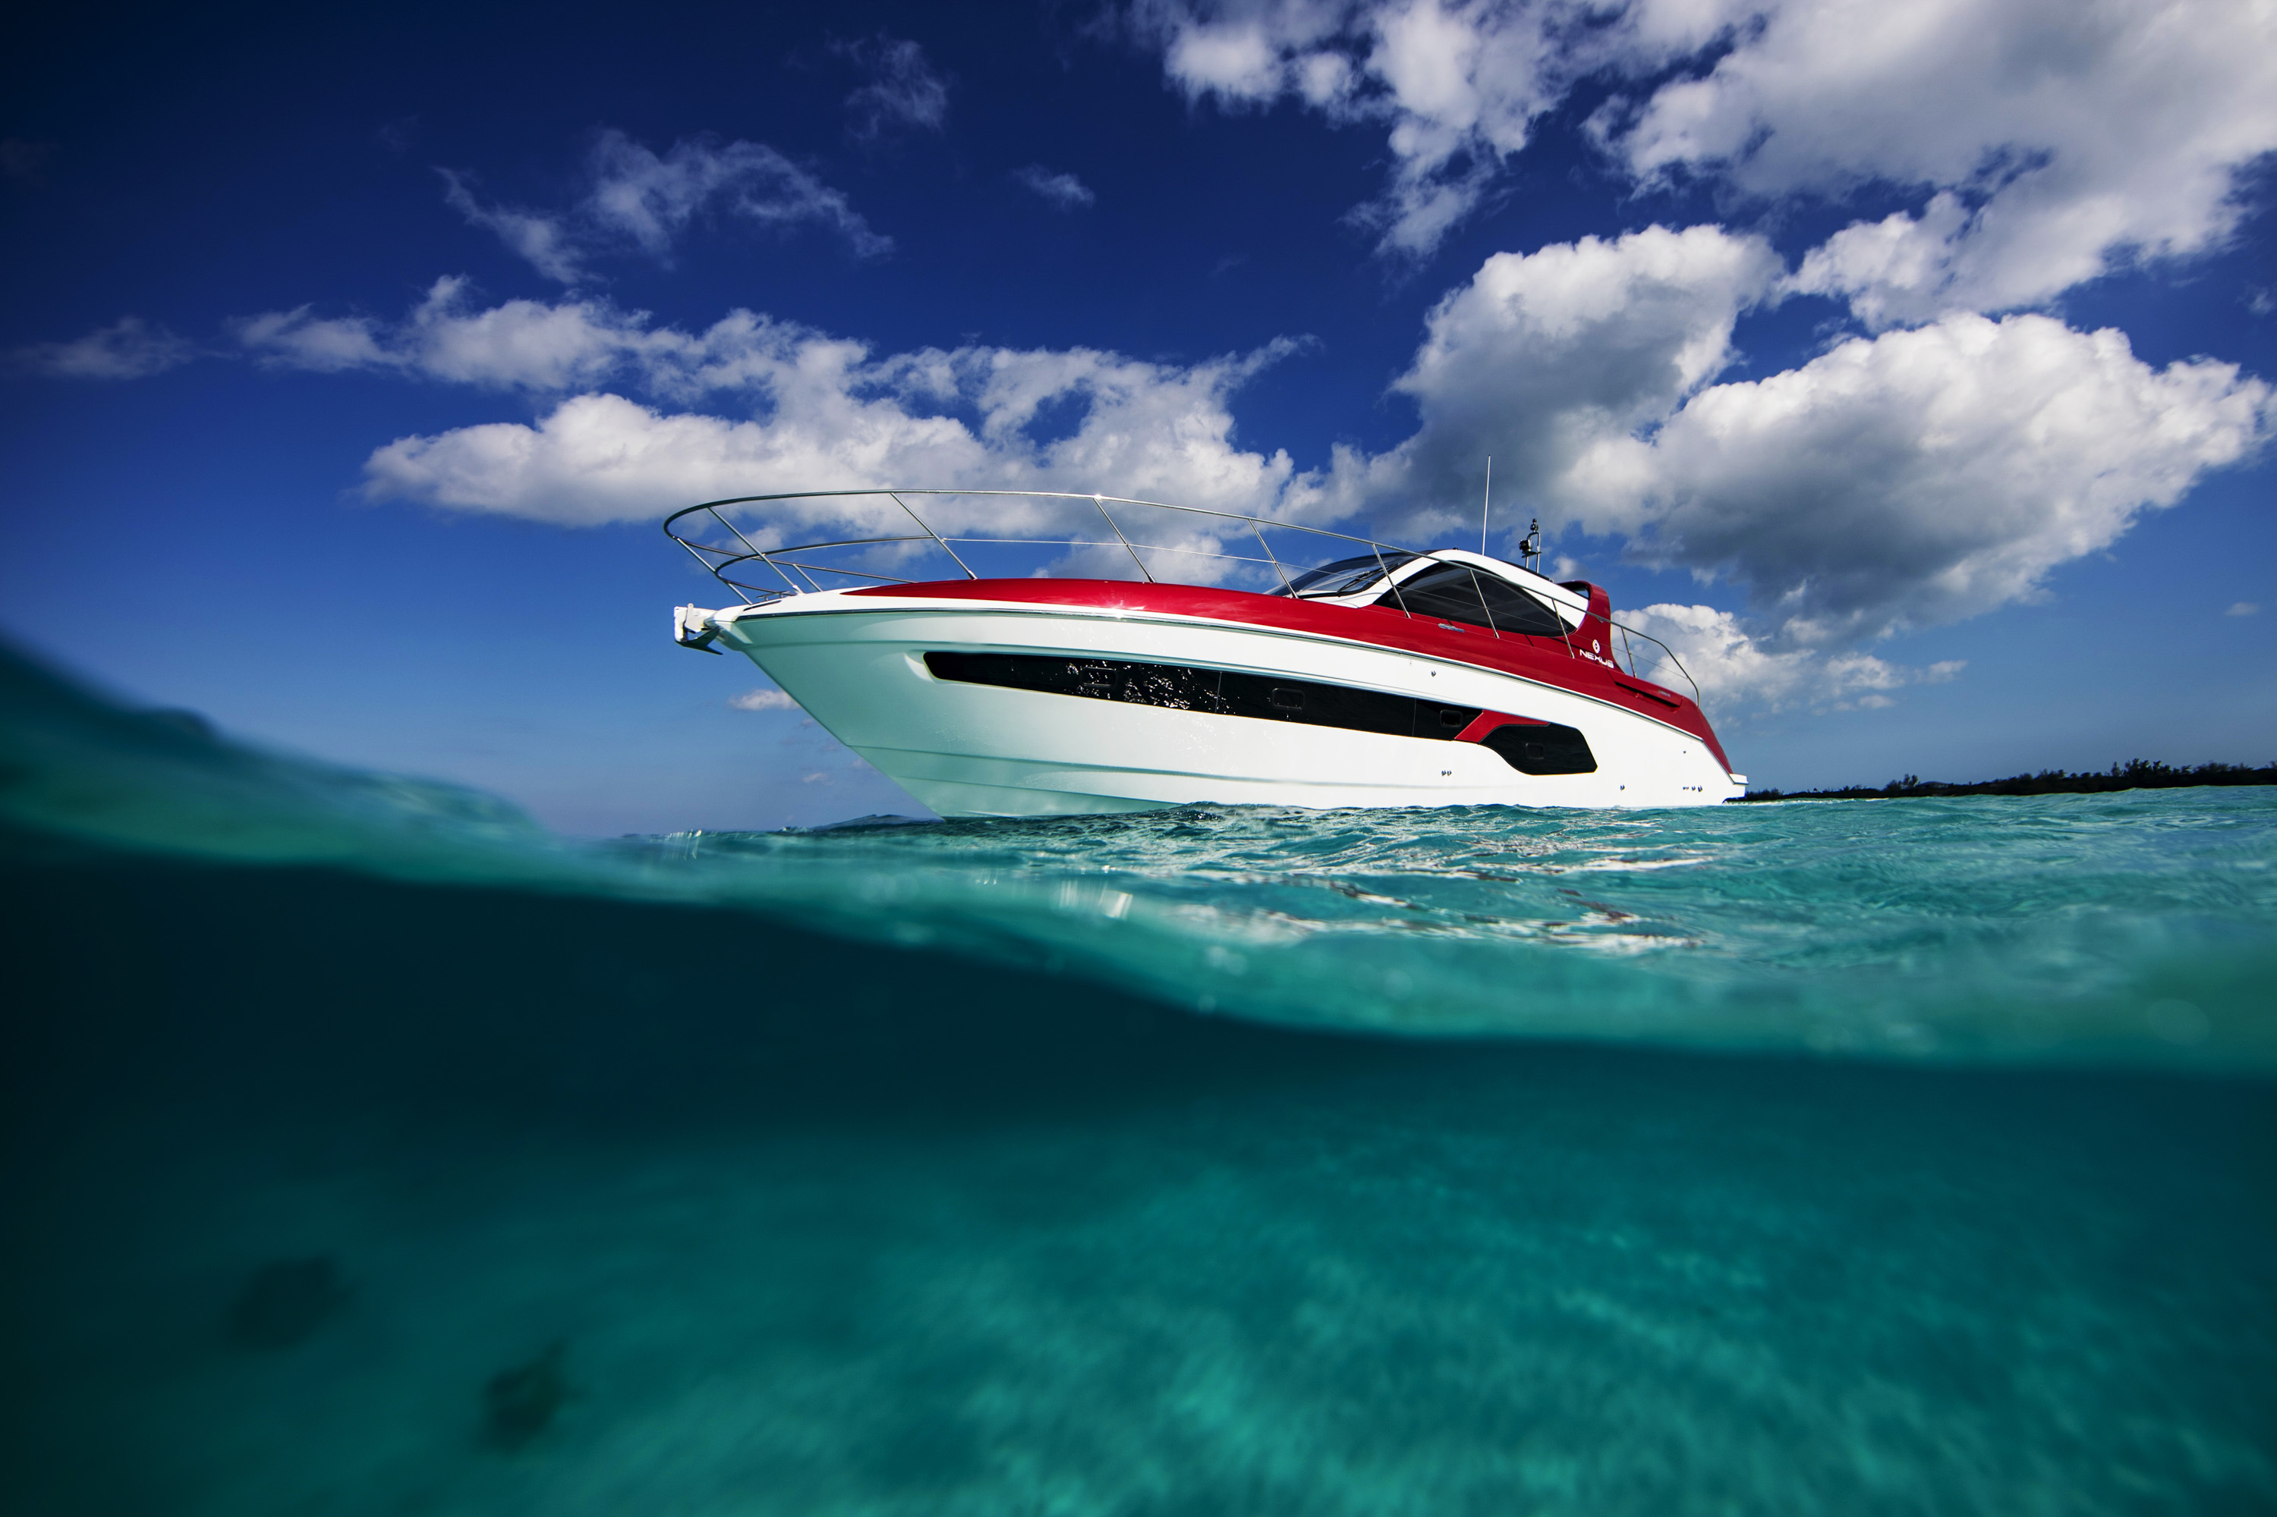

# # #

About Yanmar
With beginnings in Osaka, Japan, in 1912, Yanmar was the first to succeed in making a compact diesel engine of a practical size in 1933. With industrial diesel engines as the cornerstone of its enterprise, Yanmar has continued to expand its product range, services, and expertise to deliver total solutions as an industrial equipment manufacturer. As a provider of small and large engines, agricultural machinery and facilities, construction equipment, energy systems, marine equipment, machine tools, and components, Yanmar’s global business operations span seven domains. On land, at sea, and in the city, Yanmar’s mission of “providing sustainable solutions focused on the challenges customers face, in food production and harnessing power, thereby enriching people's lives for all our tomorrows” is a testament to Yanmar's determination to provide us with “A Sustainable Future.”

About Azimut Benetti Group
Azimut Benetti Group, which owns the prestigious brands Azimut Yachts, Benetti Yachts, Yachtique, , Lusben, Marina di Varazze and Royal Yacht Club Moscow, offers the most extensive range of motor boats from 34 feet in length to the 100-meter-plus yachts built by Benetti. A leader in production, Azimut Benetti has the most extensive sales network in the boating industry worldwide with 138 sites in 68 countries.

Azimut Yachts is the brand of the company established in 1969 by Paolo Vitelli and currently based in Avigliana (Turin), which builds fiberglass yachts. The company started with sailing boat chartering and later developed into a large luxury yacht-building industry. The first major work started with a contract at the shipyard of Amerglass, a modern Dutch shipyard producing boats in fiberglass. The business developed quickly, adding the distribution of sailing boats, motor cruisers and finally motor yachts from different makers, including British Powles, Westerly and others. Today the brand offers luxury yachts from 10 up to 38 metres and more, organized in different collections: Verve, Atlantis, Magellano Flybridge, S and Grande.

About NEXUS Luxury Collection
NEXUS Luxury Collection is an international real estate development and asset management company owned by Tavistock Group, golfing greats Tiger Woods and Ernie Els, and actor and musician Justin Timberlake. The NEXUS portfolio of businesses includes the 600-acre luxury resort community of Albany in The Bahamas; The Sanctuary, a state-of-the-art recording studio; NEXUS Club New York; NEXUS Club at Baha Mar; NEXUS Club at Exumas in The Bahamas; the Hero World Challenge; and the Hurricane Junior Golf Tour. For more information, visit nexusluxco.com.

