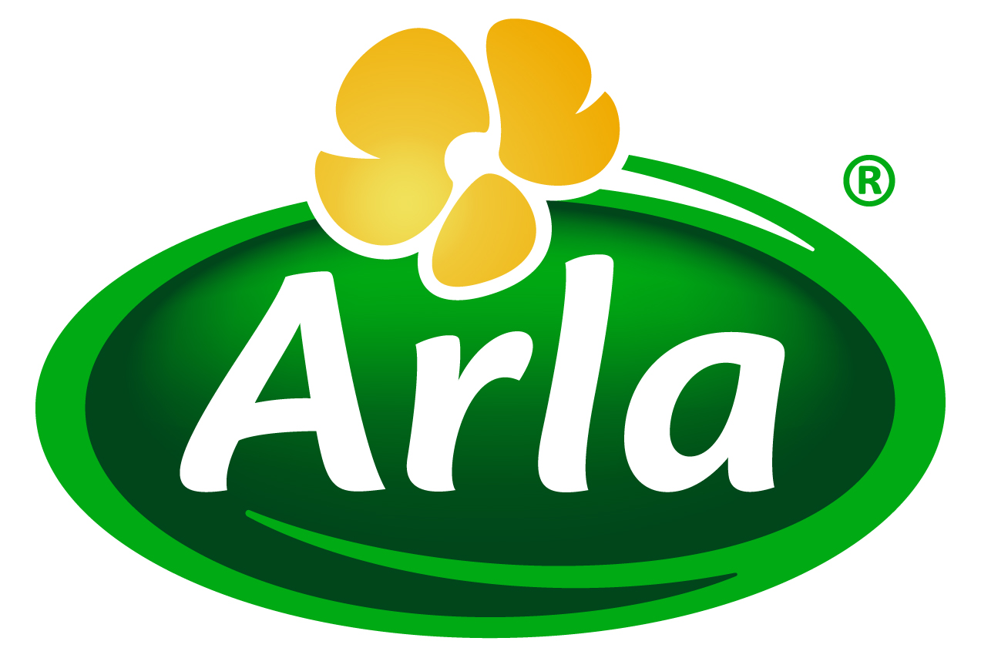
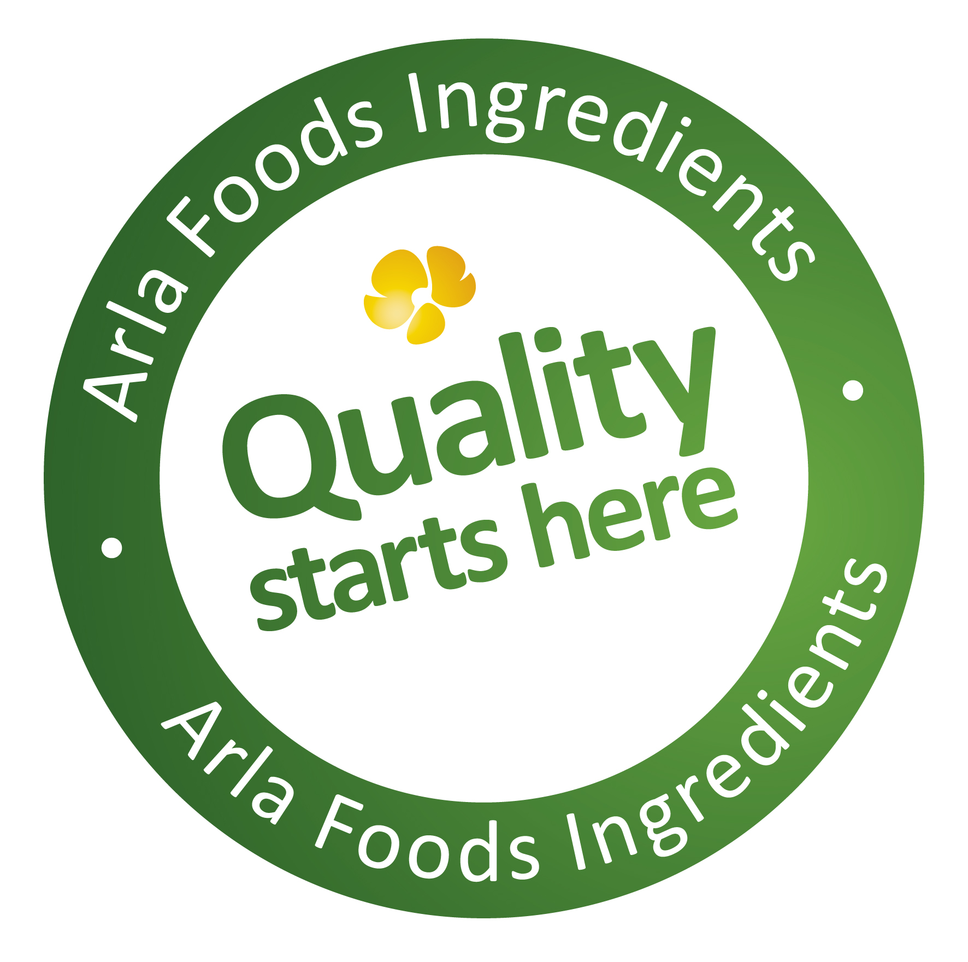

1 September 2014
PRESS RELEASE

New factory set to boost supplies of
‘gold standard’ whey protein

Arla Foods Ingredients is investing €38 million in a new factory in Denmark to meet booming demand for whey protein hydrolysates. The investment will further strengthen the company’s position as a global leader in natural whey ingredients.

The manufacturing plant is to be located next to Arla Foods Ingredients’ existing whey protein facility in Videbæk, Denmark, where the company is also in the process of building a new lactose factory. The whey protein factory is scheduled to be fully operational towards the end of 2016.

The new factory will increase three-fold Arla Foods Ingredients’ capacity to produce whey protein hydrolysates, a ‘gold standard’ form of whey that offers superior benefits compared with intact proteins, and has applications in the infant, sports and clinical nutrition categories.

Henrik Andersen, CEO of Arla Foods Ingredients, said: “When we speak with our customers they make it clear that whey protein hydrolysates are a very big part of their future plans and they are keen to work with companies who can guarantee ongoing security of supply. The investment in this factory sends out a strong signal that Arla Foods Ingredients will continue to be at the vanguard of the hydrolysates sector and that we will be able to satisfy demand while adhering to the strictest quality and safety standards.”

The new factory in Videbæk will further the commitments made by Arla Foods Ingredients through its ‘Quality starts here’ brand platform.

Henrik Andersen added: “There are five cornerstones to Quality starts here, including promising our customers security of supply backed by adequate capacity, logistics and documentation. Our new hydrolysates factory in Videbæk will ensure we can meet this pledge and maintain our position as the world’s leading supplier of high quality whey protein ingredients.”

ENDS

For more information, please contact:

Miranda Mills, Ingredient Communications
Tel: +44 207 193 4167
Email: Miranda.mills@ingredientcommunications.com

About Arla Foods Ingredients
Quality starts here: Arla Foods Ingredients is a global leader in natural whey ingredients for products in a range of categories – from bakery, beverages, dairy and ice cream to clinical, infant and sports nutrition.
The cornerstones of our business are innovative ingredients, world-class facilities and a staff of dedicated experts. Drawing on our portfolio of functional and nutritional whey proteins, milk minerals, lactose and permeate, our expert team delivers solutions that bring new food products quickly and efficiently to market. Our application centres run hundreds of customer product trials every week. All ingredients are produced using state-of-the-art processing technology at our plant in Denmark, or by one of our joint ventures in Argentina, Germany and the UK.
Arla Foods Ingredients Group P/S is a 100% owned subsidiary of Arla Foods, a global dairy company and cooperative owned by dairy farmers in Denmark, Sweden, the UK, Germany, the Netherlands, Belgium and Luxemburg.

RSS Feed
Visit our website at http://www.mynewsdesk.com/arla-foods-ingredients and sign up to our News RSS feed for all the latest developments – updated regularly.

Twitter
Follow us on twitter for all the latest updates @ArlaIngredients

