Press release
Düsseldorf, 07/07/2023
Excavators meet agriculture: More than just tractors
Agriculture is essential for our society but faces numerous challenges such as climate change and market volatility. Key agricultural equipment, such as tractors and excavators, are indispensable and enable a wide range of work on the farm. On possible areas of application for excavators in agriculture and how used machines offer a cost-efficient solution ...
Agriculture is the backbone of our society, providing our food and preserving our landscapes. But at the same time, it is an industry that faces major challenges: climate change, soil erosion and market volatility require adaptability and innovation. Agricultural equipment plays a crucial role in these tasks, especially tractors and excavators. Unlike highly specialised harvesting machines, they are all-rounders on the farm.
Applications of excavators in agriculture
By using various attachments, excavators can perform diverse tasks on the farm. Classic excavator work – such as earth excavation, removing soil or transporting bulk materials – is also common in agricultural operations. In addition, it can also be used as a forklift for transporting heavy objects, such as barrels or straw bales. Long-arm excavators can also act as cranes or load items onto high storage areas or dump bulk goods into silos and high containers. Wheeled excavators can also be used as sweepers to clean roads and yard areas. And finally: excavators can pull and push trailers. The advantage is that they are manoeuvrable.
Agriculture in the EU
In 2019, the EU-27 agricultural sector’s investment in its physical assets (tools, machinery, equipment, and buildings and plantations) amounted to an estimated 56 billion euros. This represented nearly a third of the gross value added, i.e. the value of goods and services produced minus preliminary inputs such as the cost of seeds, fertilisers and feed, staff, energy sources, etc. While only five countries (France, Germany, Italy, the Netherlands, and Spain) made up about 70% of these investments, the nations that invested the most relative to the size of their agricultural sectors were Finland, Luxembourg, Austria, and Sweden.
Used machinery: an efficient response to cost pressure
Cost pressure in agriculture is constantly increasing. This is primarily due to rising operational costs, volatile market prices, and growing regulatory requirements. In such an environment, cost-efficient investment opportunities are crucial for farmers. This is where used machinery can offer a significant advantage. As they are generally much cheaper than new models, yet still provide reliable performance and durability. They enable farmers to expand or renew their machinery fleet without busting their budgets. And those who associate used machines with scrap-worthy rust buckets, might be surprised. Because of insolvencies and restructurings, high-quality and even newer machines come onto the market.
Auction of high-quality used tractors and construction machinery
Due to a fleet renewal of a Portuguese rental company, about 35 construction and agricultural machines as well as accessories have found their way to Surplex.com. The auction runs only until 12/07 and includes:
- KUBOTA tractors: 4x M5111 LP, 1x M5101 NQ
- JCB excavators: 2x SITEMASTER 3CX4T (backhoe loader), 3x JCB 535-125 (telescopic loader)
- truck: RENAULT 320DXI
- several articulated telescopic platforms and articulated mast platforms
- wood chipper: GREENMECH ARBORIST 150RF
- accessories: 2x D&A HAMMER 50V hammer
- several mobile dust filter units
The tractors, the wood chipping machine and some filter systems are from the year of construction 2019 or 2020. When companies restructure their portfolios, modern equipment enters the used machinery market. The majority of the machines are located near Lisbon, Portugal, but also at other locations. Good to know for buyers: There are no minimum prices in this auction, so there can be no unpleasant surprises and the highest bid wins. Another incentive is the variably designed buyer’s premium, which in this auction depends on the hammer price. From € 25,001, a premium of only five per cent applies. This is particularly worthwhile for large construction machines. More information on the auction and the machines on offer is available on the Surplex.com website.

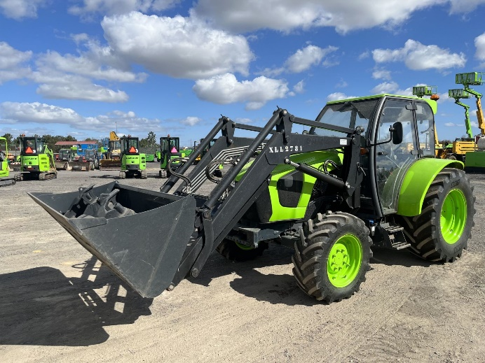 | Photo 1  Where agriculture and construction machinery meet: The tractor (here a Kubota M5111 LP) is probably the most widespread machine in agribusiness. In 2021, almost 150,000 of these agricultural tractors were newly registered across Europe.  (© Surplex).
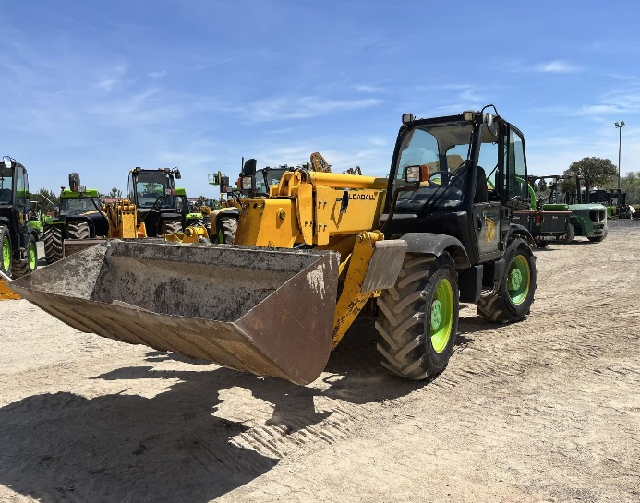 | Photo 2  Agriculture is... sometimes also excavators. For telescopic loaders (like this JCB 535-125) there is a range of attachments available for agricultural use.  (© Surplex).

