Press Release

6th January, 2am CET

For on-the-move music lovers who value the difference

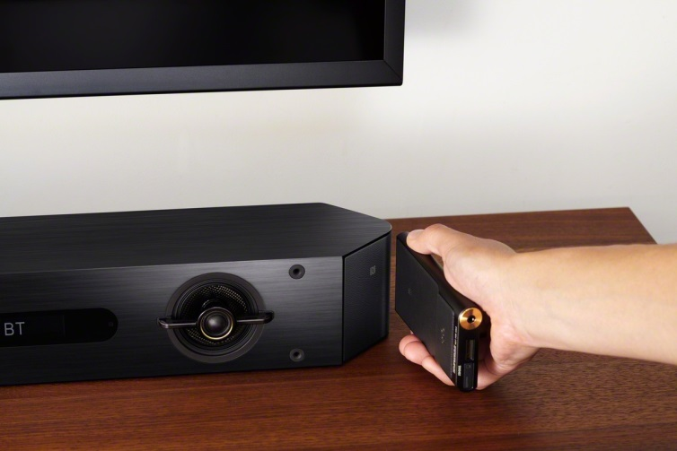
Audiophile listening: Sony introduces Walkman® NW-ZX2 with High-Resolution Audio

- Superb Hi-Res sound from Walkman® with S-Master HX™ and DSEE HX™
- Upgraded signal path and power supply stages with premium components
- LDAC for high quality wireless listening via Bluetooth®
- Long 60hr battery life and 128GB (expandable) capacity to store your Hi-Res music collection
- Luxurious design with body sculpted from solid aluminium

Sony’s legendary Walkman® family gains a new flagship that’s specially made for serious music lovers. The High-Resolution Walkman® NW-ZX2 puts the exquisite musical refinement of Hi-Res Audio right in your pocket – taking you beyond CD quality for an unparalleled listening experience while you’re out and about.

Converting analogue sound to digital formats like CD and MP3 can compromise the purity of the original signal. Hi-Res Audio retains far more detail during the analogue-to-digital conversion process, for a more authentic, emotionally involving musical experience.

The beautifully styled Walkman® NW-ZX2 is an accomplished performer, with a host of meticulous design refinements ensuring audio that captures every nuance of the artist’s original creativity.

Sony’s S-Master HX full digital amplifier keeps audio signal processing entirely in the digital domain to support pristine playback of Hi-Res sound. This advanced technology accurately processes massive amounts of wide-bandwidth audio data while minimising noise and distortion.

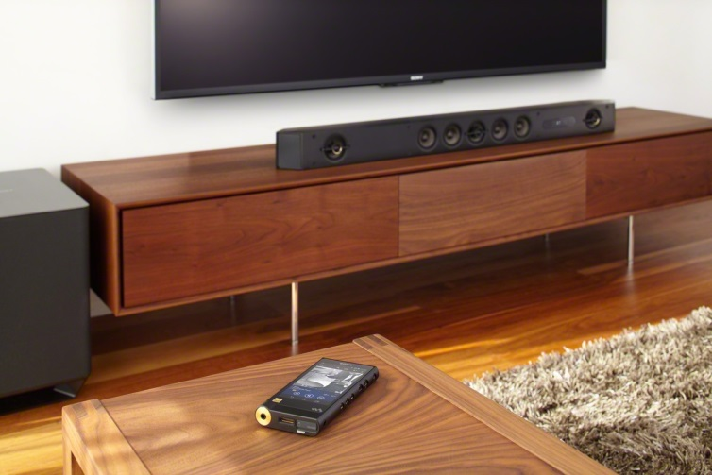
Powerful DSEE HX processing recreates crucial high-frequency musical information that’s lost in compressed sound files. CD and MP3 sources are upscaled, expanding sampling frequency and bit-depth beyond their original values to near Hi-Res quality (corresponding to 192 kHz/24-bit audio). With immense amounts of musical detail to enjoy, you’ll feel as if you’re really there in the studio or concert hall.

The audiophile credentials of the next-generation Walkman® NW-ZX2 are clear from the very first touch. The player’s frame is milled from solid aluminium alloy for immense rigidity, while internal use of gold-plated copper plate reduces electrical impedance to assist with overall sound quality.

Inside, there’s an impressive list of other design enhancements to excite any true audiophile. Significant improvements in the player’s power supply include an electric double-layer capacitor to smooth out voltage drops.

Every stage of the audio pathway is upgraded with extensive use of thick-film copper-layer PCBs, OFC (Oxygen Free Copper) cables and high purity lead-free solder. Overall sound quality is further enhanced by use of carefully-selected components including coils, MELF type resistors and film condensers with superior audio characteristics.

One digital clock source is replaced by two, with dedicated crystal oscillators for 44.1/88.2/176.4 kHz (CD/DSD) and 48/96/192 kHz sources respectively. Whatever music file or format you’re listening to, you’ll enjoy extra clarity and transparency with improved stereo separation.

The NW-ZX2 is the first ever Walkman® that supports the efficient LDAC codec. This new audio technology from Sony lets you enjoy high quality wireless audio via Bluetooth®. Transmitting data three times more efficiently than previous Bluetooth® connections LDAC provides an enhanced wireless listening experience for all your music. One-touch pairing with NFC makes wireless connection between Walkman® and other devices instant and effortless.

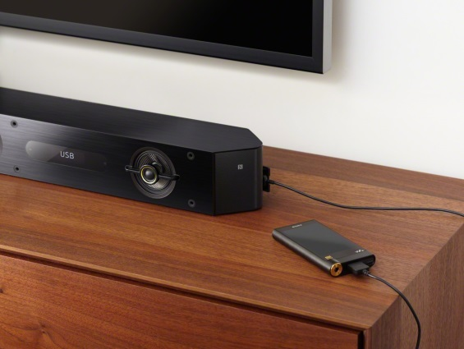
Serious music lovers will appreciate a generous 128GB of internal storage – plenty of space for your Hi-Res collection. Expanded to 256GB (with optional microSD card), there’s room over 1700 songs stored as Hi-Res Audio files (at 150MB/song). In addition, stamina is boosted by a new high capacity Li-ion battery that boosts playback time to as long as 60hrs (MP3 files) from a single charge.
Dual-band (2.4/5 GHz) Wi-Fi compatibility lets you enjoy Hi-Res music stored on your DLNA home network, free of electrical interference. The player also supports a USB audio connection function for direct, jitter-free digital connection to portable headphone amps and USB DAC amps.

Price and availability

The new Walkman® NW-ZX2 with High-Resolution Audio from Sony is on sale in Europe from Spring 2015 and will have a retail price of 11.500 NOK.

– Ends –

 | Technical Specifications NW-ZX2
Memory capacity | 128 GB
External memory | microSD (card not included)
Key features | High-Resolution Audio playback, S-Master HX Digital Amplifier, DSEE HX (Digital Sound Enhancement Engine), ClearAudio+, Clear Bass, Equaliser, VPT, one-touch listening via NFC and Bluetooth® connectivity, 7 “OS-CON” capacitor
Compatible audio formats | MP3, WMA¹, FLAC (192KHz/24bit), Linear PCM (192KHz/24bit), WAV (192KHz/24bit), AAC-LC², HE-AAC, Apple Lossless (192KHz/24bit), AIFF (192KHz/24bit), DSD (2.8MHz, 5.6MHz)
Battery life | MP3 60 hours*  *(MP3 128kbps)
Hi-Res Audio 33 hrs*
*(FLAC 192kHz/24bit)
Charging time | Approximately 4.5 hours
Operating platform | Android™ 4.2
Display | 4.0 inch FWVGA (854x480) Triluminos™ Display for mobile
Communication mode | Wi-Fi (IEEE 802.11b/g/n/a)
Bluetooth® | Bluetooth® (A2DP/AVRCP/OPP/HID/SPP)  Supported Codec: SBC/LDAC
NFC | Yes
Included applications | Media Go (for Windows), Content Transfer for Mac (for Mac OS)
Dimensions | 65.1x131.2x18.5 mm (WxHxD, excluding max. protruding section)
Mass | Weight: Approx. 235 g
Accessories | USB cable, leather carrying case, spacer (headphones not included)

For more information, please contact:
Tanni Toft, Nordic Jr. Product Manger Walkman/ RM
tanni.toft@eu.sony.com

About Sony Corporation
Sony Corporation is a leading manufacturer of audio, video, game, communications, key device and information technology products for the consumer and professional markets. With its music, pictures, computer entertainment and online businesses, Sony is uniquely positioned to be the leading electronics and entertainment company in the world. Sony recorded consolidated annual sales of approximately $75 billion for the fiscal year ended March 31, 2014. Sony Global Web Site: http://www.sony.net/

With MP3 playback
Bluetooth A2DP, SBC(328kbps,44.1kHz)

