

Highest quality with our new product line “Elements”:
Super joint sealant that sticks and insulates
in all environments

ESSVE launches a new universal sealant, ESS FLEX MF-X, which sticks, insulates and glues everywhere. The new sealant is resistant to moisture, cold and mould in an unsurpassed way.  The new multifunctional sealant ESS FLEX MF-X is a part of ESSVE’s new Elements series, which is a line of products of the highest quality. A premium glue is also launched at the same time as the sealant.  Functional in all environments, the sealant can even be applied under water. It has anti-mould properties and can be fastened and fixed to all types of materials without destroying the surface. Also perfect for the do-it-yourself handyman who wants to be able to use the same sealant in the boat, car, summer cottage, or for the bathroom renovation. It is a particularly good match for the rooms that are exposed to moisture in the summer cottage since it is well resistant to sunlight and saltwater.  – The sealant is perfect for the do-it-yourself handyman who doesn’t want to be bothered with a whole range of products. ESS FLEX MF-X allows you to concentrate on your job instead of spending time on finding the proper product for each application, says Magnus Carlsson, Product Manager for Glue and Sealants at ESSVE.  ESS FLEX MF-X is launched in the colours white, a crystal clear transparent colour that doesn’t turn yellow, grey, and a metal colour.  ESS FLEX MF-X from ESSVE –  the perfect choice for the do-it-yourself handyman  - Perfect for application in environments that are damp, cold, warm and dirty.  - Does not contain solvents or other substances that are harmful to the environment.  - Easy to paint over and hardens under water  - Has anti-moulding properties making it perfect for bathrooms and other spaces that are exposed to humidity.  - Available in five different colours, for example metal colour and a crystal clear transparent colour. | 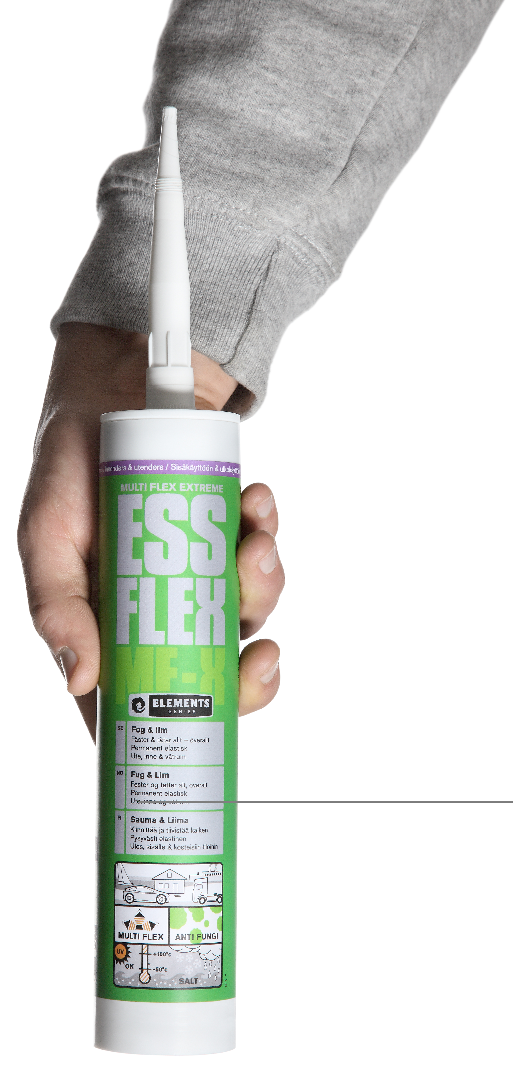  About ESSVE  ESSVE’s goal is to serve its customers in the construction industry and the branch of industry with products of high quality to attractive prices. The customer’s needs are always in focus at ESSVE.  ESSVE has a 40 year industry legacy and a solid experience in product development, support and staff training. ESSVE distributes and markets products in Northern Europe.  Website: www.essve.se  Brands in the ESSVE portfolio are  ESSVE’s solutions for attachment: Products that are developed and adjusted to suit Nordic construction rules and conditions. Mounting, screw, industy- and attachment elements, mixed nails, fixings, glue, joint, drill and drill bits.  FireSeal: Type approved and tested systems for fire sealing of lead-throughs.  TJEP: Air-driven machine nailers for the constructions industry.  ESSVE-compressors: AMP- compressors for constructions sites.  ESSVE Rivets: Fastning elements for professional handicraft.

