|  |  |  |
| --- | --- | --- |
| 2004HyundaiLogoStacked_Blue288 | Hyundai Motor America 3200 Park Center Drive, Costa Mesa, CA 92626  TEL: 714-965-3000 FAX: 714-378-1008 MEDIA WEBSITE: HyundaiNews.com CORPORATE WEBSITE: HyundaiUSA.com | NewsBureauLogo |
|  | EMBARGOED UNTIL JAN. 9 AT 3:10 PM EST |  |

Contacts: Derek Joyce Jim Trainor

(714) 594-1728 (714) 594-1629

(714) 376-6653 (mobile) (714) 316-6421 (mobile)

#### [djoyce@hmausa.com](mailto:djoyce@hmausa.com) [jtrainor@hmausa.com](mailto:jtrainor@hmausa.com)

# 2013 GENESIS COUPE REVEALS MORE AGGRESSIVE DESIGN COUPLED WITH SERIOUS PERFORMANCE CREDENTIALS

**Hyundai’s Rear-drive Sport Coupe Receives More Powerful Powertrain Technologies, More Aggressive Design, Upscale Interior Refinement and Blue Link® Telematics**

**DETROIT, Jan. 9, 2012**– Hyundai Motor America today introduced the significantly redesigned 2013 Genesis Coupe in a North American debut at the Detroit North American International Auto Show. In keeping with impressive performance upgrades, Genesis Coupe now sports more aggressive coupe styling, complemented by improved interior materials and design. Both 4-cylinder and V6 engines benefit from significant technology enhancements, with the 3.8-liter V6 engine receiving sophisticated direct-injection technology and the 2.0-liter turbocharged engine upgrading to a more precise twin-scroll turbocharger and larger intercooler. Automatic transmissions for these two models now have 8-speeds, with paddle-shift SHIFTRONIC® manual-shifting capability. Hyundai’s proprietary telematics platform, Blue Link®, is now available, providing Genesis Coupe owners with a variety of infotainment services to meet their individual connectivity needs.

**HIGHLIGHTS FOR 2013 GENESIS COUPE**

* Refreshed, more aggressive exterior design
  + New front fascia, grille, headlight, fog light, hood designs
  + New 18- and 19-inch wheel
  + New LED-enhanced taillight design
  + Available LED daytime running lights (DRLs)
* 3.8-liter V6 engine receives direct-injection technology
  + 348 horsepower, 295 lb.-ft. torque (rating with premium fuel)
  + Improved fuel economy for both transmissions
    - 18 city/28 highway – 8-speed A/T
    - 18 city/27 highway – 6-speed M/T
* 2.0-liter 4-cylinder turbocharged engine receives new twin-scroll turbocharger and larger, more thermally-efficient intercooler
  + 274 horsepower, 275 lb.-ft. torque (rating with premium fuel)
  + Improved fuel economy for A/T
    - 20 city/31 highway – 8-speed A/T
    - 21 city/30 highway – 6-speed M/T
* New, in-house-developed 8-speed automatic transmissions
  + Paddle-shift SHIFTRONIC® capability
* New, retuned low-velocity-control suspension dampers
* Blue Link® telematics available on 3.8 Grand Touring/Track and 2.0T Premium
* Electroluminescent gauge cluster with information display
* Telescopic steering wheel (added to tilt function)
* Driver seat power lumbar adjustment
* Redesigned center stack appearance and gauges

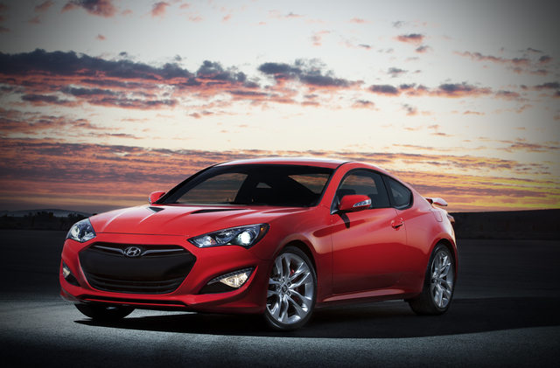

**AGGRESSIVE DESIGN CUES MATCH ENHANCED DYNAMIC PERFORMANCE**

The refreshed Genesis Coupe strikes a more menacing demeanor, with an aggressively redesigned front fascia, grille, headlights, LED daytime running lights, fog lights and hood with heat extractor cues. The side view reveals new, aggressive 18- and 19-inch alloy wheel designs with deeper dimensional sculpting. Finally, the rear taillights provide a visual spark via premium LED illumination and new contours. Of course, the traditional rear-drive sport coupe proportions remain, with a long wheelbase and short front and rear overhangs producing a classic wedge-like profile. Genesis Coupe’s bodyside character line is an innovative “Z”-shaped design that integrates seamlessly with a unique, drop-beltline rear window graphic.

Genesis Coupe’s arching roofline and tapering greenhouse highlight the exterior profile and emphasize the car’s broad shoulders and wide stance. To complete the aggressive sports car look, the depth between the fenders and the greenhouse has been maximized.

Enlarged openings in the front fascia allow for better engine breathing along with a more aggressive look. Dual asymmetrical exhaust tips integrated with the blackout rear diffuser treatment complete the performance message from the rear.

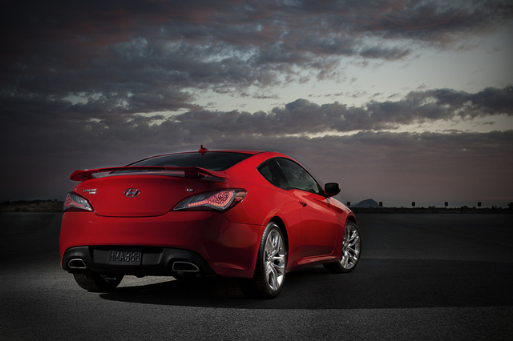

**POWERTRAIN ENHANCEMENTS**

Both Genesis Coupe engines receive significant technology upgrades, backing up its new design statement with impressive performance gains. The 3.8-liter Lambda DOHC V6 engine adds sophisticated direct-injection technology, adding 42 horsepower (a generous 14 percent increase) and 29 lb.-ft of torque (an eleven percent increase). Peak horsepower rises to 348 at 6,400 RPM, with peak torque increasing to 295 lb.-ft. at 5,300 RPM on premium fuel. In addition, lambda-engine anti-knock technology gives this V6 the versatility to run on regular fuel. This new direct-injected engine will easily propel the Genesis Coupe from zero to 60 mph in the lower five-second range on its way to an impressive 149 mph electronically-limited top speed. The Lambda V6 intake system also now employs an intake sound induction pipe into the cabin to ensure this engine’s aural character matches its visceral appeal.

To further broaden the power band, the 3.8-liter engine uses Dual Continuously Variable Valve Timing (Dual CVVT) and a Variable Intake System (VIS) that helps cylinders breathe most efficiently at both low and high RPM. The combination of high-pressure, precisely-metered direct injection with efficient cylinder breathing results in outstanding throttle response and off-the-line acceleration coupled with remarkable fuel efficiency. The V6 engine uses an alloy block and cylinder heads for lighter weight and thermal efficiency and features durable, quiet timing chains with no scheduled maintenance.

All these technologies serve to give Genesis Coupe 3.8 an impressive power-to-weight ratio of only 10.0:1; significantly lower than the more expensive Infiniti G37 and BMW 335i.

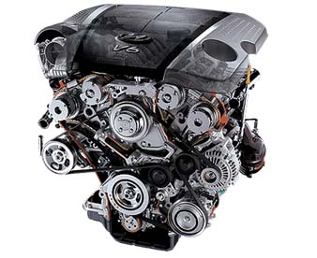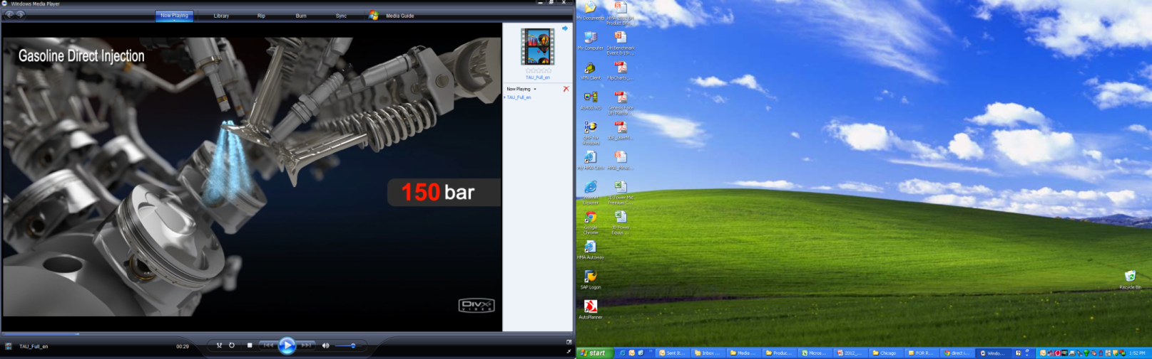

2013 Genesis Coupe 3.8-liter Lambda Direct-Injected DOHC V6 Engine

|  |  |  |  |
| --- | --- | --- | --- |
|  | **2013**  **Genesis Coupe 3.8** | **2012**  **Infiniti G37 Coupe** | **2012**  **BMW 335i Coupe** |
| **Engine** | **3.8L V6** | 3.7L V6 | 3.0L I6 turbo |
| **HP @ RPM** | **348 @ 6400** | 330 @ 7000 | 300 @ 5800 |
| **Power-to-Weight (lbs./HP)** | **10.0:1** | 11.0:1 | 11.9:1 |
| **Torque @ RPM** | **295 @ 5300** | 270 @ 5200 | 300 @ 1300-5000 |

Not to be outdone by its bigger brother, the turbocharged, intercooled 2.0-liter DOHC inline four-cylinder substitutes a new twin-scroll design for its turbocharger in addition to a larger intercooler with enhanced thermal efficiency. The twin-scroll design is more efficient at recovering exhaust energy and produces cooler cylinder temperatures than the former single-scroll design. In addition, the twin-scroll is more precise, with improved combustion efficiency, reduced turbo lag, leaner air/fuel ratios and more evenly distributed pressure in the exhaust ports, resulting in simultaneous power, efficiency and emissions improvements. Also, a 53 percent larger intercooler further reduces intake temperatures, providing denser, cooler air from which to develop even more power.

This turbocharged engine also benefits from Dual CVVT on both intake and exhaust camshafts. The 2.0-liter turbo now generates 274 horsepower (a massive 30 percent increase) and 275 lb.-ft. of torque (an impressive 23 percent increase) on premium fuel. And, unlike many competitive turbo engines, this turbo’s anti-knock sensors automatically adjust ignition timing and engine mapping to run perfectly on regular fuel, yielding 260 horsepower at 6,000 RPM and 260 lb.-ft. of torque at 2,000 RPM. The turbo engine also features a cast-aluminum cylinder block and cylinder head. All these improvements give the Genesis Coupe 2.0T a power-to-weight ratio of 12.3, superior to the upcoming Scion FR-S sports coupe and the Honda Civic Si.

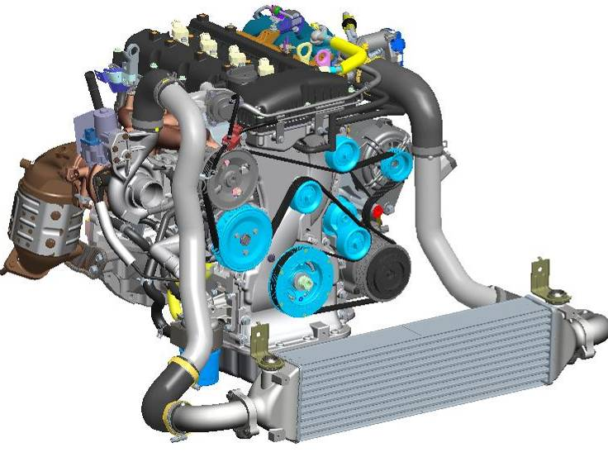

2013 Genesis Coupe 2.0 Twin-scroll Turbocharged DOHC 4-cylinder Engine

Both V6 and 4-cylinder engines also feature deeper, baritone-sounding dual cat-back exhausts to complement more efficient breathing on the intake side. To ensure that all this new power is evenly distributed to the pavement, Genesis Coupe also offers an available Torsen® limited-slip differential on R-Spec and Track models.

|  |  |  |  |
| --- | --- | --- | --- |
|  | **2013**  **Genesis Coupe 2.0T** | **2013**  **Scion FR-S (est.)** | **2012**  **Honda Civic Si** |
| **Engine** | **2.0L I4 Turbo** | 2.0L I4 | 2.4L I4 |
| **HP @ RPM** | **274 @ 6000** | 197 @ 7000 | 201 @ 7000 |
| **Power-to-Weight (lbs./HP)** | **12.3:1** | 13.7:1 | 14.3:1 |
| **Torque @ RPM** | **275 @ 2000** | 151 @ 6600 | 170 @ 4400 |

**REAR-WHEEL-DRIVE ARCHITECTURE**

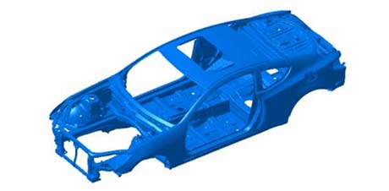

2013 Genesis Coupe Body Shell Architecture

Genesis Coupe’s body shell makes generous use of ultra-high-tensile steel. The rear-wheel drive powertrain configuration provides a well-balanced 55:45 front-to-rear weight distribution for the 2.0T, and 56:44 for the 3.8 model.

**SPORT-TUNED SUSPENSION**

No well-tuned sport coupe chassis should give the perception of being overwhelmed by its powertrain, and Genesis Coupe is no exception to this rule. Spring, damper, and bushing ratings all have been precisely recalibrated to match these new powertrains with better road feel, more precise body motion control and improved ride comfort.

Genesis Coupe employs a MacPherson strut **dual-link front suspension** and a five-link rear suspension setup.The front suspension **is mounted to the body via a solid subframe that** is lighter and stronger than a comparable multi-piece component would be**. To help reduce body roll** and tune the Genesis Coupe’s at-the-limit handling for maximum predictability, 23-mm diameter front and 19-mm diameter rear stabilizer bars are fitted.

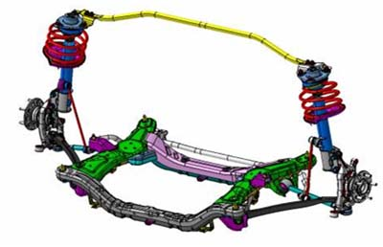

2013 Genesis Coupe MacPherson strut **dual-link front suspension**

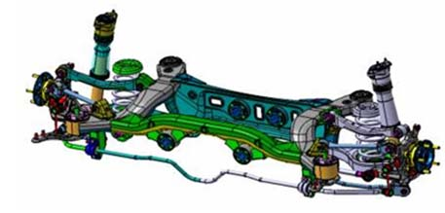

2013 Genesis Coupe five-link rear suspension

While all Genesis Coupe models offer a true rear-drive sport driving experience, the high-performance Genesis Coupe R-Spec and Track models raise the bar even higher with differentiated, track-tuned suspension calibrations. The R-Spec/Track suspension features both firmer front spring rates (seven percent) and rear spring rates (eleven percent), with matched damper rates. The Genesis Coupe R-Spec/Track models also deliver a significant increase in roll control over other versions of the Genesis Coupe via thicker stabilizer bars (24mm front/20mm rear). For 2013, all Genesis Coupes receive improved low-velocity-control dampers for refined ride comfort coupled with improved body control.

In addition, all R-Spec and Track models now receive front strut camber adjustment bolts that can be easily installed in the front strut assembly at their owner’s discretion. These camber adjustment bolts allow approximately -1.5 degrees of negative front camber adjustment for sharper, more responsive apex turn-in and significant understeer reduction in competitive events.

Of course, superb Genesis Coupe structural rigidity sets the fundamental foundation for dynamic precision, regardless of specific suspension calibration.

**STEERING**

**Hydraulic, RPM-sensing rack-and-pinion steering has been recalibrated with an even quicker, 13.8:1 ratio, delivering both linear feel and agile response to driver inputs. This new steering ratio is a full seven-percent quicker than the previous model, yielding intuitive steering response and precision. To further optimize driver ergonomics, telescopic adjustment also has been added to tilt adjustment for 2013.**

**TRANSMISSIONS**

Both engines are mated to standard six-speed manual transmissions which have been extensively refined to provide more driver-friendly shift gating and balanced weighting precision. The clutch take-up, feel, and engagement characteristics also have been refined for optimum shifting ease and feel. Both engines now offer an in-house-developed eight-speed automatic with paddle-shift SHIFTRONIC® manual-shifting capability. Each transmission has been specifically tuned to match its engine’s unique power and torque curve characteristics.

In addition to the steering wheel-mounted paddle shifters, each automatic offers shift capability via the shift lever according to individual driver preference. A clear LCD readout on the instrument panel shows the selected gear at all times.

**HIGH PERFORMANCE BRAKING SYSTEMS**

Brembo® four-piston calipers clamp down on fade-resistant 13.4-inch ventilated front brake rotors and 13-inch ventilated rear rotors on both R-Spec and Track models. All other models get substantial 12.6-inch front ventilated rotors and 12.4-inch rotors in the rear with floating single-piston calipers.

**UPSCALE INTERIOR REFINEMENT**

The 2013 Genesis Coupe interior has been enhanced with distinctive, upscale features and design cues. The instrument panel crash pad features a stitched-seam appearance for a distinctly upscale look, and the parking brake lever is leather-wrapped on leather-equipped models. The instrument cluster now features an electroluminescent gauge cluster for premium ambience and superior readability. A new driver-side rear seat walk-in assist function has been added for more convenient rear seat access from the driver’s side. Convenient seatbelt assist guides make it easier for front passengers to buckle up.

In addition, driver seat power lumbar support is now available and front seatback pockets are standard on all Genesis Coupes. A center stack multi-gauge cluster with instantaneous mpg, torque level (3.8 models) or turbocharger boost pressure (2.0T models), and oil temperature is standard on all trims. A center fascia tray with cover has been added for enhanced storage, and interior surfaces now have a softer touch with lower sheen for a more up-market feel. Sport front seats with deep side bolsters offer superb lateral support for enthusiastic driving in all trim configurations.

Among other premium features are an available Infinity® premium audio system and two-stage front seat heaters. Genesis Coupe also offers the convenience of a Proximity Key and push-button start.

**INNOVATIVE TECHNOLOGIES**

Genesis Coupe offers Xenon high-intensity discharge (HID) headlights, for brighter illumination intensity, more daylight-like lighting character and reduced power consumption. In addition, the visual cut lines of these HID headlights are razor sharp, providing maximum nighttime visibility to the driver without the risk of blinding oncoming traffic.

Music lovers will welcome the Genesis Coupe’s standard auxiliary input jacks (3.5 mm mini-jack and USB input) to accommodate and charge personal audio devices such as an iPod®. When an iPod or flash drive is connected through the USB port in the center storage compartment, not only does it play music through the vehicle’s audio system, but it also charges the iPod and allows the driver to access tracks with the steering wheel audio controls. This system also allows both driver and passengers to easily view song/artist/title information and control the music from the audio head unit rather than the iPod unit. This safety-oriented function allows the driver to keep his or her focus on the road at all times.

**HYUNDAI BLUE LINK®**

Hyundai Blue Link telematics is available on 2013 Genesis Coupe with a 90-day complimentary trial period. The Blue Link platform is available on 3.8 Grand Touring/Track and 2.0T Premium trim levels. Blue Link can be accessed from the buttons on the rearview mirror inside the Genesis Coupe, the web and via smart phone. Blue Link is offered in three telematics service packages: Assurance, Essentials and Guidance.

“Blue Link combines safety, service and infotainment into a complete package that works to both help simplify Hyundai owners’ lives and reduce distracted driving,” said Barry Ratzlaff, director of customer satisfaction and service business development, Hyundai Motor America. “We’ve carefully studied how drivers rely on smart phones and navigation systems as an innovative link to the outside world. Blue Link brings that seamless connectivity directly into the car with technology like voice text messaging, Point-of-Interest (POI) web search download, turn-by-turn navigation, and monthly vehicle reporting. Our agent-assisted advanced voice recognition system offers a 21st century solution to performing POI searches in the vehicle.  This unique and innovative approach enables Hyundai to deliver fast, accurate searches and downloads of POIs to vehicles without the unnecessary costs of traditional operator-only type systems of our competitors.”

More details on Hyundai Blue Link are available at [www.HyundaiBlueLink.com](http://www.HyundaiBlueLink.com).

**SEGMENT-LEADING STANDARD SAFETY TECHNOLOGIES**

In keeping with Hyundai’s focus on offering segment-leading standard safety technologies across its lineup, the 2013 Genesis Coupe includes a wide range of both active and passive safety features. Standard safety technology includes driver and front passenger advanced frontal airbags, along with front seat-mounted side airbags, side air curtains and active front head restraints.

Genesis Coupe has strong unibody construction, along with front and rear crumple zones, bodyside reinforcements and five-mph energy-absorbing bumpers. The hood also includes buckling creases and safety stops.

The front seatbelts have pretensioners and force limiters, and the rear seats feature LATCH (Lower Anchors and Tethers for Children), which make affixing child safety seats easier.

All Genesis Coupe models feature standard four-channel ABS with Electronic Brake-force Distribution (EBD) to optimize brake performance under various dynamic loading conditions. The system also includes Brake Assist, which provides maximum ABS-level braking force when a panic stop is detected.

Electronic Stability Control (ESC), one of the industry’s most effective life-saving technologies, is standard in all Genesis Coupe models. Insurance Institute for Highway Safety (IIHS) studies suggest vehicles equipped with ESC experience 56 percent fewer fatalities in single-vehicle crashes than those without it.

In a nod to enthusiasts, 2013 Genesis Coupe now offers a specially-tuned three-stage driver-selectable ESC mode. This new three-stage ESC function offers more options for various driver preferences and road conditions:

1. Full-on ESC function (default mode on start-up)
2. Intermediate ESC function with driver powertrain override control and retained ESC/TCS braking function
3. Full-off ESC function for uninhibited driver vehicle control in all conditions

The driver-selectable full-off ESC mode has been calibrated to provide drivers with a larger performance envelope should they choose to participate in competitive events such as autocrosses or track days. The Genesis Coupe anti-lock braking system function (ABS) remains fully functional in all ESC modes to help drivers maintain steering control under adverse braking conditions.

**COLOR PALETTE**

With Genesis Coupe’s more aggressive exterior design cues, fresh exterior color offerings are now available, with seven new colors added to the palette. In keeping with Genesis Coupe color names selected at launch, all new color names are derived from world-famous racing circuits and their most challenging track segments. These new colors include: Parabolica Blue, Catalunya Copper, Monaco White, Becketts Black, Circuit Silver, Gran Premio Gray, and Shoreline Drive Blue.

To further complement Genesis Coupe’s freshened interior design and premium materials, a new tan leather interior, a new red leather bolster/red cloth insert interior, and a new gray leather bolster/gray cloth insert interior have been added to the interior color environment selections.

**HYUNDAI MOTOR AMERICA**

Hyundai Motor America, headquartered in Costa Mesa, Calif., is a subsidiary of Hyundai Motor Co. of Korea. Hyundai vehicles are distributed throughout the United States by Hyundai Motor America and are sold and serviced through more than 800 dealerships nationwide. All Hyundai vehicles sold in the U.S. are covered by the Hyundai Assurance program, which includes the 5-year/60,000-mile fully transferable new vehicle warranty, Hyundai’s 10-year/100,000-mile powertrain warranty, 5-years of complimentary Roadside Assistance and the Hyundai Trade-in Value Guarantee. Hyundai is a registered trademark of Hyundai Motor Company. All rights reserved. ©2011 Hyundai Motor America.

# # #  
Journalists are invited to visit our news media website: [www.hyundainews.com](http://www.hyundainews.com) and follow us on Twitter: [@Hyundai.com](http://twitter.com/hyundai)