Press Release, March 23

Svenskt Tenn Designs Interiors for NK's New Restaurants

NK, Stockholm's most exclusive department store, will today unveil four new restaurants, designed by Cilla Ramnek and Martin Edvardsson from Svenskt Tenn's interior design studio. The restaurants will be run by the owner of one of Stockholm's two-star restaurants, Frantzén.
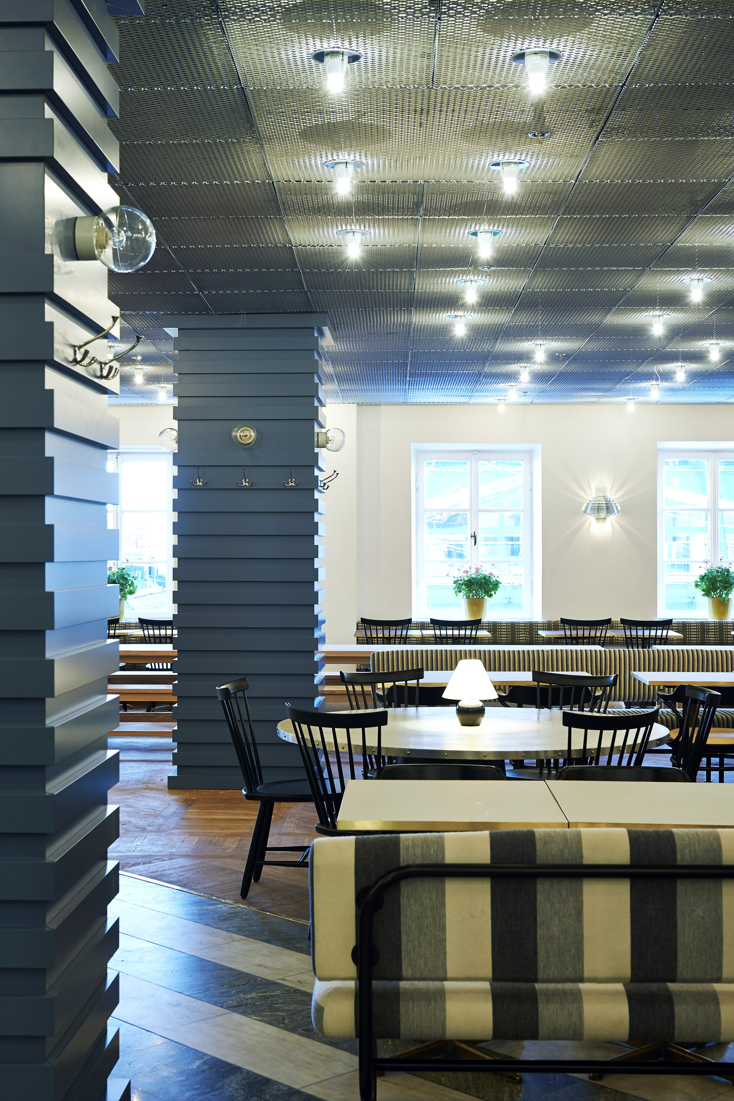
“We have created a setting to Björn Frantzéns fabulous food – a relaxed environment where people will feel good and enjoy themselves”, says Cilla Ramnek, interior designer at Svenskt Tenn.

Svenskt Tenn's interior design studio performs projects in homes and offices worldwide. The inspiration always comes from the philosophy of founder Estrid Ericson's and designer Josef Frank that one must create rooms designed for people to spend time in, rather than follow a certain aesthetic. It is practical and it shows how to mix colors, styles and qualities designing elegant interiors that last.

The commission by Frantzén includes the interiors of four different restaurants. In addition to lighting, furniture and art Svenskt Tenn have also selected all the flooring and ceilings. The designers have preserved classic details, like a large round window between the new Wine Bar and the store's center atrium, while at the same time making changes to create more space like taking down a wall towards the Boberg's Dining Room.

“We wanted to keep the exclusive atmosphere but make it more welcoming. We have chosen to use a lot of Scandinavian design, for example Gemla, Malmsten and Artek, combining it with selected objects from our own rich collection, such as Josef Frank's carpet ''No. 1'' that hangs from the walls of the Nordic canteen”, says Martin Edvardsson, interior architect at Svenskt Tenn.

For further information, please contact:

Vicky Nordh, Marketing Assistant: +46 8-670 16 23 or vicky.nordh@svenskttenn.se

Thommy Bindefeld, Marketing Director: +46 8 670 16 02 or thommy.bindefeld@svenskttenn.se

Svenskt Tenn is an interior design company with retail stores at Strandvägen in Stockholm and online. Since 1975, Svenskt Tenn is owned by the Kjell and Märta Beijer Foundation, which provides research grants within ecology, medicine and the preservation of Swedish interior design tradition.

