TECHNICAL DATA SHEET

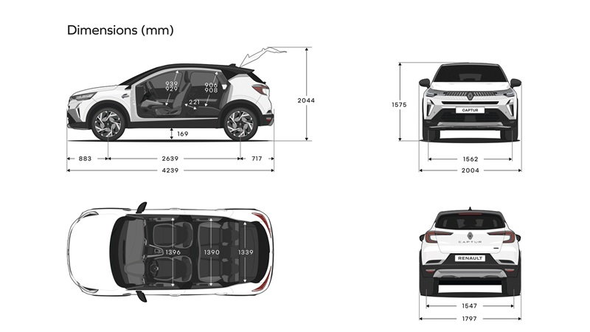Dimensions

TRUNK VOLUME | All versions except full hybrid | Full Hybrid Version
With row 2 moved forward / moved back to stop (+ 132L) in litres | 484 / 616 | 348 / 480
With row 2 advanced / retracted to stop (+ 114 dm3) in VDA standard dm3 | 422 / 536 | 326 / 440
Maximum volume (up to the height of the seat) - rear bench folded down | 1 596 | 1 458

DIMENSIONS (mm)
Overhall lenght | 4 239
Wheelbase | 2 639
Front overhang | 883
Rear overhang | 717
Overall width with folded mirrors / unfolded mirrors | 1 797 / 2 003
Front track ground | 1 562
Rear track ground | 1 547
Overall height without/with longitudinal roof bars | 1 575
Open tailgate height | 2 044
Trunk sill height | 779
Ground clearance unladen / with max. load | 169 / 132
Rear Knee radius row 2 advanced / retracted to stop | 61 / 221
Front elbow room | 1 396
Rear elbow room | 1390
Front shoulder width | 1371
Rear shoulder width | 1340
Front headroom | 889 / 879 - 939 / 929
Rear headroom | 849 / 849 - 906 / 908
Trunk entry maximum width | 953
Interior width between wheel arches | 976
Maximum load length with rear bench folded | 1 571

Powertrain characteristics

 | RENAULT CAPTUR
Powertrain | 1.0 TCE 90 | 1.0 TCE 100 LPG | 1.3 TCE 140 mild hybrid | 1.3 TCE 155 | 1.3 TCE 160 mild hybrid | E-Tech full hybrid 145
Fuel | Petrol | Petrol | Petrol | Petrol | Petrol | Petrol
Electification | No | No | MH12  Costing stop 7kph | No | MH12  Costing stop 20kph | HEV  245V
Cylinder Capacity [L]/[cm3] | 1.0 / 999 | 1.0 / 999 | 1.3 / 1330 | 1.3 / 1330 | 1.3 / 1330 | 1.6 / 1598
Number of Cylinder | 3 | 3 | 4 | 4 | 4 | 4
Number of valves | 12 | 12 | 16 | 16 | 16 | 16
Torque [Nm/tr] | 160 Nm @2750rpm | 160 Nm petrol mode / 2750rpm  170Nm LPG mode / 2000rpm | 260 Nm @3500rpm | 270 Nm @1700rpm | 270 Nm @1750rpm | 145 Nm @ 3200rpm ICE mode / 250Nm ICE+EM
Air Alimentation | Turbo | Turbo | Turbo | Turbo | Turbo | Atmo
CO² gr/km WLTP | 131 | 119 | 133 | 149 | 133 | 105
0 to 100 km/h (s) | 14 | 13 | 10.4 | 8.5 | 8.5 | 10
Fuel consumption | 5,8 - 5,9 | 6,0 - 6,1 L with unleaded / 7,7-7,9 L with LPG | 5,8 - 5,9 | 6.2 | 5,8 - 5,9 | 4,7 - 4,9

