KONGSBERG to supply Norwegian Coastguard vessels with sonars for multiple operations
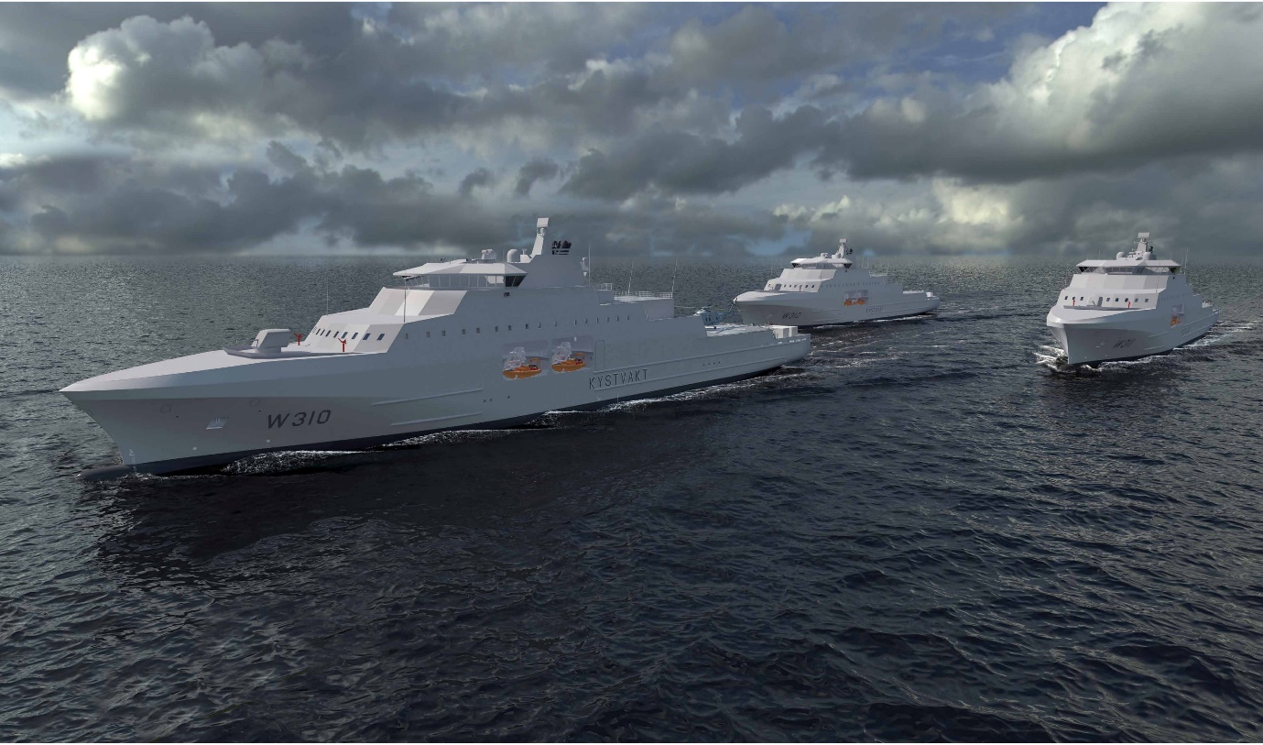
Kongsberg Maritime will deliver its SS1221 sonars to three new vessels for the Norwegian Coastguard
Kongsberg, Norway, 18th August 2020 – Kongsberg Maritime is celebrating the signing of a contract with Vard to deliver its market-leading sonars to the Norwegian Coastguard. The sonars will be used on board three new craft planned for launch between 2022 and 2024, replacing the existing Nordkapp-class vessels.
KONGSBERG will equip the new 136-metre, ice-strengthened vessels with its SS1221 sonars, which boast acoustic properties which make them ideally suited for multiple operations safeguarding Norwegian territorial waters, especially those requiring deployment in shallow-water environments.
The SS1221, principally devised for ASW operations and capable of detecting torpedoes or other small objects in the water column, is an active hull-mounted sonar which utilises sophisticated tracking algorithms. Its electronically-stabilised transmitting and receiving beams can be tilted to adjust to challenging sound speed profiles, with its integrated Sound Propagation Model determining the optimal tilt settings and enhancing the Probability of Detection (PoD) ratio. The SS1221 sonars will be delivered to the Coastguard complete with retractable hull units and gate valves for ice protection, ensuring safe and efficient operation.
“We are very pleased to have been selected by the Norwegian Coastguard, and to further strengthen our position as a principal supplier of coastal and shallow-water sonar equipment,” says Thomas H. Dahle, Director of Sales at KONGSBERG. “The Coastguard have to rely upon the most advanced technology available in order to fulfil their responsibilities effectively, and this contract is another resounding testimony to the deep level of trust the KONGSBERG brand has accumulated over our many successful years of trading.”
Ends

For further information, please contact:
Gunvor Hatling Midtbø, VP Communication
Kongsberg Maritime
Tel: +47 9921 4209
gunvor.hatling.midtbo@km.kongsberg.com
David Pugh
Saltwater Stone
Tel: +44 (0)1202 669244
d.pugh@saltwater-stone.com

About Kongsberg Maritime
Kongsberg Maritime is a global marine technology company providing innovative and reliable ‘Full Picture’ technology solutions for all marine industry sectors including merchant, offshore, cruise, subsea and naval. Headquartered in Kongsberg, Norway, Kongsberg Maritime has manufacturing, sales and service facilities in 34 countries.
Kongsberg Maritime solutions cover all aspects of marine automation, safety, manoeuvring, navigation, and dynamic positioning as well as energy management, deck handling and propulsion systems, and ship design services. Subsea solutions include single and multibeam echo sounders, sonars, AUV and USV, underwater navigation and communication systems.
Training courses at locations globally, LNG solutions, information management, position reference systems and technology for seismic and drilling operations are also part of the company’s diverse technology portfolio. Additionally, Kongsberg Maritime provides services within EIT (Electro, Instrument & Telecom) engineering and system integration, on an EPC (Engineering, Procurement & Construction) basis.
Kongsberg Maritime is part of Kongsberg Gruppen (KONGSBERG), an international, knowledge-based group that celebrated 200 years in business during 2014. KONGSBERG supplies high-technology systems and solutions to customers in the oil and gas industry, the merchant marine, and the defence and aerospace industries.
Web: Kongsberg Gruppen | Kongsberg Maritime
Social media: LinkedIn | Twitter | Facebook

