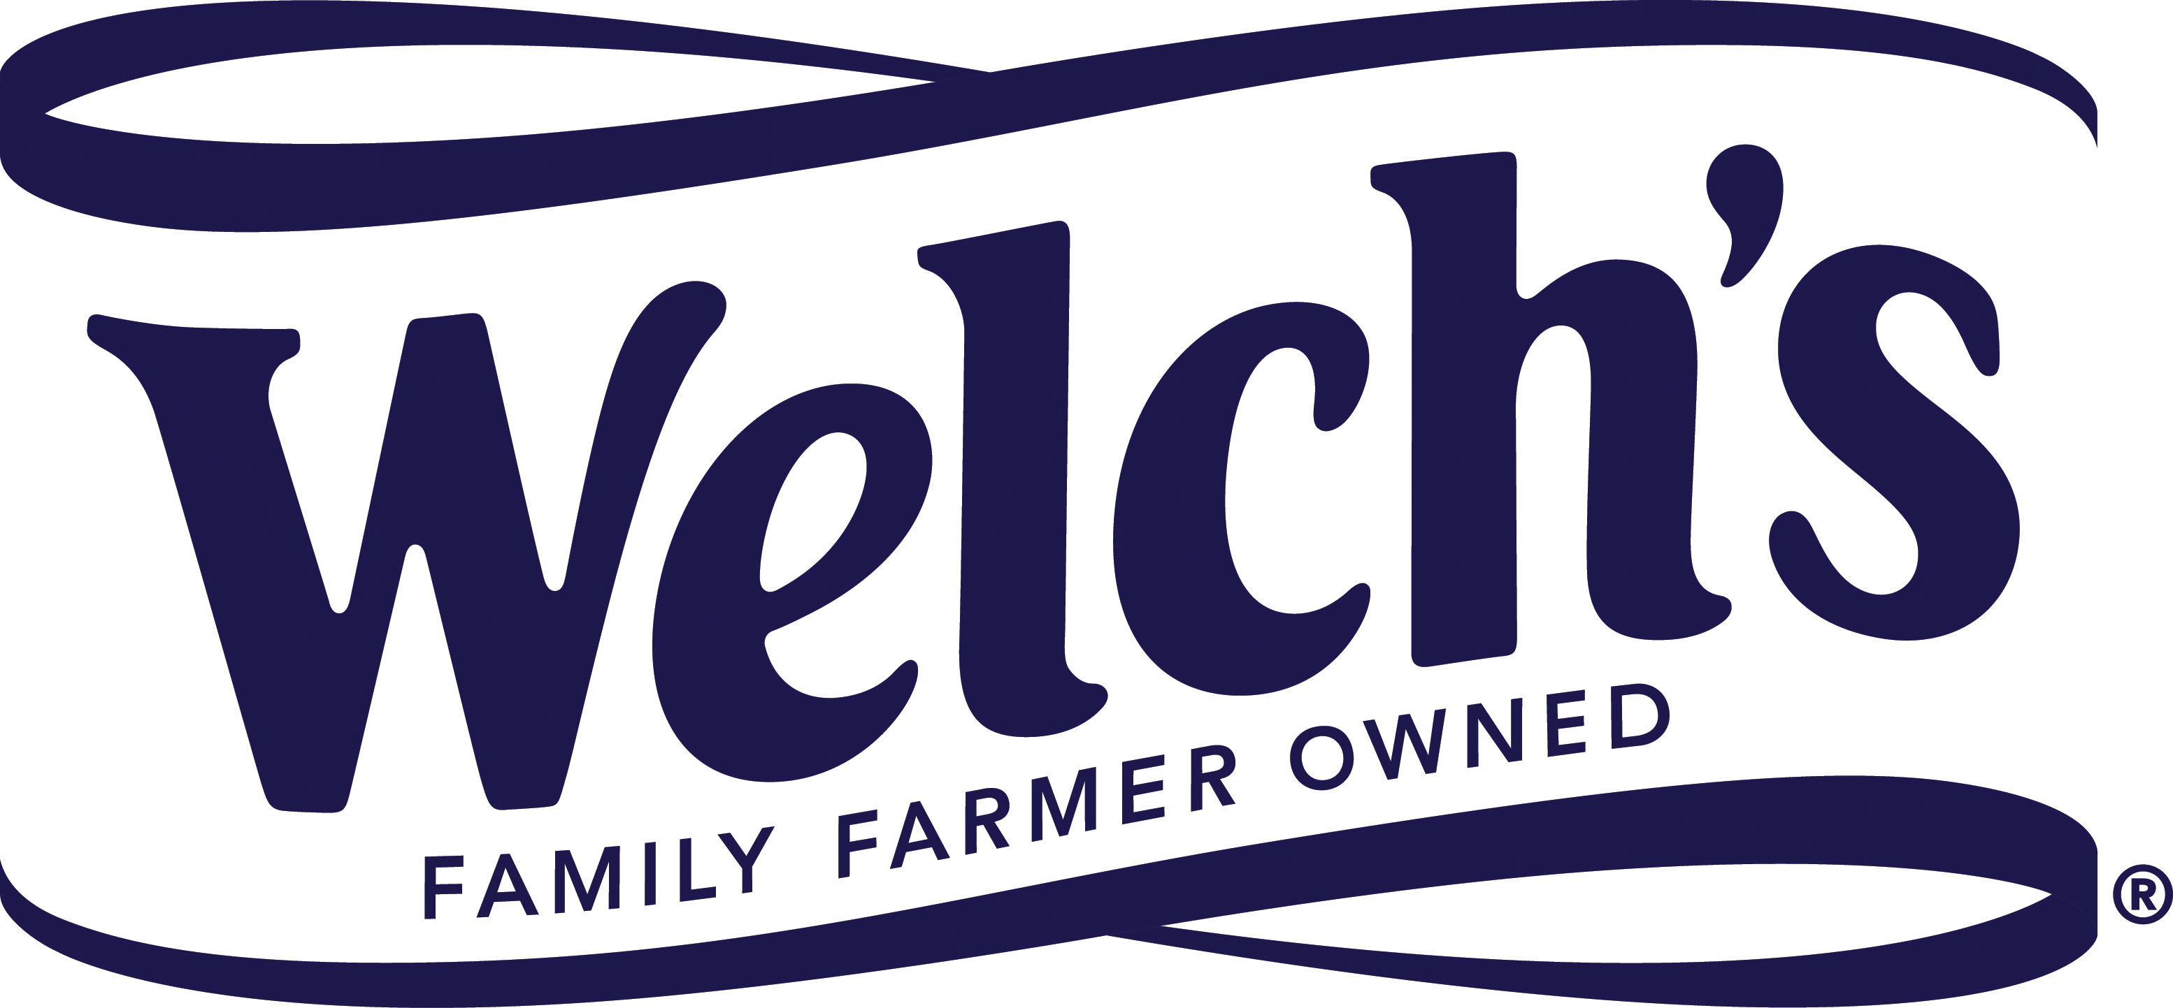

**23 April 2018**

**PRESS RELEASE**

**New wave of alcohol avoiders intensifies   
demand for soft drink innovation**

Many younger consumers are drinking alcohol in moderation – or abstaining from it altogether – creating a new and unmet need in the market for innovative soft drinks.

Data from the US highlights how, in the past two years, volume sales of alcoholic beverages in America have fallen – by around 0.1% in 2016 and 0.2% in 2017.[1] This decline, reported by market analyst IWSR in its *US Beverage Alcohol Review*, was the equivalent of 17.6 million gallons (80 million liters) last year. IWSR said the decrease in total alcoholic beverage consumption was directly related to “the slow-building trend of moderation or not drinking at all.” It added: “Signs of health and wellness permeate the industry with increasing frequency. From all-natural ingredients to low-ABV to zero-proof mocktails, consumers are clearly gravitating toward ‘healthier’ drinking experiences.”

Meanwhile, in a survey of US consumers commissioned by investment banking firm Berenberg, 64% of Generation Z respondents said that, as they grow older, they expect to drink alcohol less frequently than older generations currently do.[2] According to Berenberg, Generation Z “does not think that it is ‘cool’ to get drunk.” It adds: “We expect that members of Generation Z will continue to drink considerably less than their Millennial counterparts as they grow older. Based on observed trends and the results of initial surveys, we expect that members of Generation Z will drink upwards of 25% less per capita than Millennials did between the ages of 18 and 49.”[3]

In its recently published *Top 10 Global Consumer Trends for 2018* report,[4] market researcher Euromonitor International calls this new wave of young alcohol avoiders ‘Clean Lifers’. It also warns that these consumers are not being adequately served by the beverage market. “With sobriety rising, there is frustration at the poor range of options in terms of low alcohol or non-alcoholic drinks, especially when socializing in bars and restaurants,” it says.

Kevin Kilcoyne, VP and General Manager, Global Ingredients Group at Welch’s, commented: “There remains untapped potential in the soft drink market for new propositions that fit any occasion. Clean lifers enjoy going out and socializing, but they want to be healthy, so many of them are turning their backs on alcohol. This demonstrates that an opening also exists for products such as ‘mocktails’ – stylish beverages which look great and contain delicious and nutritious ingredients.”

Concord grape juice from Welch’s Global Ingredients Group makes a great foundation for new soft drink formulations, including mocktails. The Concord grape is a unique dark purple variety that’s delicious and naturally sweet. It is different from standard table grapes with its thick, vibrantly colored skin and crunchy seeds, which is where you’ll find the beneficial plant nutrients (polyphenols) behind this grape’s superfruit goodness. In fact, Concord grape juice has many of the same polyphenols and heart health benefits as red wine – which makes it a great option for those cutting back on their alcohol intake. Also available from Welch’s Global Ingredients Group is Niagara grape juice. Niagara is a white grape with a golden hue that delivers a sophisticated flavor profile that is crisp, sweet, light and refreshing. Plus, both juices are made in the USA.

Kevin Kilcoyne said: “Welch’s Concord and Niagara grape juices are perfect for adding wow-factor to mocktail formulations. They are delicious when combined with other fruit juices and great when carbonated to provide the perfect antidote to soda fatigue at any social gathering.”

More analysis of the trend towards moderation, and other key global trends for 2018, can be found in a new white paper by Welch’s Global Ingredients Group. **Download it for free here:** [**http://www.welchsgig.com/about-us/news-media/media-kit/white-papers/**](http://www.welchsgig.com/about-us/news-media/media-kit/white-papers/)

**ENDS**

**For more information, please contact:**

**Richard Clarke, Ingredient Communications**

**Tel: +44 1293 886291 (office) / +44 7766 256176 (cellphone)**

**Email:** [richard@ingredientcommunications.com](mailto:richard@ingredientcommunications.com)

**About Welch’s Global Ingredients Group**

Established in 2014 as a division of Welch Foods, Inc. (Welch’s), Welch’s Global Ingredients Group offers grape juice expertise and solutions to companies across the globe. Our primary ingredients are made in the USA and include Concord and Niagara grape single-strength juices, juice concentrates and purées, as well as a range of powders and fruit bites. Our sales territories are North, Central and South America; Asia, with special emphasis in Japan, Korea and China; and EMEA. In EMEA and China we operate through our distribution partner, WILD.

Welch’s is the processing and marketing subsidiary of the National Grape Cooperative. Located across America and in Ontario, Canada, the cooperative’s approximately 825 family farmers own the company and grow the delicious and inherently healthy Concord Grape used in Welch’s juices and other grape-based products. Welch’s is committed to research and development that will meet the growing demand for products that address consumers’ health and nutrition needs. Welch’s products are sold throughout the United States and in approximately 40 countries around the globe. Welch’s is an Equal Opportunity Employer – Minorities/Female/Disabled/Veterans. For more information, visit [www.welchs.com](http://www.welchs.com).

1. IWSR website. US Beverage Alcohol Volumes Decline Again in 2017. Jan 8, 2018.

   [www.theiwsr.com/content/press/2018/Press%20Release%20-%20US%20Beverage%20Alcohol%20Declines%20in%202017.pdf](http://www.theiwsr.com/content/press/2018/Press%20Release%20-%20US%20Beverage%20Alcohol%20Declines%20in%202017.pdf). (Accessed April 3, 2018)
2. # Javier Gonzalez Lastra, Matt Reid, Molly Wylenzek. Meet Generation Z. Berenberg. London, UK. Feb 16, 2018. p11; p14.

  
3. Javier Gonzalez Lastra, Matt Reid. US demographic dividend to fizzle. Berenberg. London, UK. Sep 12, 2017. p34.
4. Alison Angus. Top 10 Global Consumer Trends for 2018. Euromonitor International. London, UK. 2018. pp3-6. go.euromonitor.com/white-paper-economies-consumers-2018-global-consumer-trends-EN.html. (Accessed April 3, 2018)