Press release
Milestone contracts see Kongsberg Digital delivering multiple simulators to Tolani Maritime Institute in India

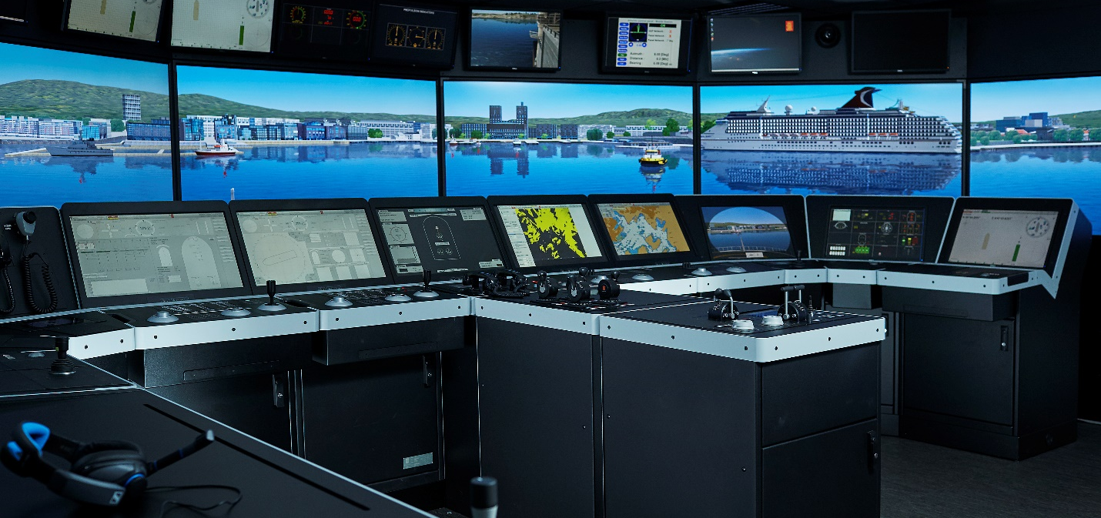

Kongsberg Digital will deliver the full range of cutting-edge K-Sim simulators, including the K-Sim Navigation bridge simulator,
to the Tolani Maritime Institute in Mumbai, India
Asker, Norway, July 1st, 2021 – Kongsberg Digital (KDI) is celebrating another significant development in maritime training technology with a landmark simulator delivery for the Tolani Education Foundation in Mumbai, India. Students and instructors at the Tolani Maritime Institute will benefit from comprehensive Engine Room, Cargo and Navigation simulator training solutions under one roof.
This delivery, which will be carried out over the coming months, sees KDI satisfying the terms of four separate but linked contracts. A Full Mission K-Sim Navigation Class A Bridge Simulator with projectors forms the core of the solution; this will be augmented and integrated with the desktop software for an Engine Room Simulator and Cargo Handling Simulator, which host two and three simulation models respectively. The fourth contract stipulation will see this software covered for eight years under KONGSBERG’s LTSSP (Long-Term System Support Program) agreement.
Each scalable simulator uses cutting-edge functionality to provide a lifelike, immersive user experience for maritime cadets. K-Sim Navigation’s industry-leading hydrodynamic models and highly advanced physical engine operate in tandem with a high-fidelity visual system to build students’ competence in their interactions with navigation equipment, other vessels, objects and weather conditions. Instructors, meanwhile, can easily construct, record and assess exercises with a simple, intuitive drag-and-drop interface.
Similarly, K-Sim Cargo familiarizes trainees with all components of a vessel’s cargo system, incorporating aspects such as the planning and execution of multiple loading and discharge operations, while K-Sim Engine accommodates basic and advanced training of marine engineers in every eventuality in the complex behavior of an engine room. All K-Sim models are certified by DNV GL and exceed existing STCW requirements.
The LTSSP lifecycle management package will provide on-call scheduled support and annual software updates for the new simulators, designed to keep them at optimum performance during their lifecycle.
“We’re very pleased to have Kongsberg Digital bringing the latest maritime simulation technology to our campus, and to be assured of their ongoing future support through the LTSSP agreement,” says Dr. Sujata Naik, Chairperson, Tolani Group. “These simulator solutions represent the most efficient and forward-thinking products of their kind on the market. This will ensure that the simulation-based training at Tolani Maritime Institute will be of the highest global standard. We envision that in the future a significant part of Maritime Training and Evaluation will be required to be carried out on such simulators; Tolani Maritime Institute will already be fully geared for this.”
“It’s very gratifying that Tolani turned to us for a futuristic, world-class solution that would bring different types of simulator models together at a single location, and have additionally opted to collaborate with us going forward through the LTSSP,” adds Andreas Jagtøyen, Executive Vice President Digital Ocean, Kongsberg Digital. “India is one of the major providers of seafarers for the world’s shipping industry and this multi simulator contract represents a holistic training approach, which we expect to see more in future.”

KONGSBERG DIGITAL
Kongsberg Digital, a subsidiary of KONGSBERG, is a provider of next-generation software and digital solutions, to customers within maritime, oil and gas, and renewables and utilities. The company consists of more than 500 software experts with leading competence within the internet of things, smart data, artificial intelligence, maritime simulation, automation and autonomous operations. Kongsberg Digital is the group-wide center of digital expertise for the KONGSBERG group.
KONGSBERG
KONGSBERG (OSE-ticker: KOG) is an international, leading global technology corporation delivering mission-critical systems and solutions with extreme performance for customers that operate under extremely challenging conditions. We work with nations, businesses and research environments to push the boundaries of technology development in industries such as space, offshore and energy, merchant marine, defense and aerospace, and more. KONGSBERG has about 11,000 employees located in more than 40 countries, creating a total revenue of NOK 25.6bn in 2020.
Follow us on: kongsberg.com, Facebook, Twitter and LinkedIn

CONTACT:  Mathilde Magnussen  VP Communication and Marketing  Kongsberg Digital  (+47) 67 55 67 01  mathilde.magnussen@kdi.kongsberg.com | Anne Voith  Communication and Marketing Manager Simulation  Kongsberg Digital  (+47) 48 08 46 40  Anne.voith@kdi.kongsberg.com
Ronny Lie  Chief Communication Officer  Kongsberg Gruppen ASA  (+47) 91 61 07 98  ronny.lie@kog.kongsberg.com | David Pugh  Account Manager  Saltwater Stone  (+44) 1202 669244  d.pugh@saltwater-stone.com

