FOR IMMEDIATE RELEASE

Intellian’s large VSAT products gain approval from ANATEL

Intellian’s v240MT 2, v240M 2, v240M and v150NX antennas
have been approved by ANATEL for use in Brazil

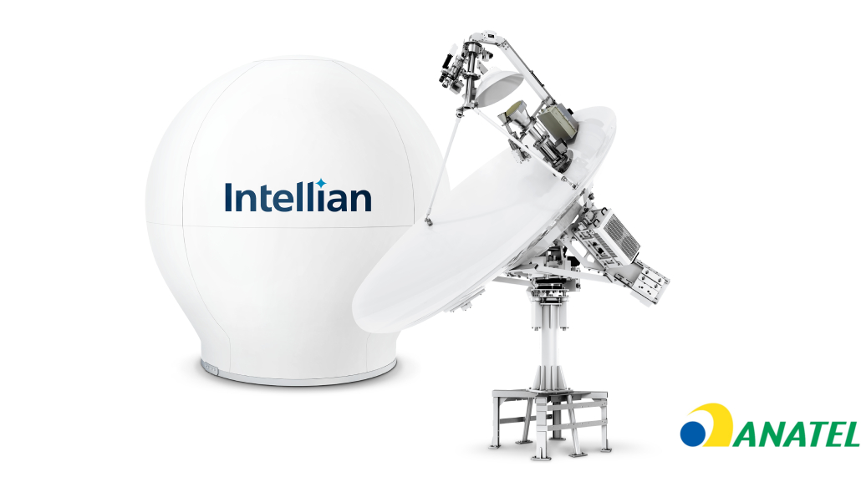Intellian’s innovative antennas deliver best-in-class RF performance across multiple bands and orbits

5 January 2021 – Intellian is pleased to announce that it has received approval for its v240MT 2, v240M 2, v240M and v150NX antennas from the Brazilian National Telecommunications Agency, ANATEL. These powerful, high-throughput antennas are widely used in the energy industry, so this approval opens the door for Brazil’s extensive oil and gas market to adopt Intellian’s leading antenna technology.
According to Brazilian Regulations (Federal Law 9472/97), telecommunications products to be sold and used in Brazil must have a Certificate of Conformity issued by a Designated Certification Body (OCD), indicating that they comply with Brazilian regulatory requirements. This certificate must also be approved by ANATEL.
Intellian’s innovative v240MT 2 antenna combines C, Ku and Ka band communications on a single reflector to enable auto-switching between all three bands, together with both GEO and MEO satellite tracking. The v240M 2 and v240M do the same for the C and Ku bands, while the v150NX antenna works across multiple orbits and can be easily converted between operation on the Ku and Ka bands. This flexibility to change band and orbit places the choice of operator firmly with the customer and ensures that the antennas are ready for the development of future, non-geostationary (NGSO) networks.
Approval for the antennas extends to include a range of BUC options, to allow customers to tailor their antennas’ output power and hence their uplink bandwidth.
Sam McKee, General Manager Americas, Intellian Technologies, concludes: “We are delighted to receive this approval. The Brazilian oil and gas markets are ideally placed to benefit from the award-winning technology and best-in-class RF performance of our v240MT 2, v240M 2, v240M and v150NX antennas. These products are ready for the next generation of satellite networks, so by choosing Intellian, customers are safeguarding their connectivity for the future and guaranteeing a seamless and cost-effective pathway to new services as they come online.”
-Ends-

For further enquiries, please contact:
Sadie Brown / Marketing Manager
Intellian Ltd
T +44 2380 019 021 ext. 1612
Sadie.Brown@intelliantech.com
David Pugh
Saltwater Stone
T +44 1202 669 244
d.pugh@saltwater-stone.com

About Intellian Technologies
Intellian is a leading global technology and solutions provider for satellite communications, empowering connectivity for the maritime, government, military, energy, cruise and enterprise sectors. Founded in 2004, Intellian is renowned for its innovative design, future-proofed technologies and outstanding customer support, which combined with continued investment in its partners, logistics network, quality control and low environmental impact production facilities make it a trusted enabler within the satellite communications industry. Its bold, pioneering solutions include the award-winning v240MT – the world’s first tri-band, multi-orbit antenna system – and the future-proof NX series antennas, optimized for high performance and low cost of ownership.
Intellian has a worldwide presence with over 400 employees, 10 global offices and five logistics centers on three continents. Intellian Technologies Inc. is listed on the Korean Stock Exchange, KOSDAQ (189300:KS).

