The advantages of online marketing

Let’s look at the big picture

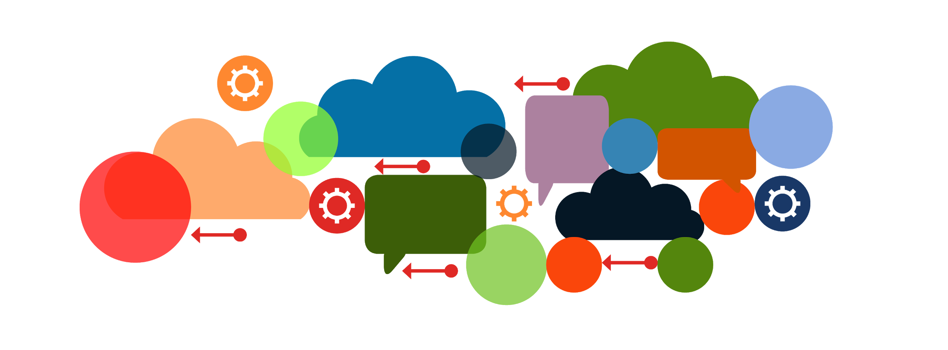

When running a business, one tries its best to be as visible to its customers as possible. Online visibility is a key factor for success and in order to increase it, we should adapt a solid online marketing strategy.
Traditional marketing includes advertisements on printed material such as in newspapers, newsletters, magazines, brochures. Let’s not forget to mention broadcasts – radio and television commercials, as well as specialized forms like on-screen movie theater advertising.
No doubt that all of these can still be efficient, depending on your business model you might make good use of them. But since the internet has become an extremely important factor of our everyday life and business (almost half of the population has access to it), why not make use of it? Actually, not only can it benefit you to have a nice website of your own, but nowadays NOT being online can be a serious disadvantage.
Let’s take a look at the main advantages online marketing has to offer and why it became so crucial:
Improving your customer loyalty
Customers show their loyalty while constantly purchasing products from your site. How can you increase their loyalty? Firstly, remember to have a good, user-friendly interface and meaningful content. Your site should contain an intuitive menu structure which will help the user to navigate through the site. You can also implement one of the customer loyalty programs, like subscription program or exclusive membership benefits. By having a well-maintained website, the connection between your customers and your brand can become much stronger.
Convenience
According to a Google study from last year, 7 out of 10 senior executives now use mobile devices to look up product - or service information after they first hear of it. 73% of executives stated that a bad mobile experience will make them less likely to do business with the company. The figures speak for themselves. Making business as convenient as possible for you customers is a key success factor.
Improve your reach
By putting your business online, you can overcome geographical barriers and reach international audience without having to open a second office abroad.
Not only you can expand your reach, you can easily improve your demographic targeting as well. In order to do so you need to know your buyer’s persona, age group and characteristics you want to aim for. You can achieve that easily through social media and AdWords campaigns. Moreover, your offer may be personalized for a specific audience group, which makes a campaign even more efficient.
Everything is measurable real-time
Thanks to cheap tracking tools like Google Analytics or Going Up, everything regarding your website can be measured. You can track all results of your activities, may those be positive or negative. Clicks, impressions, open rates, bounce rate etc. can be measured in real-time. In case something goes not as planned, you can change it right away reducing lost and damage.
Don’t be intrusive
We all agree, that advertisements can rub people the wrong way when not done well. Commercials interrupting your favorite movie may be disturbing and will most likely have a negative effect. The good thing about online marketing is that you have several ways to target only those, who are most probably interested. If you have a certain type of merchandise, advertise on relevant websites – for example, TradeMachines – used machinery.
It holds their attention
While advertising through traditional channels can be passively received (you just turn the side of a newspaper with an expensive ad without reading it), online marketing engages with active users. They are focused on browsing the internet (for example looking for/exchanging information) and your ad finds them when they are paying attention. The likelihood of them comprehending your ad is higher, not to mention the change of engagement. You can also encourage them to take action, visit your website and read about your products and services, which will make your message sink in better!
Easier follow-up
Sales experts say it takes 7 to 12 contacts before customers are ready to buy. It would be extremely hard to reach this number offline, and we would most likely face a drastic decrease of sales. With the help of online technologies, such as pre-scheduled emails or personalized offers to Twitter accounts you can warm up the leads and your job becomes much easier.
And saving the best for last, save money!
Not only you have all these advantages over traditional marketing, but the operation and implementation costs you have to spend on being present online are much lower than the costs an offline marketing campaign would require. Many of the online marketing tools are free of charge and you can easily learn how to use them, avoiding the costs of an external marketing agency. Does this mean with online marketing you get more for less money? Exactly…

