

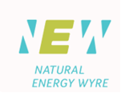
PRESS RELEASE

Target: Editors
Date: Wednesday 10th June 2015
Page: 1 of 3
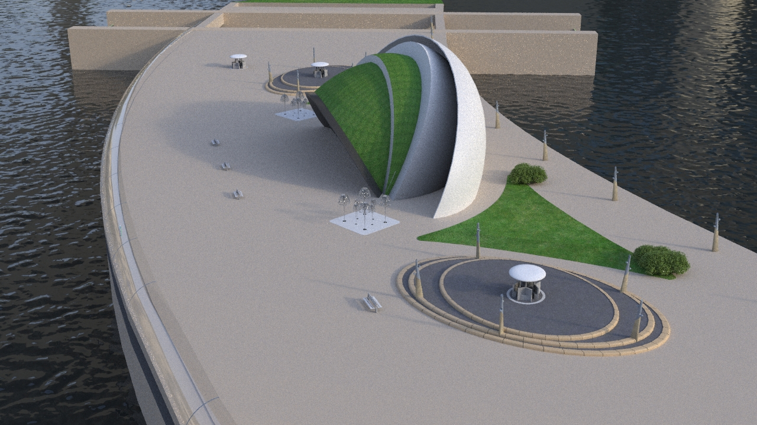
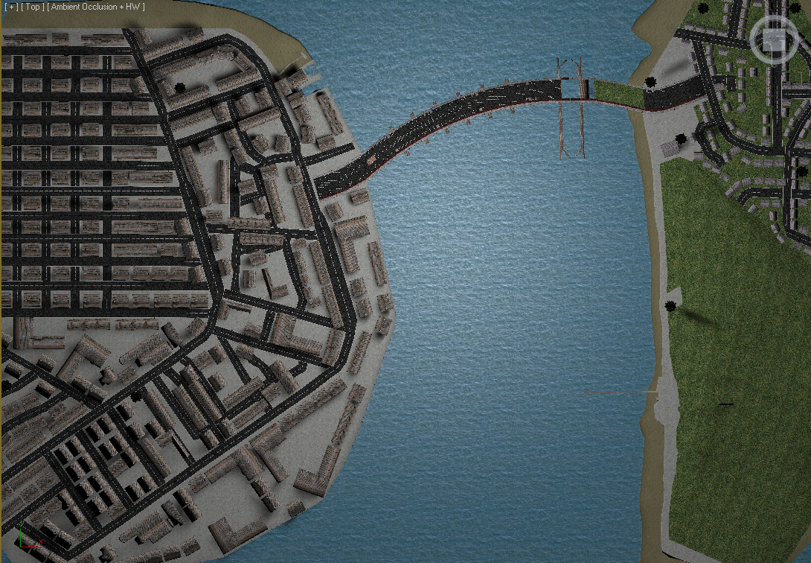

Photograph: An artist’s impression of the Wyre Tidal Barrage

Headline: Wyre Tidal Barrage launches

Main Body:

Natural Energy Wyre Limited, has launched the UK’s first Estuary Tidal Barrage project spanning the river Wyre in Lancashire, UK. The £200m project, one of the least expensive energy projects in Great Britain, is now moving forward after a landmark deal with the Duchy of Lancaster. The deal granting exclusivity rights to build a tidal barrage across the river Wyre means that the project managed by Natural Energy Wyre Limited is now able to move forward to the funding and planning application stage.

The Wyre Tidal Barrage, managed by Natural Energy Wyre Limited will be the first tidal energy power station in the UK, with a an installed capacity of 90MW/hr of electrical energy from a single construction being powered by predictable tidal movement. The project which has a lifespan of over 120 years will provide electricity for tens of thousands of homes in the UK and will support the National Grid and UK Government in their clean renewable energy objectives.

Bob Long, Managing Director of Natural Energy Wyre Ltd commented “This is a real milestone in the project, it’s one of the most exciting stages now and gives us the green light to move forward with the next stage in developing a clean renewable energy project right here in the North West of the UK. It’s a project that is very close to my heart living locally and I am, along with the rest of the board of Directors, completely committed to delivering the project for the benefit of all.”

The project will now move forward with securing the £10m stage one funding which is needed for full completion of the planning application with the project based on proven current turbine and energy production technologies covering the 600m span of the mouth of the river with six turbines. It will have the benefit of an emergency vehicle access road, pedestrian and cyclist access to each side of the river, a multipurpose learning and development Centre, two lock pits (one for commercial and one for leisure craft) and stunning views out to sea and down river for visitors.

The project has the support of many key stakeholders including Wyre Council, cross party support at Lancashire County Council, Arup, Lancaster University, Andritz Hydro and leading environmental consultants Hyder, as well as the Duchy of Lancaster. Graeme Chalk, Head of Project Management for The Duchy of Lancaster, commented: “This project reflects the Duchy’s commitment to environmental sustainability and the use of renewable energy. We look forward to working with the team at Natural Energy Wyre as they take this project forward to deliver the full range of benefits proposed. Once planning and development issues have been resolved, the tidal barrage will provide a source of green and affordable energy for many years to come.”

The scheme will also have a profound impact on the surrounding area with a list of benefits including:

An increase in water based activities on the river.
Leisure facilities including river side dining.
Retail environments.
Commercial investment due to carbon credit incentives for energy hungry processes.
An anticipated 600,000 visitors per annum.
Full pedestrian and cyclist access.
Two lock pits for safe passage of vessels.
Thousands of jobs.
Renewable green energy to power tens of thousands of homes.
Flood defence.
Improved habitat for birds.
Educational learning centre for primary and high school children along with University level research facilities.
Visitor centre to explore how the barrage works and the benefits it brings.
An emergency vehicle access road bringing peace of mind to those in the rural villages to the east of the river.
Reduced UK dependency on energy imports increasing UK energy security

Bob Long Managing Director explains “This is great news for all local people, on both sides of the river and beyond, a real opportunity to be involved in helping the UK become less dependent on imported energy and the burning of fossil fuels.”

Currently the UK Government have a commitment to deliver 15% of its energy from renewables by 2020. It currently only achieves 5% meaning all projects that can make a real difference and energy contribution are of great interest to DECC.

The next phase is the planning process including full public consultation and then the construction stages. Full construction is anticipated to take three years before the Wyre Tidal Barrage will be fully functioning, producing renewable energy four times a day, on the turn of the tide, for over 100 years.

Visit www.naturalenergywyre.co.uk for more visuals, 3D animated video and downloadable information and your opportunity to have your say.

--------ENDS-------


Media Contact: David Jones
Managing Director
Thirty 30 Media Ltd
M: +44 (0)7813 291216
E: david@thirty30media.co.uk
W: www.thirty30media.co.uk

Notes to Editors:

Natural Energy Wyre Ltd are a dynamic company dedicated to successfully delivering the
Wyre Tidal Barrage, the first tidal energy power station in the UK. The project is focussed on the production of approximately 150GWatt of electricity annually from a single construction, powered by predictable tidal energy. Please visit www.naturalenergywyre.co.uk for full information and downloadable reports.

The tide flows into the River Wyre twice daily and is caused by the gravitational pull of both the moon and the sun. The energy source is completely predictable and reliable (unlike many other renewable technologies) and this is the reason we have focussed on harnessing such a plentiful, natural resource.

The project requires a purpose-built Wyre Tidal Barrage across the river estuary, from Fleetwood to Knott End, specifically designed to extract natural energy. This carefully engineered development will house a number of sophisticated and specifically commissioned turbines to control the passage of water in and out of the river. Put simply, the huge movement of water will force the turbines inside the structure to rotate, powering the attached generators. This will produce a massive amount of energy from each and every tide, which is then fed into the National Grid.

The Wyre Tidal Barrage is strategically positioned for optimum energy extraction coupled with delivering the maximum flood defence potential for local residents. The span of the river between Fleetwood and Knott End is just 600 meters and the average tidal range of approximately 10 meters, making it the most economic site for this purpose in the UK (based upon a basic kW/£ generating cost). The completed Wyre Tidal Barrage, with a build cost of under £200 million, will relentlessly deliver vast amounts of green energy powering tens of thousands of homes.

The Wyre Tidal Barrage will generate positive outcomes at every level; green energy production, local employment boosts, increased trade from tourism, much needed local flood defences, environmental protection and vibrant economic growth. Motivation for green energy has never been higher. Fossil fuels are running out at an ever increasing rate and reducing our dependency on them is accepted as the only sustainable way forward.

