Lund, 27 September 2010

PRESS RELEASE

The first ever Nordic Cleantech Open is launched today!

If you have just started a cleantech company, now may be the perfect time for you! A start-up competition that will identify, upgrade and highlight the very best of the upcoming Nordic cleantech stars is launched today. With official backing in all Nordic countries and heavy involvement from the investment community this initiative aims to have a real impact on the acceleration of clean technologies.

Despite increased media focus on environmental issues, the pipeline of high quality cleantech start-ups could use encouragement.

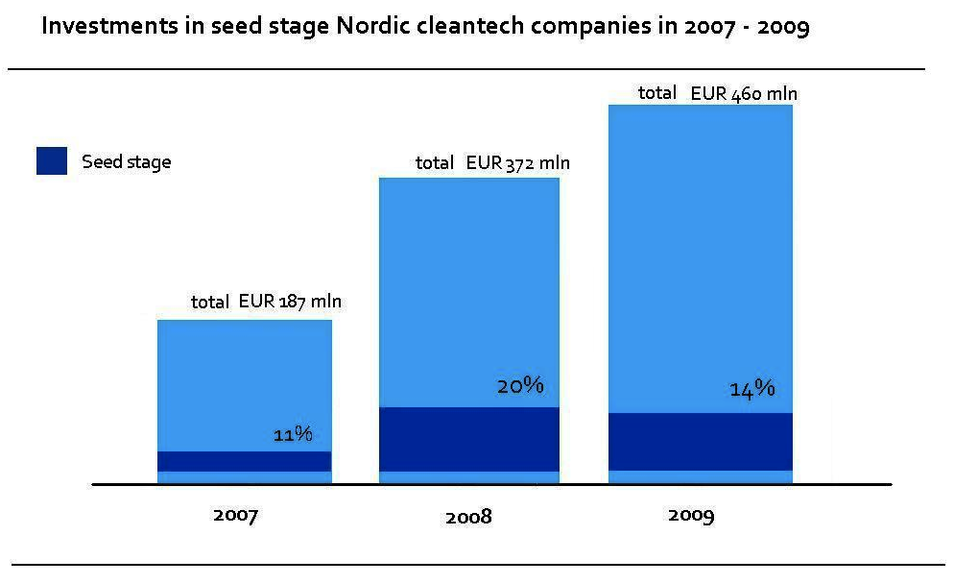
Cleantech Scandinavia, the leading cleantech investor network in the Nordics, noticed that the total amount of venture capital injected in the Nordic cleantech industry has grown impressively for the last three years but the number of deals in the early stages have had a bumpy ride. The graph below is based on data covering all investments made in Nordic cleantech growth companies over the last 3 years.
2009 was a year when investors clearly played it safe and 70% of funding went to later stage companies while seed stage companies attracted only about 14% of the capital.
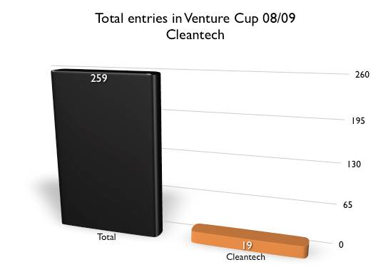
Venture Cup, the leading Nordic business plan competition, had noticed a similar development, when Venture Cup Denmark only received 7% of their entries in cleantech last year.

This development combined with a genuine belief in the market potential for cleantech solutions was the motivation for starting the Nordic Cleantech Open.

“At Investinor we mainly focus on later stage investments. It is however absolutely fundamental for the quality of our dealflow that there is a sound and vigorous early stage capital market for promising cleantech start-ups. Investinor therefore warmly welcomes initiatives such as the Nordic Cleantech Open, which will contribute to boosting entrepreneurship within the sector.” – says Helle Moen, Investment Director at Investinor.

Based on Cleantech Scandinavia’s analysis of deals during first half of 2010, early stage investing may now be on a long awaited rise – the first half year saw seed stage investments up by over 50% in the number of deals and close to a third (26,7%) of the total amounts of funding.

“We have been wanting to do something to accelerate the pipeline of new cleantech innovations for a long time, and I believe the timing is now perfect to do so. We are still developing the value to the participants but we already have an impressive list of events lined up for the finalists and a lot of cleantech-focused investors in the jury, so we are off to a good start.” says Alexander Lidgren of Cleantech Scandinavia, Founder and Managing Director of Nordic Cleantech Open.

About the Nordic Cleantech Open:
The Nordic Cleantech Open is a business competition, aiming to identify, upgrade and display the top 25 early stage cleantech companies in the Nordic region each year.
Identify: Trough working with the start-up ecosystem to identify existing cleantech start-ups and to inspire entrepreneurs about the cleantech potential.
Upgrade: A highly competent jury selects 25 top runners based on their growth potential. These 25 will undergo a program of activities that will help them build a solid business case, including a Nordic weekend camp, where we utilize an extensive network of cleantech professionals, including leading investors and industrials.
Highlight: A Nordic final in Copenhagen brings together leading investors, professionals and industrials active in the cleantech sector and selects the ultimate winner. Nordic Cleantech Open also selects the Nordic finalists to enter the internationally renowned Cleantech Open in California, where teams from all over the world take part.

For more information visit www.nordiccleantechopen.com or contact:
Alexander Lidgren
+46736601007
bigge@nordiccleantechopen.com
www.nordiccleantechopen.com

Nordic Cleantech Open is organised by Cleantech Scandinavia, Venture Cup Denmark and Innovit Iceland and was founded in partnership with the organisations listed below:

