**Racing siblings Bäckman once again part of the HMSG Customer Racing Junior Driver initiative**

**Andreas and Jessica Bäckman have been selected by Hyundai Motorsport Customer Racing to be part of their Junior Driver initiative that supports young racing drivers for the second year in a row.  
– It feels super exciting to be one of the few chosen racing drivers for the Hyundai Motorsport Customer Racing Junior Driver initiative once again, Andreas says.**

Hyundai Motorsport Customer Racing announced today the selected drivers for their Junior Driver initiative. For 2020 Hyundai Motorsport Customer Racing will support four young talented drivers, including the Swedish racing siblings Andreas and Jessica Bäckman for the second consecutive year. Each selected driver will receive engineers’ support from the Customer Racing department as well as receiving mentoring from the current WTCR drivers in order to help them improve their on-track performance. The scheme also includes support off the track, including individual feedback in order to build a professional profile which are essential to reach a professional future motorsport career in FIA WTCR.

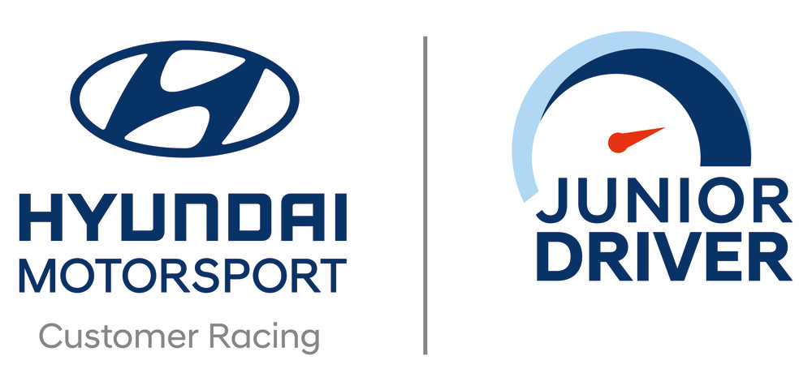

**Racing siblings with an aim to win**Andreas and Jessica Bäckman will drive Hyundai i30 N TCR racing cars in TCR Europe during the 2020 season, again together with the successful Italian team Target Competition that ended up as TCR Europe Team Champions in 2019. The siblings that are part of Sweden National Team for this year are now predicted to keep being as successful as their history implies. Last year, Andreas reached 4th place overall in the TCR Europe Championship with one race win at Circuit of Barcelona Catalunya in Spain as well as two consecutive Pole-positions and multiple podiums during the year. While Jessica became the first woman in the history to finish on the podium in the prestigious TCR Europe Championship. Apart from that she also had two successful podiums in TCR Scandinavia and TCR Germany, and got selected to represent Sweden in the Olympics of Motorsport, FIA Motorsport Games, where she finished in 6th place overall.  
– It feels super exciting to be one of the few chosen racing drivers in the Hyundai Motorsport Customer Racing Junior Driver initiative once again. We are truly honored that Hyundai Motorsport keeps believing in us and we will do everything we can to make this year the best so far, Andreas Bäckman says.  
– The opportunity also gives us the best possible conditions in order to develop as drivers and eventually reach our goal: to compete in FIA WTCR against the best touring car drivers in the world, Jessica Bäckman says.