MIIKE SNOW RELEASE LEAD SINGLE “GENGHIS KHAN” FROM FORTHCOMING ALBUM iii

iii ARRIVES EVERYWHERE MARCH 04, 2016

PRE-ORDERS AVAILABLE STARTING TODAY
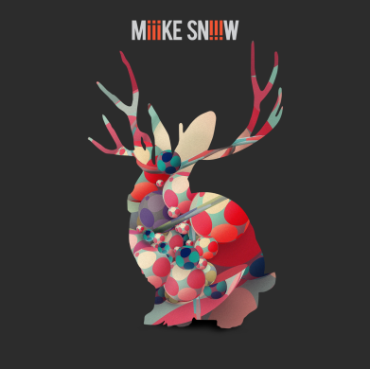
Miike Snow’s new album iii, which marks the Swedish/American trio’s first studio album since 2012’s Happy to You release, arrives everywhere March 4, 2016 via Downtown/Atlantic Records. iii is preceded by the album’s lead single, “Genghis Khan,” a powerful pop anthem with a soulful edge, which is streaming now via the Miike Snow YouTube channel - Listen here: https://www.youtube.com/watch?v=8uHoww0gpyc. The track’s companion music video will see its premiere next year.
iii is available for pre-order starting today at all digital retailers and will be accompanied by a trio of instant grat downloads: “Genghis Khan,” “Heart Is Full,” and Run The Jewels remix of “Heart Is Full” (pre-order here: http://smarturl.it/MiikeSnowiii). These songs, plus additional Miike Snow material, can also be streamed here: http://smarturl.it/MikeSnowSpotify.View the track listing for iii below.
“Heart Is Full,” which marked the band’s triumphant return and first taste of new music in 3 years, premiered last month. The track’s cinematic video, directed by Lance Drake, is streaming now at Miike Snow’s official YouTube channel and can be seen here: https://www.youtube.com/watch?v=EWJHK0JT_Xc. Stereogum called the track “a big, bold metropolitan pop track bolstered by walloping boom-bap drum loop, blaring soul samples, Auto-Tuned crooning, and one of those humongous pop-rock choruses…,” with SPIN stating that “Heart Is Full” is “a bold, almost jazzy new track that’s a bit of a departure from the rest of their music, though their signature, wintery vibes shine through in the chorus.” In addition, Run The Jewels put their spin on “Heart Is Full,” hailed by The FADER as a “hard-hitting transatlantic collaboration.” Check it out here:https://soundcloud.com/miikesnow/miike-snow-heart-is-full-feat-run-the-jewels-remix.
The new album wasn’t crafted in one fell swoop. Instead, Miike Snow (Andrew Wyatt, Christian Karlsson & Pontus Winnberg) collaborated across space and time, meeting in Stockholm, Los Angeles and New York for short periods over almost two years. Each musician began with different songs, sometimes sending them back and forth digitally when they couldn’t be together in one room. The combination of the musicians is an electric one, as exemplified on the album and in their live shows. “I think we really weren’t meant to be in the studio together and do music together and then we do and it just works,” Karlsson reflects. “I think that’s the whole magic with this band. We have so much trust and respect for each other…nothing comes together easier than Miike Snow. The pieces just fall into place.”
Over the past eight years, the band’s innovative sensibility has left a lingering impact on the state of music and shifted the way other artists approach pop music. In some ways, iii is both a return to form and an expansion of what has come before. “It feels like we did a little excursion on album two and now we’re back where we were on album one,” Winnberg says. “It’s the original Miike Snow sound, but taken to the next level.”

iii TRACK LISTING:
My Trigger
The Heart Of Me
Genghis Khan
Heart Is Full
For U (Feat. Charli XCX)
I Feel The Weight
Back Of The Car
Lonely Life
Over And Over
Longshot (7 Nights)

Connect with Miike Snow:
http://www.miikesnow.com/heartisfull/
https://www.facebook.com/miikesnow
https://twitter.com/miikesnow
https://instagram.com/miikesnow/
SoundCloud.com/miikesnow

