2023-03-23

PRESS RELEASE
Successful scientific experiment with sounding rocket for space scientists in Kiruna in collaboration with SSC Esrange

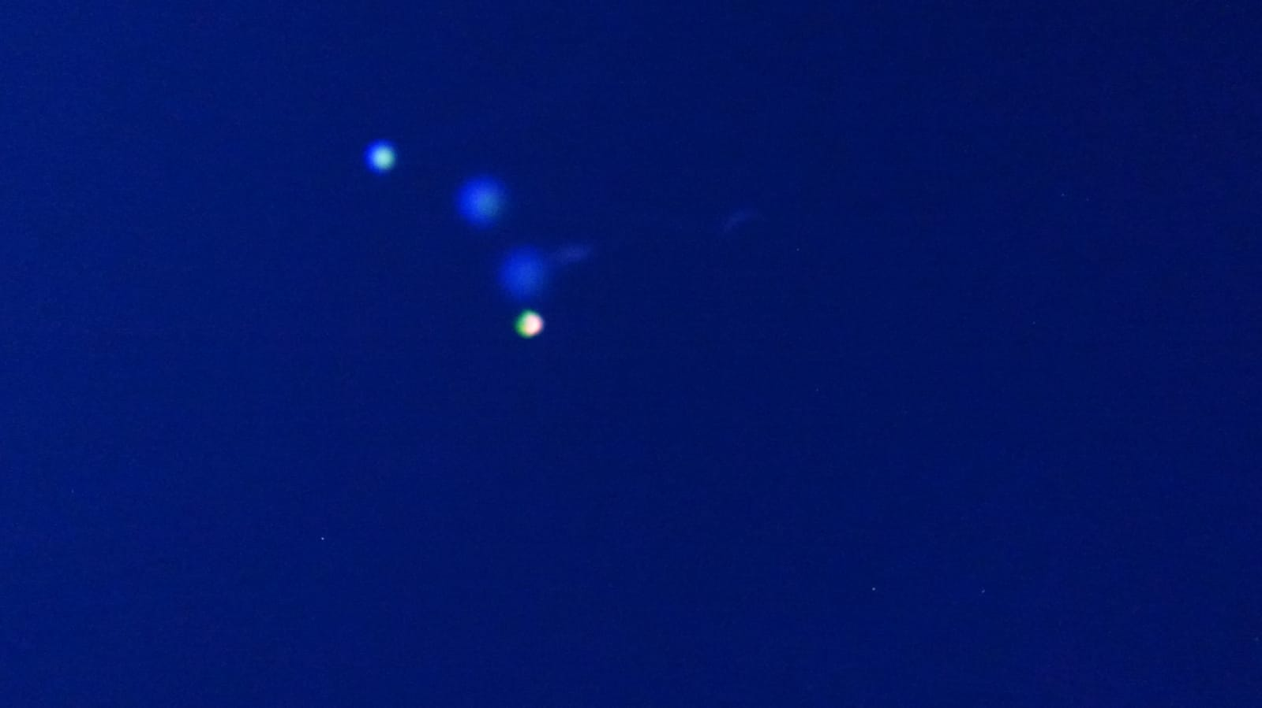
This is what it looked like in the evening sky just as the BROR rocket was launched from the Esrange Space Center outside Kiruna on Thursday evening. Photo: Johan Kero/IRF
At 19:23 local time on March 23, a sounding rocket with a scientific experiment from the Swedish Institute of Space Physics (IRF) in Kiruna was launched from Esrange Space Center. Thanks to collected data, IRF's space scientists can study conditions in near-Earth space, the ionosphere. The information contributes to a piece of the puzzle in aurora research that can enable better space weather forecasts.
﻿﻿﻿
Space weather is about how the sun's activity and its solar wind of charged particles affect critical infrastructure on Earth and on satellites.
IRF scientist Tima Sergienko is Principal Investigator for the BROR scientific experiment.
"I am very happy that our scientific experiment BROR worked out great. We have obtained important results. I hope that an analysis of the obtained data will allow us to take another step in understanding such an amazing phenomenon as the aurora. I am eternally grateful to all the participants in the experiment", says Tima Sergienko.
The project is carried out within a national program for balloons and sounding rockets where Swedish research gets the opportunity to carry out space research from Esrange. The program is financed by the Swedish National Space Agency.
“This was probably one of the most beautiful rocket launches I have experienced from Esrange. But more importantly, this research will pave the way for a deeper understanding of space weather, the phenomenon of aurora and how it affects space infrastructure which is crucial for our societies on Earth. I’m proud of the SSC team that designed the payload and launched the BROR rocket for the scientists at IRF”, says Krister Sjölander, Vice President Science Services and Head of Payloads & Flight Systems at SSC.
Contact:
Johan Kero, Head of the research program Solar, Space and Atmospheric Research, Swedish Institute of Space Physics, +46 980 790 84, johan.kero@irf.se
Press contact:
Annelie Klint Nilsson, Information officer, Swedish Institute of Space Physics
+ 46 980 790 76, annelie.klint-nilsson@irf.se
Martin Eriksson, Information officer, Swedish Institute of Space Physics
+ 46 980 791 78, martin.eriksson@irf.se
More information:
Press release 9 March: https://www.irf.se/en/news/2023/03/09/space-scientists-in-kiruna-will-use-sounding-rocket-to-create-colorful-clouds-for-aurora-studies/
https://www.irf.se/en/news/2023/03/10/irfs-space-scientists-answer-questions-about-the-scientific-experiment/
SSC Esrange livestream from the launch: https://www.youtube.com/@SwedishSpace/streams

