JL Audio’s Marine Audio Source Unit Makes its METS Debut
METSTRADE 2016, Amsterdam, 15-17th November, Hall 1, stand 01.535
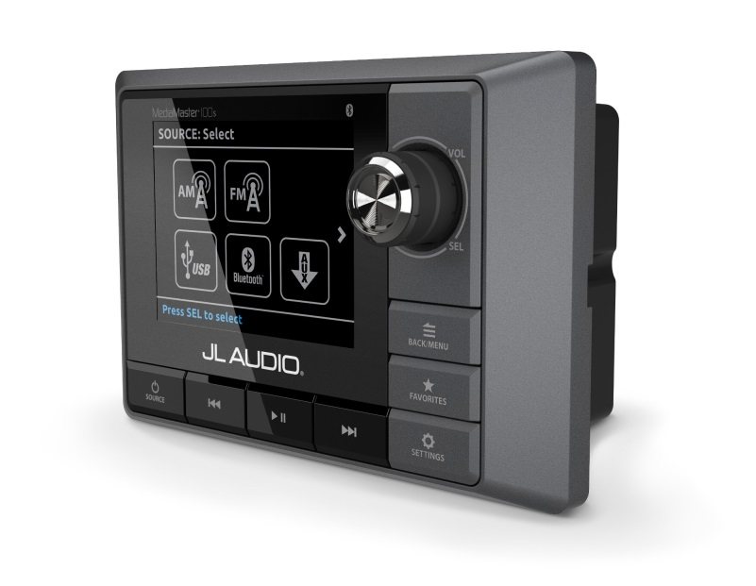
JL Audio Marine Europe, the European distributor for the US’s leading marine audio systems, JL Audio, will be debuting its highly anticipated marine audio source unit at this year’s METSTRADE.

Offering superb audio performance, excellent ergonomics and advanced audio features, the MediaMaster®100s marks JL Audio’s entry into this important product category and completes an extensive line-up of high quality, marine audio products offering an integrated marine audio solution to boatbuilders and customers.

As with all JL Audio marine products, the MediaMaster®100s is purpose-built and engineered specifically for the marine environment by a team of specialists at JL Audio’s manufacturing base in the US. The result after months of rigorous testing is a better sounding head unit with a beautiful interface that works great on the water.

One of the most advanced features of the MediaMaster®100s is its 4-zone control which enables the user to set up varying equalization profiles and volumes levels in different areas of the boat.

JL Audio Marine Europe’s Managing Director, Paul Baker said: “The MediaMaster®100s is a milestone product for us as it creates the opportunity to build a full JL Audio marine sound system, from source unit to amplifiers, speakers and subwoofers. This is the high-end source unit our European customers have been waiting for and after months of rigorous testing under the strictest controls we are delighted to offer them a cohesive system that will be unrivalled for sound quality and longevity.

Upgrading to a JL Audio Marine system will not only offer customers a far superior sound. Our products typically provide around eight years of premium audio listening compared with other marine audio products lasting only one to two years in a marine environment. This makes our marine audio systems a fantastic investment for any boat owner that appreciates his or her music.”

JL Audio products are renowned for offering an exceptionally high level of marine audio performance and tested well beyond industry standard. The typical chip amplifiers used in most marine source units have been removed and instead, the MediaMaster®100s is equipped with preamp-level audio circuits, which have been installed in an 8-channel unit with 4V RMS outputs to offer amazing sound reproduction. This design offers excellent system control flexibility in a wide range of marine audio system configurations.

The source functionality of the MediaMaster®100s has been designed for today’s advanced media applications and offers a wide range of connectivity options for external devices such as Bluetooth® audio streaming, USB 2.0 direct-digital connection for a smartphone or USB storage device, analogue auxiliary input for connection to a wide range of audio sources and an NMEA 2K-compliant CAN offers connectivity to compatible marine electronics.

The physical design of the MediaMaster®100s has been carefully engineered to deliver excellent ergonomics and features an intuitive interface with large text for easy legibility while in motion and large buttons and control knob for ease of use. A high-brightness, full-colour 3.5-inch LCD display offers day and night lighting modes with user-defined display brightness, button brightness, remote brightness and display themes.

The MediaMaster®100s can be controlled anywhere on board up to 22.8 metres (75ft) away with up to three MMR-20 remote controls unit. Built for marine applications, the MMR-20 is IP67 weatherproof rated and features the most common functions of the MediaMaster®100s in a simple, intuitive design that’s easy-to-use. Its large, backlit controls and LED source indicators are easily identifiable, day or night, with brightness settings that can be adjusted. A small footprint and simple, one-hole design means the MMR-20 can be installed in even the tightest of spaces.

The MediaMaster®100s has an RRP of £499.99 including VAT and €549.99 excluding VAT. The MMR-20 remote controller has an RRP of £129.99 including VAT and €129.99 excluding VAT. For further information and a list of distributors, contact JL Audio Marine Europe on T: +44 (0) 1202 664 390, E: enquiries@jlaudiomarine.eu or visit www.jlaudiomarine.eu

ENDS

Main features:
- Digital Tuner - AM/FM with NOAA weather band capability
- RDS (Radio Data System) displays extended FM program info, where available
- Store up to 18 of your favourite channels for quick access, across all tuner bands
- Bluetooth® with the aptX® codec streams top-quality audio from compatible devices, with full control of play/pause and track up/down functions
- USB 2.0 direct digital connection for an iPhone® or USB storage device, with album cover art support and folder browsing capabilities
- Conveniently charges phone or media player with 1.0 amp USB output
- Analogue auxiliary input accepts audio signal from a wide range of audio source
- NMEA 2K - Compliant CAN bus is also supported (requires adaptor/sold separately)
- Connect up to three MMR-20 Wired Remote Controllers (sold separately) to add remote control functionality from extended locations
About JL Audio
JL Audio is America’s leading luxury car and marine audio manufacturer. The company prides itself on exceptional durability and consistency created with extensive testing. Its marine division provides speaker systems designed and built for the testing environment of the ocean. The marine range brings high end, home audio quality to the leisure, luxury yacht and sports boat market.

About JL Audio UK
JL Audio UK is responsible for marketing and distributing JL Audio’s car and marine audio systems throughout Europe.
For further information and images or to arrange a test of the MediaMaster®100s, please contact Karen Bartlett, Saltwater Stone, T: +44 (0)1202 669244, E: k.bartlett@saltwater-stone.com
www.saltwater-stone.com

