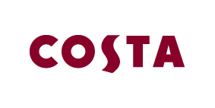
Thursday 9th July 2015

COSTA TRIALS ‘FRESH’ BRAND PARTNERSHIP WITH CHOP’D
The nation’s favourite coffee shop launches trial with London’s premium salad brand

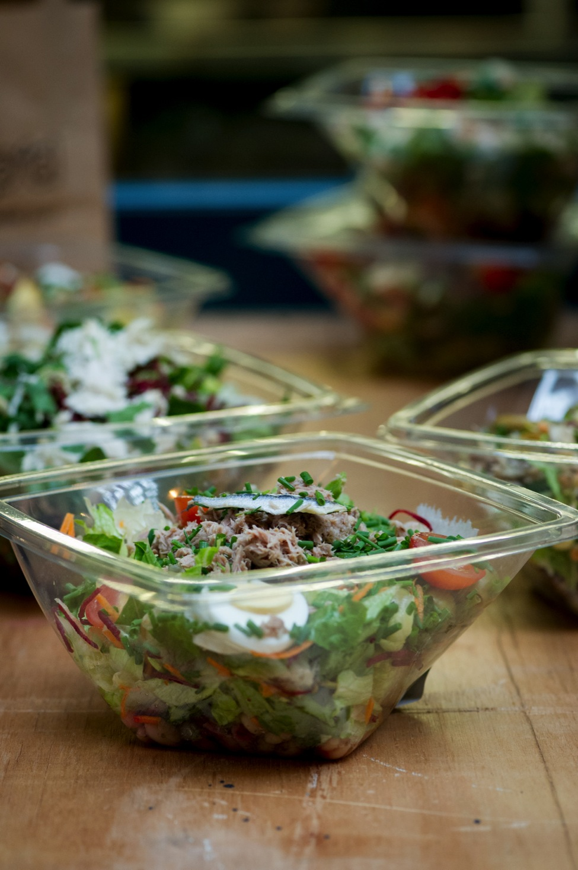

Today the nation’s favourite coffee shop brand Costa has launched a trial partnership with London salad brand Chop’d to offer fresh salads across select Costa stores in London.

The partnership is the first time Costa has collaborated with another food or drink brand. Working with London based Chop’d, a company that is committed to great quality, Costa is now offering healthy, fresh food to compliment it’s handcrafted barista coffee and provide real choice for its customers.

Carol Welch, Group Brand & Innovation Director at Costa said, “At Costa, our customers define the focus of our innovation, and having listened to their feedback, I’m delighted to partner with Chop’d in this trial. As the handcrafted fresh food company Chop’d is a great fit with our handcrafted coffee. As brands, we both originate from London, which means we share a passion and expertise for offering irresistible coffee alongside freshly prepared, delicious food, aiming to delight our customers day in, day out.”

Chop’d salads was founded in 2004 and currently has 12 stores in London. The trial will initially see the Chop’d Jerk Chicken, Tuna Niçoise, Feta & Lentil, Parma Ham & Mozzarella and Falafel & Houmous salads appear across six Costa stores in central London.

Eddie Holmes, Managing Director of Chop'd said, “We are delighted to have been handpicked by Costa to be their salad partner. It really is a great fit due to our joint passion for using the best ingredients, delighting our customers and of course both being born and bred in London.

To think that our food will be tasted by a far wider audience really excites us and helps us on our mission to offer the best salads, soups and stews the UK has ever tasted.”

The new Chop’d salads prices start from £4.50 and will be available on trial in the following stores from Thursday 9th July until Wednesday 30th September:

- Cabot Place
- Costa To Go Holborn
- Costa To Go Moorgate
- Costa St. James
- Costa Eldon St
- Costa Great Marlborough Street

ENDS

For further information please contact the Costa Press Office at Costateam@onegreenbean.com or call 0207 017 1014

About Costa
Costa is the UK’s favourite coffee shop, having been awarded “Best Branded Coffee Shop Chain in the UK and Ireland" by Allegra Strategies for five years running (2010, 2011, 2012, 2013 & November 2014).

Winner of “Best Branded Coffee Chain in Europe” Allegra Strategies 2010, 2011, 2012, 2013 and 2014.

With over 1,800 coffee shops in the UK and more than 1,100 overseas, Costa is the fastest growing coffee shop business in the UK and the second largest coffee shop operator in the world. Founded in London by Italian brothers Sergio and Bruno Costa in 1971, Costa has become the UK’s favourite coffee shop chain and diversified into both the at-home and gourmet self-serve markets.

Costa employs over 12,000 people and is creating around 1,500 jobs this year and over 4,500 jobs in the next three years in the UK. We continue to be part of the Sunday Times Best Companies To Work For list.

Costa is committed to looking after coffee-growers. That's why we've established The Costa Foundation, a registered charity. The Costa Foundation's aims are to relieve poverty, advance education and the health and environment of coffee-growing communities around the world. So far, The Costa Foundation has funded the building of 42 schools and improved the social and economic welfare of coffee-growing communities.

About Chop’d
Chop’d opened their first store in December 2004 and currently have 12 stores across London.

Chop’d is dedicated to using only the best, locally sourced ingredients and use the same trusted suppliers as they did when they opened.

Chop'd is run by good friends Eddie Holmes and Allan Cook, who have a hands-on approach to food and can sometimes be seen helping out in the teams in-store.

