25 November 2013

PRESS RELEASE

Stockholm Design Talks boost Stockholm’s efforts
to be the hub of Scandinavian furniture and lighting design

The outlook for furniture sales is looking brighter and soon it will be time to fling open the doors to the 63rd Stockholm Furniture & Light Fair. In February the eyes of the world will be on Stockholm as the global elite in furniture design and lighting will assemble at the fair to see the latest in Scandinavian design. The event will be bigger than ever with the introduction of Stockholm Design Talks – a new knowledge and discussion driven forum on furniture and interior design. The talks will be themed: Moving Forward.

Stockholm Furniture & Light Fair is the most important meeting point for Scandinavian furniture and lighting design, an intensive week in which Stockholm welcomes thousands of internationally influential people keen to see the latest products and hear the latest news. Approximately 750 companies will be exhibiting at the fair in 2014, about 80 percent of them from Scandinavia. In total the fair is expected to attract up to 40,000 people, including industry representatives, journalists, and other interested visitors. New for 2014 is the launch of Stockholm Design Talks, which will further boost Stockholm’s position as the creative home of Scandinavian furniture and lighting design.

– “Those of us who have been working on the fair for many years now have identified an increased need to inspire and pass on expertise to people working in the industry. We want the fair and Stockholm Design Talks to become the point in the year when we stop and look around us. We want to help each other by sharing case studies and experiences in a more structured way, and we also want to seize the opportunity to deepen the debate on furniture and lighting design in an international arena, in a week that attracts so many influential people to Stockholm. The result is a forum in which can be done, Stockholm Design Talks – Moving Forward, where we’ve invited moderators, speakers and panelists from all around the world to take part”, says Cecilia Nyberg, Event Manager, Stockholm Furniture & Light Fair.

The theme of Stockholm Design Talks this year is Moving Forward, focusing on the need for the furniture and design industry to look into the future, as it emerges from a tough financial period. The theme includes local Scandinavian perspectives side by side with international outlooks and a forward striving approach. Packed with powerful content and with familiar names as panelists, Stockholm Design Talks will inspire visitors, highlight the latest issues in the industry, including e-commerce and design, offer an insight into new trends and provide the tools for success in a national and international arena.

The program will feature three focus areas clearly linked to the overall theme Moving Forward. The areas will be headed by three top names. Hospitality Design is led by Guy Dittrich, a hotels and design specialist and writer, featured in a heap of international publications including Wallpaper. Design Pays? is headed by Mark Isitt, winner of the Spot City prize in 2008 for his articles on urban planning and segregation. Last but not least, The Power of Scandinavian Design is led by Hanna Nova Beatrice, design journalist and editor-in-chief of Residence Magazine. Residence will also be hosting the parts of the program open to the public on the Saturday.

Stockholm Furniture & Light Fair will be held on February 4-8 2014 at Stockholmsmässan.
Public day is Saturday 8 February, when the fair is open to everyone from 10. a.m. to 5 p.m..
The entire week is also Stockholm Design Week, with plenty going on across the Swedish capital.

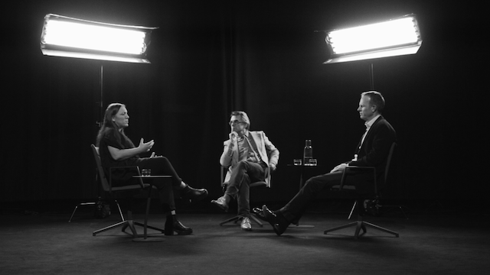

For a sneak peek of Stockholm Design Talks have a look at:

VIMEO
About the Stockholm Design Talks: https://vimeo.com/79659839
- The Power of Scandinavian Design: https://vimeo.com/79654646
- Hospitality Design: https://vimeo.com/79659837
- Design Pays?: https://vimeo.com/79659838
- https://vimeo.com/stockholmfurniturefair

YOU TUBE
About the Stockholm Design Talks: http://www.youtube.com/watch?v=PFxyAIM-G9g
- The Power of Scandinavian Design: http://www.youtube.com/watch?v=f4CRjOdvpdo
- Hospitality Design: http://www.youtube.com/watch?v=o8Ndsmq7_QA
- Design Pays?: http://www.youtube.com/watch?v=lDVTuFag7jI
- http://www.youtube.com/sthlmfurniturefair

For a more detailed program or more information about the fair, please visit: http://www.stockholmfurniturelightfair.se/news/stockholm-design-talks
The program is being continuously updated.

Or contact:
Lotta Signeul, presskontakt, tel. +46 708 19 99 19, lotta.signeul@stockholmsmassan.se
Cecilia Nyberg, Event Manager, tel +46 8 749 4386, cecilia.nyberg@stockholmsmassan.se

Furniture retail was the winning sector in HUI Research’s latest Swedish Retail Sales Index. Following two months of negative growth, furniture sales were up by 5.8 percent.

