IMMEDIATE RELEASE

Saturday, January 7, 2012

**So it’s True! The British are Traditionally Romantic.**

**A recent survey reveals what people really prefer when it comes to sharing their love on Valentine’s Day – and in the age of mobile technology, the result comes as a bit of a surprise.**

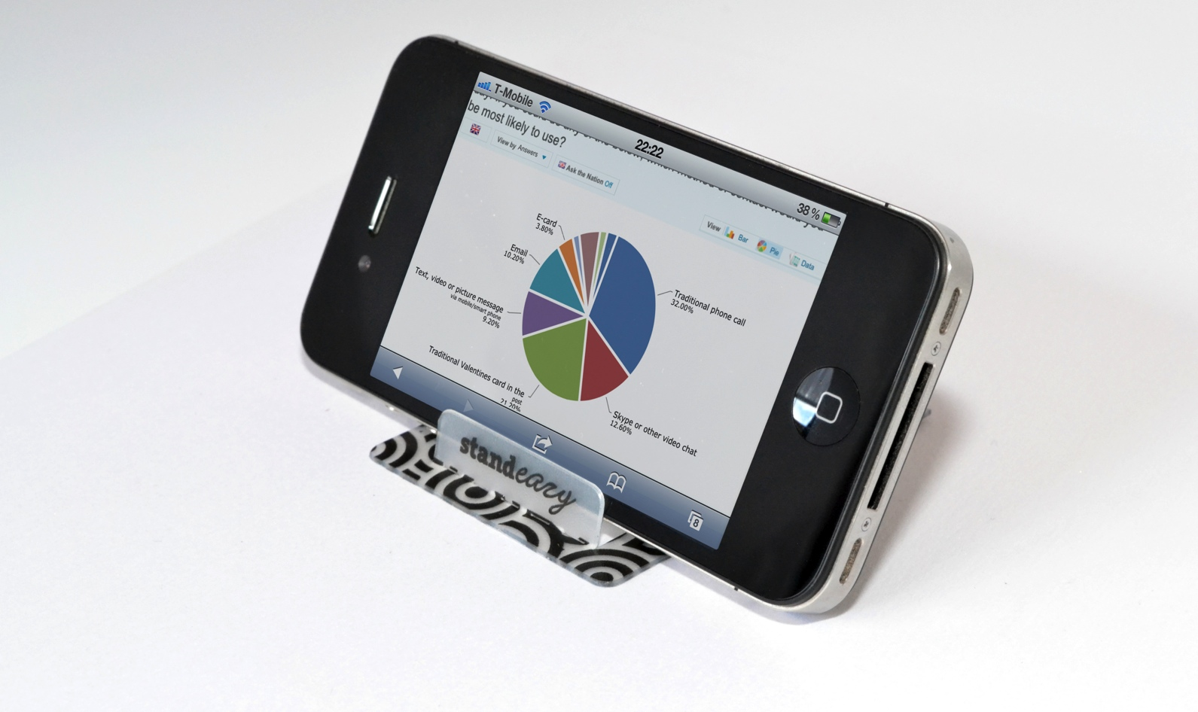

Valentine’s Day is approaching fast and, with recent developments in the social and mobile market, one wonders what couples will prefer as a means to send their love if they can’t arrange a dinner date or romantic meeting.

Standeazy, the UK designers of a credit card sized smartphone stand, conducted a survey of more than 500 people with surprising results. No matter what age group, region or gender, most people will simply pick up the phone to send their love on Valentine’s Day.

32% of those questioned prefer a traditional phone call whilst 21% would rather send a card in the post. But, both are followed by 13% (more in younger age groups) who will use Skype or other video chat applications to let cupid do his work on Valentine’s Day.

Twitter was one of the least favourite options to send a kiss – together with posting on Google+ or Facebook and sending an E-card.

So, it seems that when love is concerned, the British like their traditions – but are embracing the next best thing to meeting in person – a hug and a kiss via Skype or video chat. What a heart-warming discovery.

--- END

Notes to the editor:

For detailed survey data, please contact Regine Wilber (see details below).

Standeazy Limited are designers and manufacturers of credit card sized smartphone stands that fit into any card wallet and allow users to prop up their phone to watch TV, video, use Skype or FaceTime and lots of other apps hands-free wherever they are.

For product samples please contact Regine Wilber:

regine@standeazy.com

Mobile: 07940 564849.

Standeazy Limited

12 Somerville Road

Sutton Coldfield

B73 6JA

[www.standeazy.com](http://www.standeazy.com)