**Proxio and Lantmännen Cerealia initiates major transport mapping project**

*Proxio, leading actor of cost and emission saving services within transportation recently initiated a project with Lantmännen Cerealia. The aim of the project is to identify potential areas where transportation costs can be decreased and in turn reduce Cerealia’s environmental footprint.*

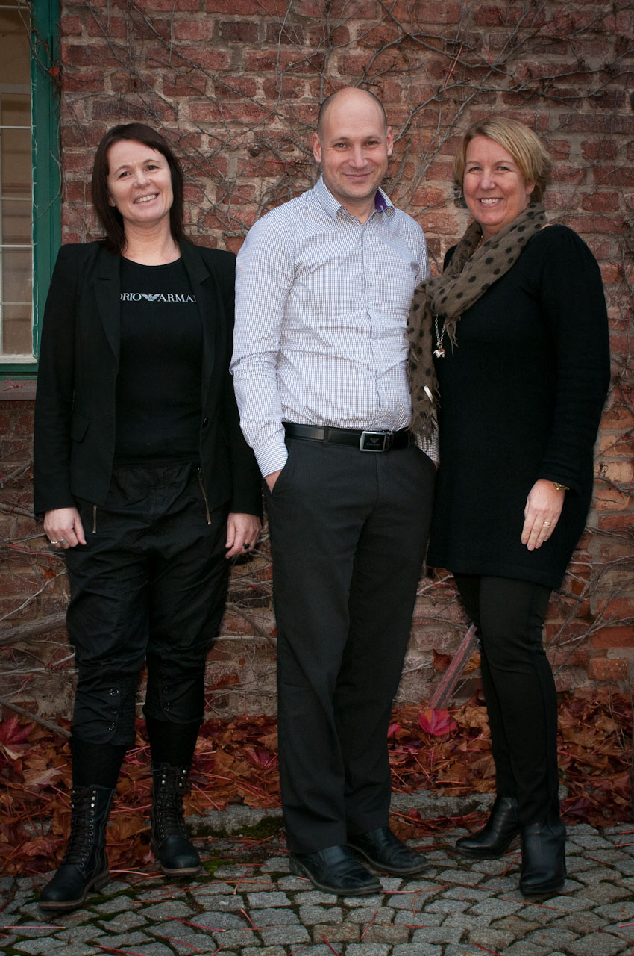*Lantmännen Cerealia’s main objective is to develop, produce and market corn based products, e.g. flour, grains and pasta.  AXA, Kungsörnen, GoGreen, START, Nord Mills and HavneMøllerne are examples of strong brands which their products are marketed under.*

”Lantmännen has been on the wish list of dream clients for a long time. We are very happy that Lantmännen Cerealia has decided to proceed with Proxio as an important partner for their mapping project”, says Lena Dyfverman CEO at Proxio.

Proxio is currently working as a logistics partner for several of the Nordics leading brands with the mission to optimize transportation networks in order to decrease cost and reduce environmental footprints.

”Lantmännen Cerealia has high expectations on Proxio in this project and we are convinced that Proxio will add value to us due to their combination of logistics- and software expertise”, says Tobias Traneborn Head of Logistics at Lantmännen Cerealia.

  Camilla Nilsson, Tobias Traneborn, Lena Dyfverman

For more information, please contact;

*Lena Dyfverman, CEO, Proxio*

*+46 737 16 49 09*