**HamletScenen and DIANE SOA invites you to an exclusive concert experience with world-renowned musicians at Kronborg, where she, as the host of AVALON HAMLET JAZZ, gathers artists and audience through music and dialogue.**

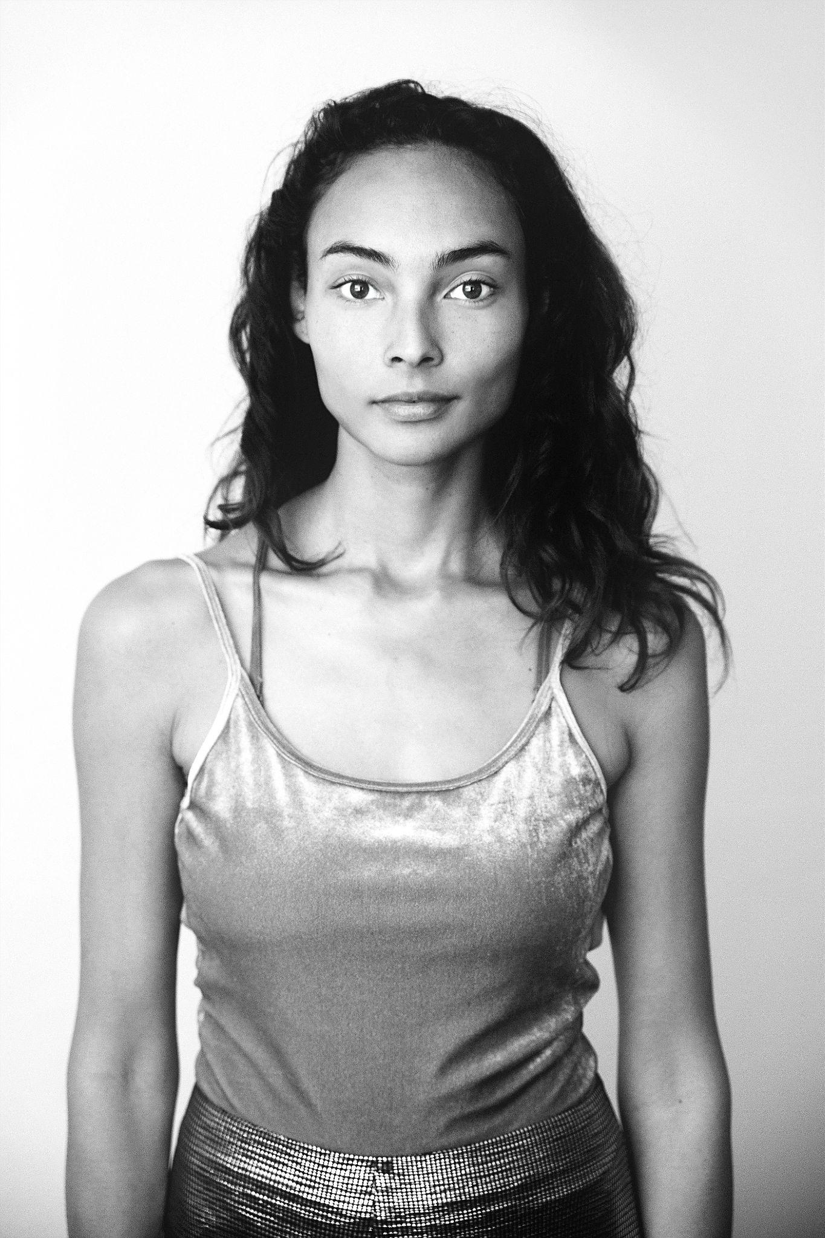

*AVALON HAMLET JAZZ host, Diane Soa  
Singer, sound healer, mother, and nature lover*

The Modern Standards Supergroup will perform four exclusive concerts under the name AVALON HAMLET JAZZ. These will take place on Saturday, August 23, at 14:00 and 20:00, and Sunday, August 24, at 14:00 and 20:00 during the ELSINORE SHAKESPEARE FESTIVAL 2025. Ticket sales begin today.

Host for AVALON HAMLET JAZZ is the renowned sound healer, singer, mother, and nature lover, Diane Soa, who, in collaboration with HamletScenen, welcomes the audience. Soa will act as the concert's moderator, guiding the audience through the evening. She will open each concert with a harmonious dialogue with the artists and the audience, setting the stage for a shared celebration of music, nature, and peace on Earth. Against the historical grandeur of Kronborg, these themes are united with timeless ideals on an unforgettable journey for both the audience and the artists. The celebration of nature’s beauty will be brought to life with a rose that is presented and named on stage—a unique tribute to the magnificence of nature and a symbol of love, strength, and grace. The proceeds from the sale of the rose will go entirely to support this important work.

The audience can look forward to experiencing a spectacular fusion of modern jazz, pop, and rock in a celebration of Avalon—land of peace and rebirth. The concerts are organized by The Avalon Rose Foundation, a newly founded nonprofit organization focused on peace and sustainability. The Avalon Rose Foundation is a natural extension of the ideals of the Avalon myth, with the purpose of supporting selected projects each year, aiming to make the world a better place.

**Modern Standards Supergroup – Concerts for a Better World  
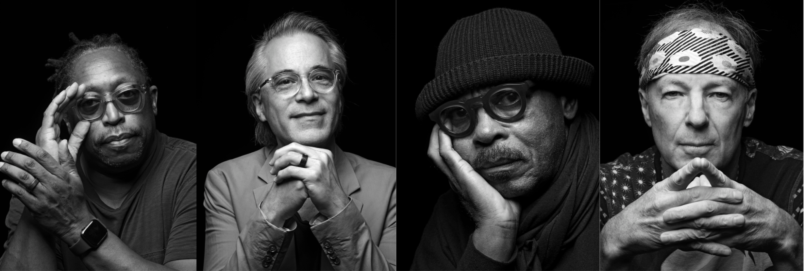***Modern Standards Supergroup: Darryl Jones, Niels Lan Doky, Harvey Mason, and Bill Evans will perform exclusive concerts for a better world at next year’s Elsinore Shakespeare Festival 2025. Photo: Atilla Kleb*

The world-renowned jazz quartet Modern Standards Supergroup, led by Helsingør's own Niels Lan Doky, will perform at Kronborg as part of the ELSINORE SHAKESPEARE FESTIVAL 2025 with four exclusive concerts under the title AVALON HAMLET JAZZ. Festival-goers can look forward to an extraordinary concert experience when some of the world’s greatest musicians, joined by a choir and guest soloists, celebrate music, nature, and world peace.

**International Stars at Kronborg**The music will be led by Helsingør's own world-famous jazz pianist Niels Lan Doky. He and the rest of the star-studded quartet, Modern Standards Supergroup, will perform selections from their repertoire, which, though the setlist is not yet confirmed, will include jazz interpretations of modern pop/rock hits from artists such as Taylor Swift, Prince, Billie Eilish, Metallica, and many others.  
The quartet consists of saxophonist Bill Evans, who has played with legends such as Miles Davis and John McLaughlin, drummer Harvey Mason, known for his work with Herbie Hancock and George Benson, and bassist Darryl Jones, who has been a permanent member of The Rolling Stones since 1994. He has also collaborated with Miles Davis and Sting.

On stage with them will be the award-winning Danish gospel choir LOVE REVOLUTION, led by Kathrina Brunnstrøm. The choir is Denmark’s leading gospel choir and has performed at major venues, including the Royal Albert Hall in London. LOVE REVOLUTION will be joined by a large children’s and youth choir, led by Kathrine Brøndsted, consisting of hundreds of enthusiastic young singers.

**Guest Soloists**The concert will also feature guest stars and top-tier surprises. Initially, the Danish singer and songwriter Erann DD will join as a guest soloist. The award-winning musician gained recognition with the single and album “Still Believing” in 2000 and has since released several albums, written music with prominent artists in Denmark, and performed at major venues across the country.

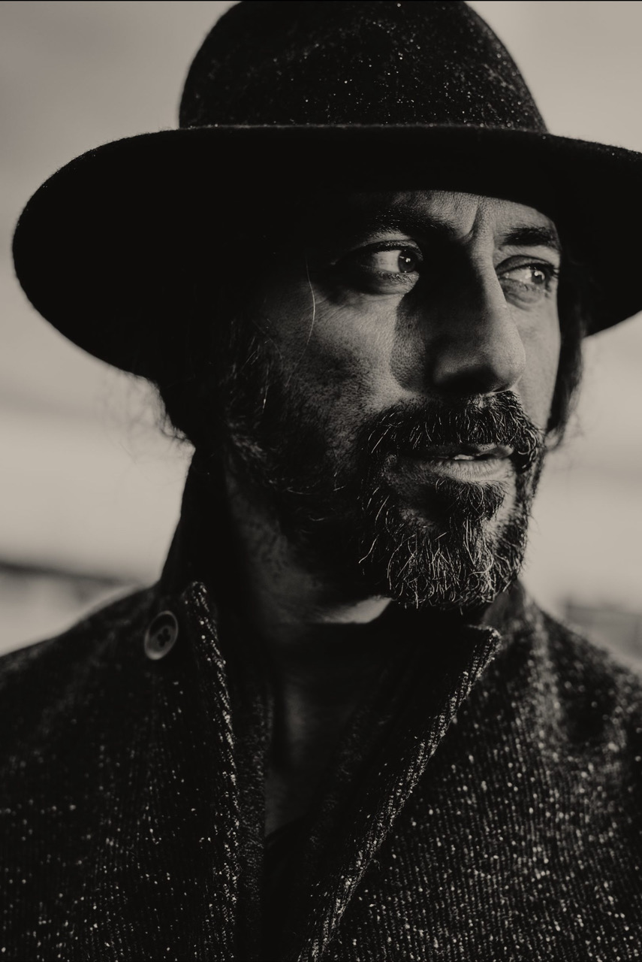  
*Guest star, singer Erann DD*

**ELSINORE SHAKESPEARE FESTIVAL 2025**As usual, the ELSINORE SHAKESPEARE FESTIVAL 2025 will also feature a series of theatrical performances, continuing the festival's tradition of bringing Shakespeare's works to life in new and compelling interpretations. The rest of the program will be announced shortly.

For more information and to purchase tickets for AVALON HAMLET JAZZ during the ELSINORE SHAKESPEARE FESTIVAL 2025, click here.

Kind regards,  
HAVE Kommunikation

For further information, please contact:  
Rikke Hesselholt // rikke@have.dk // +45 28 43 38 93  
Cecilie Hansen // cecilie@have.dk // +45 22 47 54 35