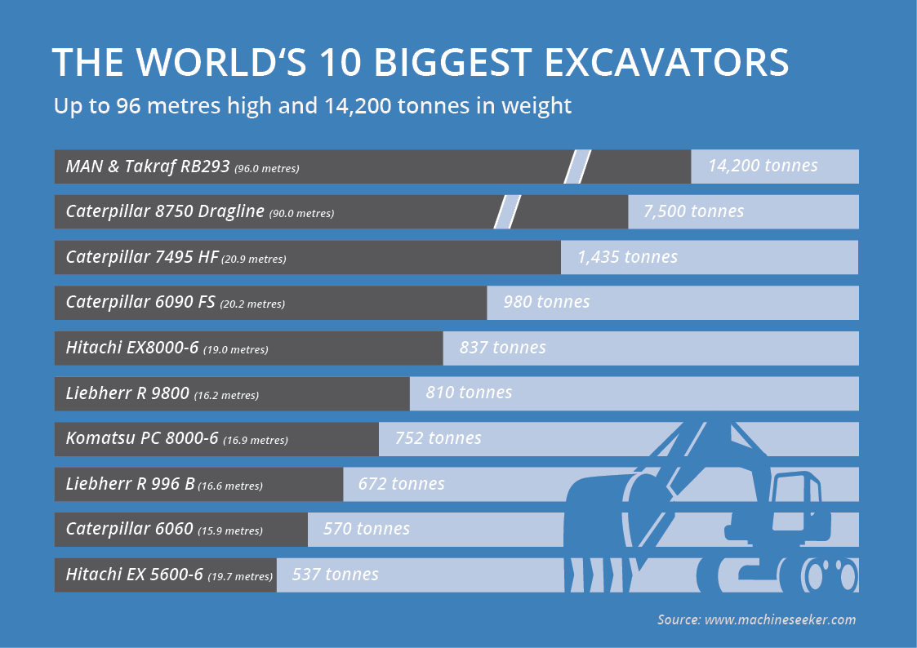

Photo Gallery: The world's 10 biggest excavators **As high as a skyscraper**

**Up to 96 metres (105 yd.) high and 14,200 tonnes in weight: The world's 10 biggest excavators are simply unbelievable. Only a few manufacturers in the world produce machines like these. The Top 10 includes everything from an electric cable excavator to a shovel excavator.**

The high performance shovel of the Liebherr R 9800 mining excavator has the phenomenal capacity of 45 cubic metres – the same volume as 400 conventional bathtubs. This monster can fully load a large dump truck in just three passes, but at 810 tonnes it only takes 6th place among the biggest excavators in the world.

In first place is a lignite excavator that was specially designed for RWE Power AG by MAN and Takraf. The RB293 bucket-wheel excavator operates at around 6,653 HP (6.745 PS), which corresponds to seven times the power of a Formula 1 racing car. It weighs 14,200 tonnes and stands 96 metres (105 yd.)high – as tall as a skyscraper.

Online marketplace [www.machineseeker.com](http://www.machineseeker.com) has put together a photo gallery of monstrous machines. Have fun looking!

**Contact**

**Patrick Ratzke**Head of PR & Communications  
machineseeker.com – marketplace for used machines

Phone: +49 (0) 201 458 455 72  
Fax: +49 (0) 201 490 93 81  
Mobile: +49 (0) 176 439 912 53  
Email: ratzke@machineseeker.com

Re-publication is royalty-free. Source of the images must be indicated.

**Download Links:**

One picture per excavator: <http://press.machineseeker.com/latest_media/tag/top-10-biggest-excavators>

Entire gallery:

<http://press.machineseeker.com/latest_media/tag/the-worlds-biggest-excavators>

**Image sources:**

1. MAN & Takraf RB293 (14.200 metric tons) // (96,0 metres / 105 yd.)

* Source: Takraf & RWE Power AG

1. Caterpillar 8750 Dragline (7.500 metric tons) // (90,0 metres / 98 yd. 1 ft.)

* Source: Caterpillar

1. Caterpillar 7495 HF (1.435 metric tons) // (20,9 metres / 23 yd.)

* Source: Caterpillar

1. Caterpillar 6090 FS (980 metric tons) // (20,2 metres / 22 yd. 3 in.)

* Source: Caterpillar

1. Hitachi EX 8000-6 (837 metric tons) // (19,0 metres / 20 yd. 2 ft.)

* Source: Hitachi

1. Liebherr R 9800 (810 metric tons) // (16,2 metres / 17 yd. 2 ft.)

* Source: Liebherr

1. Komatsu PC 8000-6 (752 metric tons) // (16,9 metres / 18 yd. 1 ft.)

* Source: Komatsu

1. Liebherr R 996 B (672 metric tons) // (16,6 metres / 18 yd. 5 in.)

* Source: Liebherr

1. Caterpillar 6060 (570 metric tons) // (15,9 metres / 17 yd. 1 ft.)

* Source: Caterpillar

1. Hitachi EX 5600-6 (537 metric tons) (19,7 metres / 21 yd. 1 ft.)

* Source: Hitachi

*N.B.: Ranking according to weight.*

**Captions:**

**Place 10:** Standing at a staggering 19.7 metres (21 yd. 1 ft.) high, it's the giant among the hydraulic excavators but only comes in at Place 10 with an operating weight of 537 tonnes. The Hitachi EX 5600-6 mining excavator is driven by a 50-litre engine with an output of 1,433 HP (1.453 PS).

**Place 9:** The Caterpillar 6060 takes Place 9. The smallest excavator in the top 10 measures an impressive 15.9 metres (17 yd. 1 ft.) and weighs 570 tonnes. Motor capacity: 3,003 HP (3.045 PS)!

**Place 8:** Eighth place goes to the Liebherr R 996 B. It's a little taller at 16.6 metres (18 yd. 5 in.) than the R 9800, but significantly lighter weighing in at 672 tonnes. It's a real powerhouse too, with an output of over 3,000 HP (3.000 PS).

**Place 7:** The Komatsu PC 8000-6 shovel excavator weighs in at 752 tonnes and takes 7th place in the world's largest excavators. The Japanese machine stands at a height of almost 17 metres (18 yd. 1 ft.) – roughly twice as tall as a normal family home.

**Place 6:** The Liebherr R 9800 follows at Place 6, boasting a height of 16.2 metres (17 yd. 2 ft.) and the staggering weight of 810 tonnes. Its shovel holds all of 45 cubic metres – that's the same capacity as 400 conventional bathtubs.

**Place 5:** The EX 8000-6 is Hitachi's heaviest excavator. 19 metres (20 yd. 2 ft.) and 837 tonnes qualify the Hitachi for Place 5. The Japanese Monster's petrol tank has a whopping 14,900 litre capacity.

**Place 4:** In fourth position is the Caterpillar 6090 FS, successor to the legendary Bucyrus RH400, which for many years was long regarded to be the world's largest mining excavator. The Cat 6090 FS is over 20 metres tall (22 yd. 3 in.) and weighs 980 tonnes – more than 50 times as heavy as a fully-laden tour bus.

**Place 3:** Third place goes to the 21-metre (23 yd.) tall Caterpillar 7495 HF. The operating weight of this electric cable excavator measures a stupendous 1,435 tonnes. The behemoth has a maximum power rating of 5,244 horsepower (5.317 PS). This excavator tackles over 100 tonnes in a single shovel load.

**Place 2:** 90 metres (98 yd. 1 ft.) high and 7,500 tonnes in weight. Place 2 is occupied by the big brother of the contestant at third place. The Dragline 8750 from Caterpillar is a true giant. According to the manufacturer, this machine has a service life of roughly 40 years when used daily.

**Place 1:** The RB293 is as heavy as 25 passenger planes and as high as a skyscraper. The world's biggest machine boasts 6,653 HP (6.745 PS) and a top speed of 10 metres per minute. It is used by RWE Power AG to extract lignite.