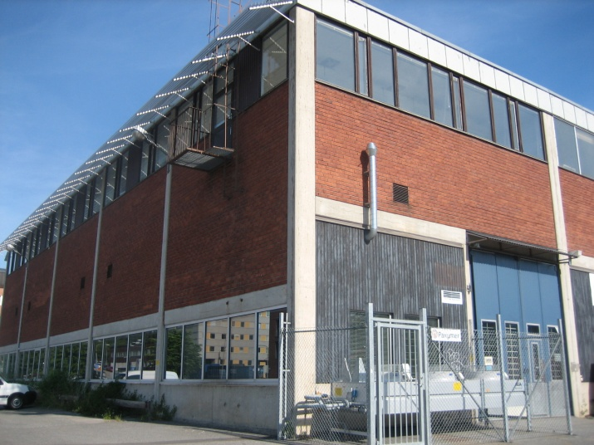
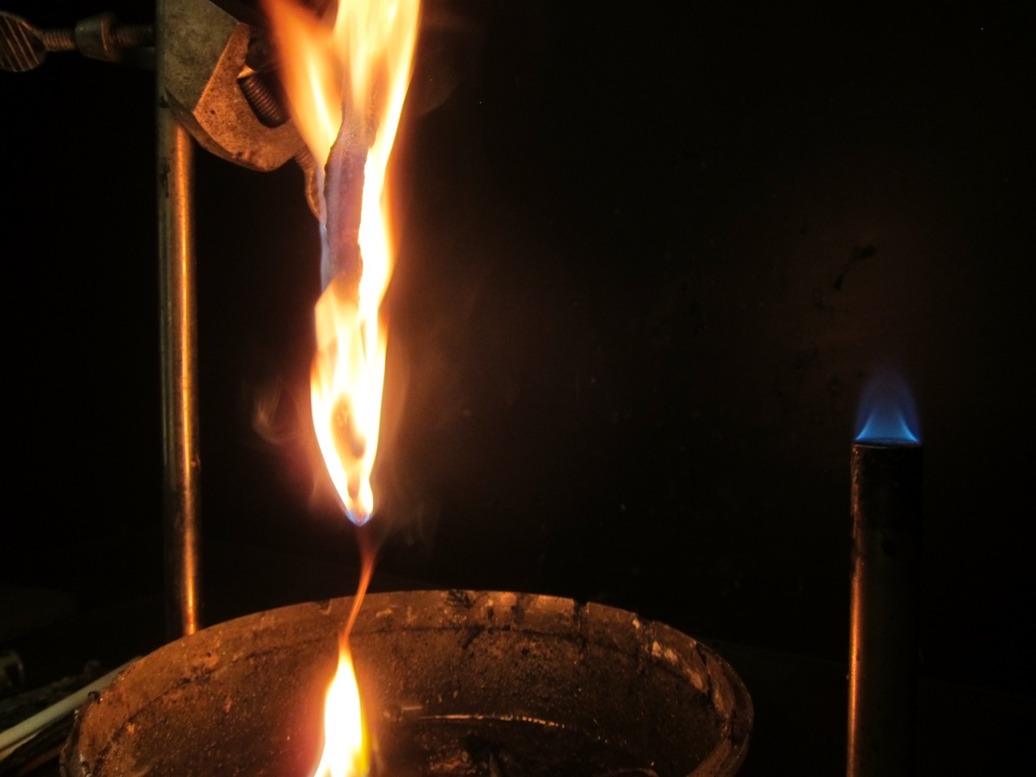
PAXYMER newsletter
Newsflash
Paxymer® Non-toxic flame retardant PP fiber will soon be reality
Mistra Innovation funds Paxymers project for halogen-free flame-retardant polypropylene fibers. The green flame retardant was selected for financing in the tough competition with a total project value of 5 million SEK. The project aims to improve environmental and functional parameters of flame retarded PP-fibers. The project will be conducted with five industrial partners and the University of Borås and Swerea/IVF. “The Market is looking for alternatives to the dominating polyester fiber especially to achieve an improved environmental footprint. Polypropylene has been a material of interest due to its good recyclability and could also result in cost and weight reductions.” says Amit Paul MD of Paxymer and project leader.
Read more: www.paxymer.se

Pending ban on Deca-BDE creates far-reaching ripples
New legislation is on its way. Another brominated flame retardant compound has been banned in the United States and Norway nominated Deca-BDE to ECHA for investigation for a potential ban.
Just months after the ban on hexa bromine within the Stockholm convention were implemented earlier this spring.
Paxymer is a proponent of this development. There are many remaining types of brominated formulations that are still allowed but the trend is clear: the legislator has gradually been banning larger molecules (first penta-, octa-; then hexa- and now Deca-BDE is nominated). These compounds have all been marketed as safe from the suppliers at various times and it casts a dark shadow of doubt on the new polymeric brominated systems.
A move away from bromine altogether introduces new challenges and possibilities for the industry and to many product design teams. New non-halogenated products will have improved recyclability, less toxic substances in the material and improved safety in fire situation through reduction of toxic smoke for instance.
One excellent example is a recent customer project where Paxymer was involved. The target was to switch a PA to flame retarded PP for one of 3M: s welding helmet. This was possible due to a creative and pragmatic approach from the application design team and clever design of the formulation together with the customer. Paxymer has
the knowledge and the experience to support our customers in these processes. /Amit Paul (MD of Paxymer AB)

Paxymer in Chemistry world!
Paxymer appears in a review article in August 2013 in Chemistry World; Phasing out of fire retardants. Brominated flame retardants are according to the author not viewed as sustainable alternatives and the article reviews some of the more interesting technologies for substitution available today. Paxymer is named as one of those.
The worldwide sales of flame retardants are currently $4 billion per annum and the market is expected to grow to about $5.8 billion by 2018. The author reviews established larger companies such as Dow, Clariant and FRX but dive deeper into the technology of some start ups where Paxymer is one of them. Special attention is given to Paxymers commitment to development according to the precautionary principle and avoiding bromine altogether due to the widespread doubt regarding its environmental and health effects. Another aspect that was an item of interest was the multi-mechanistic approach that Paxymer takes in order to achieve a process able and safe flame retardant. The article is published on http://www.rsc.org/chemistryworld/ written by Nuala Moran. http://www.rsc.org/chemistryworld/more/?search=phasing+out+of+fire+retardants&x=15&y=6
Norway proposed to add Deca-BDE to the Stockholm Pops free list.
In Norway the substance deca bromo diphenyl ether (commercial mixture c-decaBDE) is already banned since 2008. Norway recently submitted a proposal to add Deca-BDE to the Stockholm Convention on Persistent Organic Pollutants. The commercial mixture consists primarily of the fully brominated deca-BDE congener in a concentration range of 77.4 - 98.0 %.
ECHA has released a statement saying that Deca-BDE will be investigated and inclusion in the evaluations process for a ban will start in the near future. The industry has asked for clarifying facts and ECHA has stated that Deca-BDE will however not be included into the 5th draft of the Annex XIV – list of substances subject to authorization. Paxymer will of course follow the development in this matter closely. http://echa.europa.eu/documents/10162/13640/note_deca_bde_en.pdf
Bann in US-State for halogenated FR!
Octa, Penta, Deca-BDE and Tris are now banned in the State of Vermont by law. This legislation is the most demanding in the entire U.S. regarding flame retardants. It relates to flame retardants in consumer products. Vermont and California are the states with the farthest reaching legislation in the United States. They have, through local legislation, gone further than the national environmental protection agency EPA. http://www.leg.state.vt.us/docs/2014/Acts/ACT085.pdf
Flame retardants under scrutiny
Canada and the U.S. are really working hard to try to identify hazardous compounds. The U.S. Environmental Protection Agency (EPA) is currently investigating 20 flame retardant chemicals in order to be able to endorse individual compounds as safe for specific uses. Canada is requiring companies to provide data on the manufacture, import and use of 10 flame retardant chemicals, including five of the chemicals that are undergoing scrutiny at EPA. Tris for instance is one FR-chemical that is being investigated by both agencies. The goal is to be able to assess compounds or substances on many levels but also with regard to bioaccumulation and health aspects. http://cen.acs.org/index.html

Dioxin level of exposure set after 21 years
After 21 years the Environmental Protection Agency has established a safe level of exposure to the most toxic form of dioxin. The safe daily dose is 0.7 pictograms of TCDD per kilogram of body weight. TCDD is the most potent congener of the dioxins, which is one by/product of i.e. manufacturing processes involving chlorine such as PVC. TCDD effects men’s reproductive ability and also hormonal effects on newborn babies have been documented due to exposure elevated exposure of the mother. All though carcinogenetic is still under investigation the endocrine disrupting effects and liver damage are proven.
We welcome you to use and refer to the information in this newsletter and are grateful if you mention the source.
Editor: Ann-Christin Paul, ann-christin.paul@paxymer.se
If you do not wish to receive our newsletters please reply to this e-mail: info@paxymer.se with the Subject: “Unsubscribe” and you will be removed from our mailing list.

