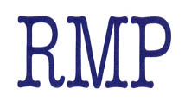

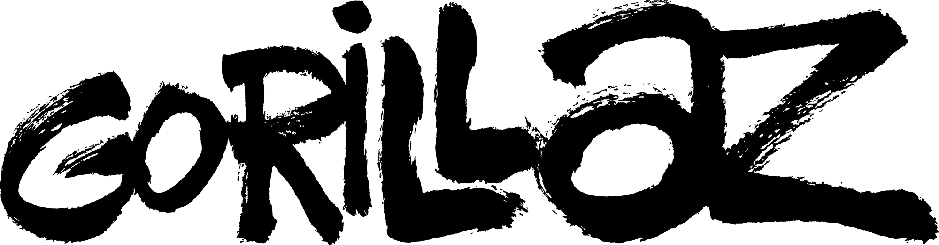

NEW STUDIO ALBUM

The Now Now

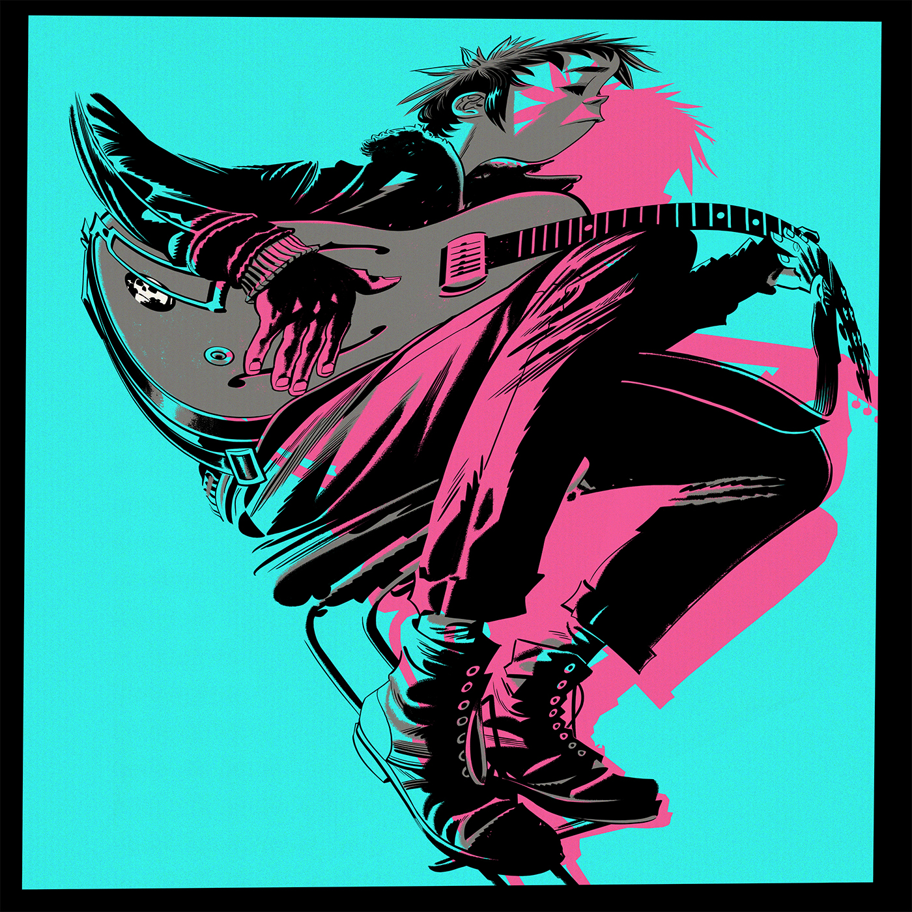

Out 29th June on Parlophone

New video for first track ‘Humility’ here

Listen to ‘Humilty’ here

A brand new studio album from Gorillaz titled The Now Now will be released by Parlophone Records on 29th June.

The Now Now is 11 all-new songs from the World’s Most Successful Virtual Act*, produced by Gorillaz, with James Ford and Remi Kabaka, and recorded entirely at Studio 13, London in February this year.

The album sessions for The Now Now saw the band largely eschewing guest stars, taking it back to the core creative crew: blue-haired, sweet-natured dreamer 2D on vocals; whip-smart Japanese badass Noodle on guitar; not forgetting Brooklyn-born philosopher and the meat–behind-the-beat Russel Hobbs on drums. And with Murdoc Niccals temporarily indisposed, bass duties on the new album have been taken up by erstwhile Gangreen Gang member Ace.

A sun-drenched new video for first track ‘Humility’, starring a roller-skating 2D and a busking Jack Black, was directed by Jamie Hewlett and filmed entirely in Venice Beach, California last month - watch it here

Gorillaz will hit the road this summer with The Now Now Tour playing extensive festival dates across Europe, to include a headline appearance – their only UK show this year - at Boomtown Festival, Hampshire on 11th August.
And Gorillaz’ own acclaimed Demon Dayz Festival – the “joyful apocalypse… and carnivalesque festival of great performances” (The Guardian)” curated by Damon Albarn and Jamie Hewlett – will make its exclusive appearance for this year at the Pico Rivera Arena in Los Angeles on 20th October, with additional dates for North America also confirmed today. (See complete tour itinerary below).
The Now Now is available as a single CD, vinyl LP or as a digital download, as well as a collector’s edition Deluxe Vinyl LP Box Set. Details including pre order information here.
Track listing for The Now Now is:
- Humility - feat George Benson
- Tranz
- Hollywood - feat Snoop Dogg + Jamie Principle
- Kansas
- Sorcererz
- Idaho
- Lake Zurich
- Magic City
- Fire Flies
- One Percent
- Souk Eye
www.gorillaz.com

31st May 2018

For hi-res PRESS SHOTS, VIDEO STILLS and ALBUM ART: www.gorillaz.com/rmpphoto

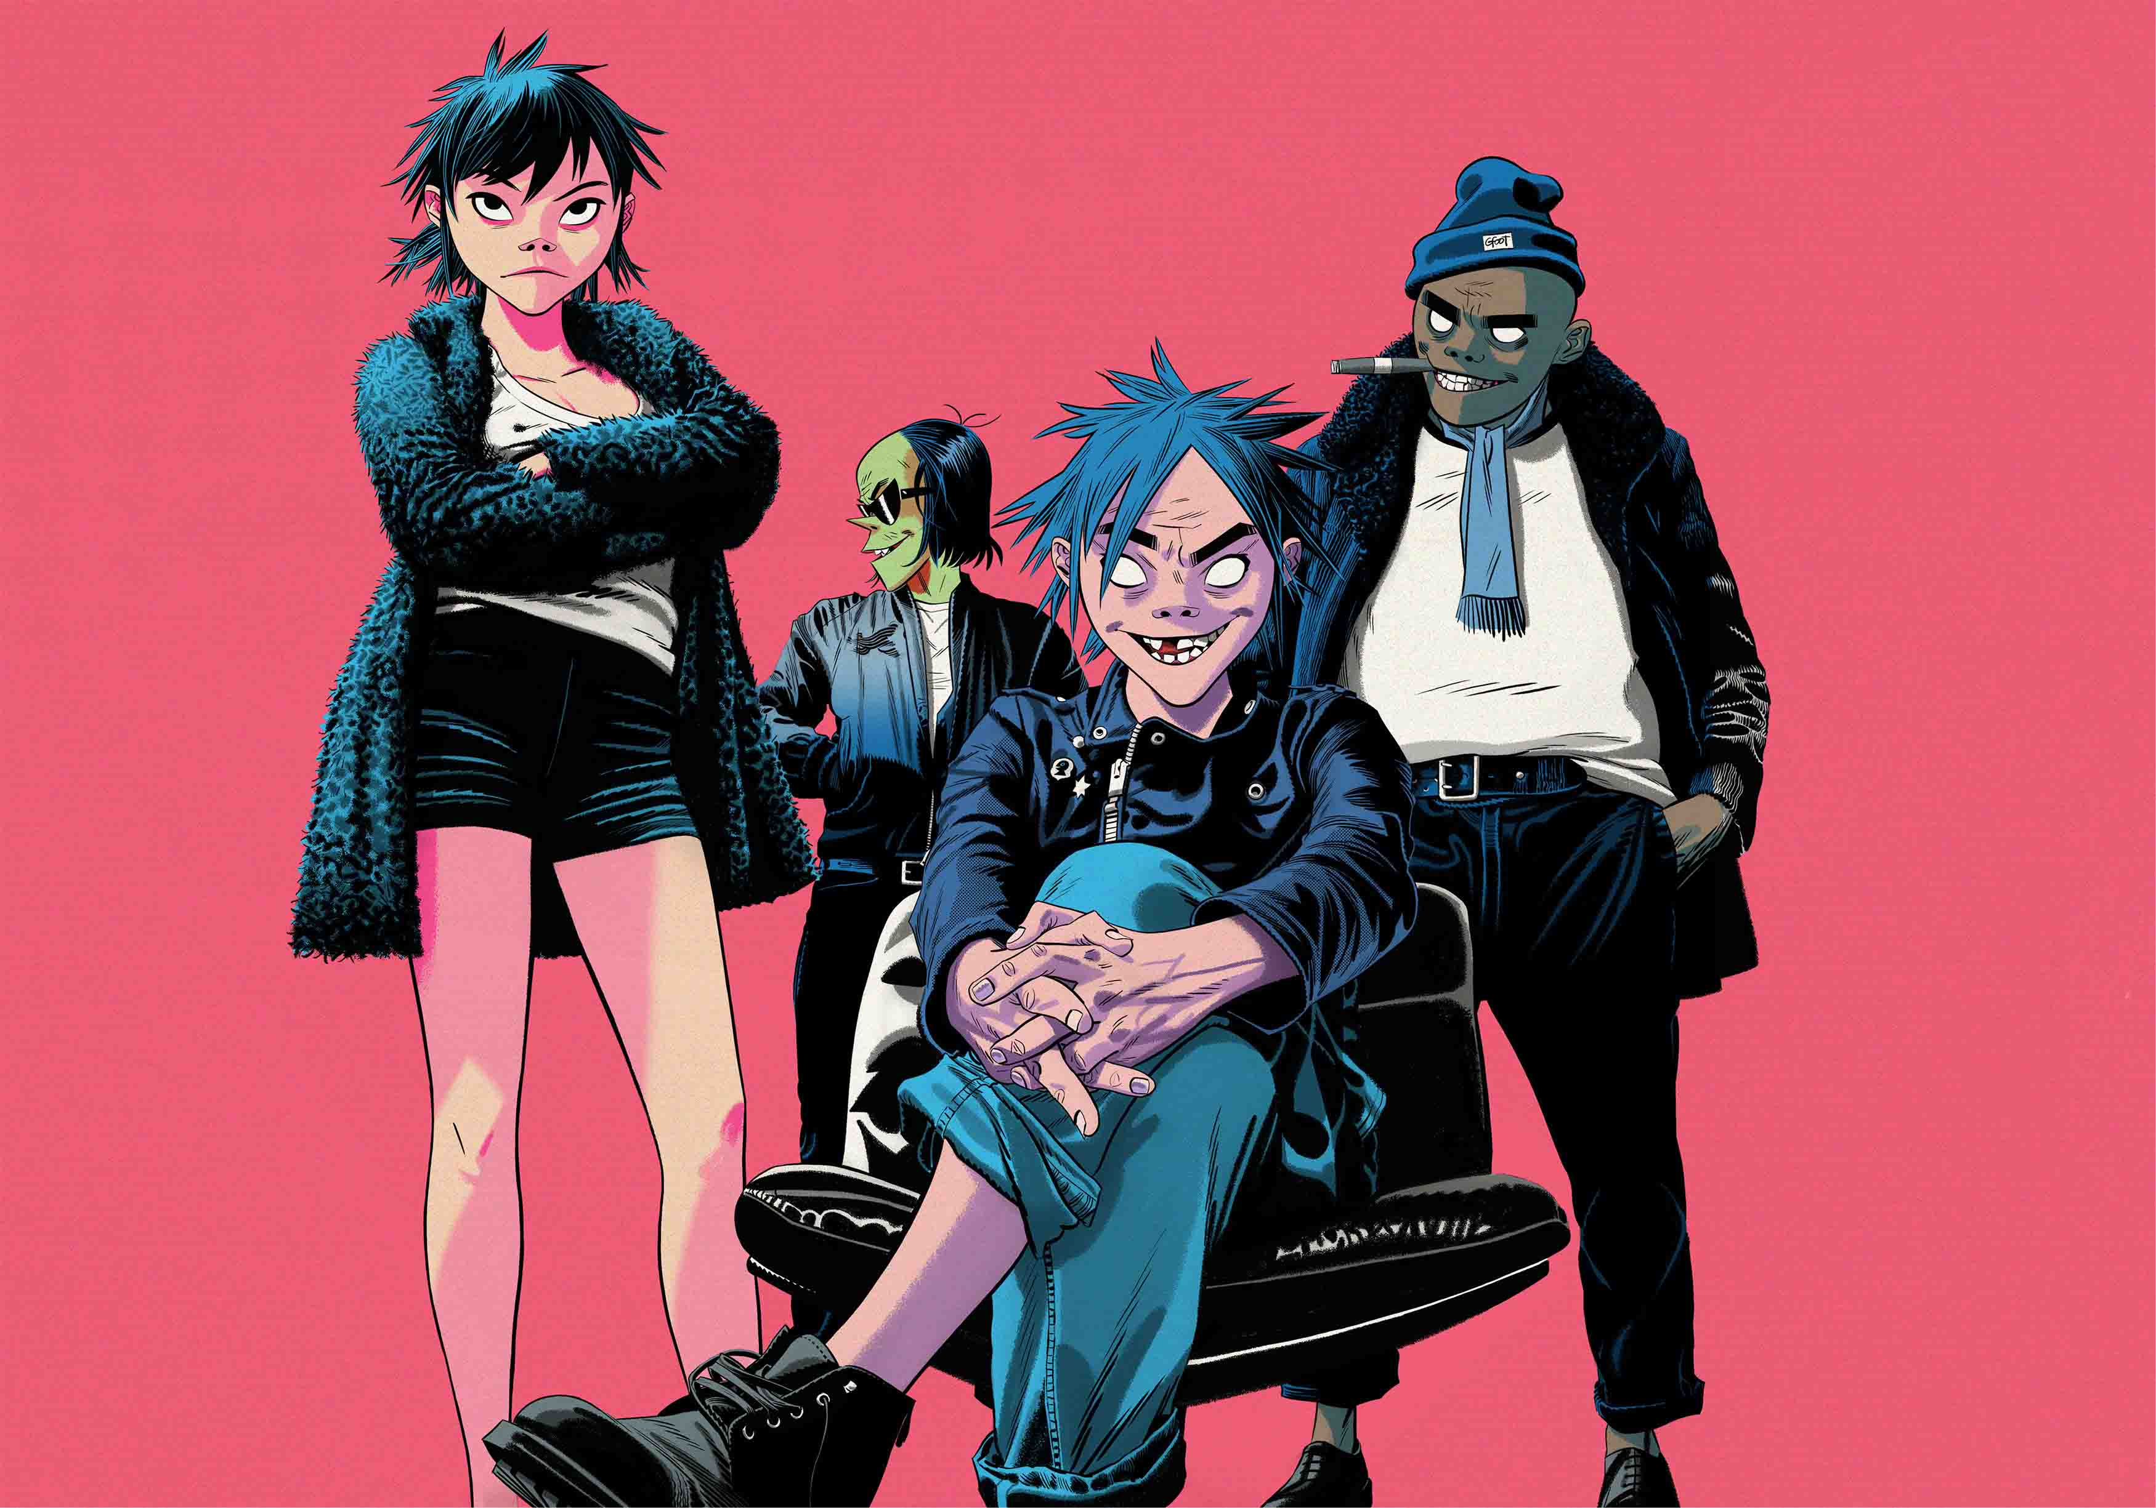
L-R: Noodle, Ace, 2D, Russel

Notes to Editors:

Virtual group Gorillaz is singer 2D, bassist Murdoc Niccals, guitarist Noodle and drummer Russel Hobbs. Created by Damon Albarn and Jamie Hewlett, their acclaimed eponymous debut album was released in 2001. The BRIT and Grammy Award winning band’s subsequent albums are Demon Days (2005), Plastic Beach (2010), The Fall (2011) and Humanz (2017). A truly global phenomenon, Gorillaz have topped charts around the world and toured the globe from San Diego to Syria, picking up hundreds of millions of streams and record sales along the way. Gorillaz have achieved success in entirely ground-breaking ways, winning numerous awards including the coveted Jim Henson Creativity Honor.

* The band are recognised by The Guinness Book Of World Records* as the planet’s Most Successful Virtual Act.
***

Gorillaz: The Now Now Tour 2018

EUROPE
1 June Rock IM Ring, Nuremberg - GERMANY
3 June Rock AM Park, Mendig - GERMANY
9 June Malahide Castle, Dublin - IRELAND
15 June Sonar, Barcelona - SPAIN
21 June Messe Arena Hall, Tokyo - JAPAN
5 July Werchter Festival, Werchter - BELGIUM
6 July Open’er Festival, Gdynia - POLAND
7 July Roskilde Festival, Roskilde - DENMARK
11 July Gurten Festival, Bern - SWITZERLAND
12 July Lucca Summer Festival, Lucca - ITALY
14 July Bilbao BBK Live, Bilbao - SPAIN
19 July Paleo Festival, Nyon - SWITZERLAND
21 July Vieilles Charrues Festival, Carhaix - FRANCE
22 July Lollapalooza, Paris - FRANCE
25 July U Park Festival, Kyiv (Kiev) - UKRAINE
28 July Park Live Festival, Moscow – RUSSIA FEDERATION
9 August Sziget Festival, Budapest - HUNGARY
11 August Boomtown Festival, HAMPSHIRE, UK
16 August Frequency Festival, St Pölten - AUSTRIA
17 August Lowlands Festival, Biddinghuizen - NETHERLANDS

NORTH AMERICA
8 October Air Canada Centre, TORONTO
9 October Bell Centre, MONTREAL
11 October Wells Fargo Center, PHILADELPHIA
13 October Barclays Center, NEW YORK
14 October TD Garden, BOSTON
16 October United Centre, CHICAGO
20 October Demon Dayz Festival, LOS ANGELES

www.gorillaz.com/tour

