**Invitation: LEADING CHANGE International Women's Day, BREAKFAST with PANEL and WORKSHOPS, Monday 9/3 at Ekskäret Klustret 07:00-10.30  
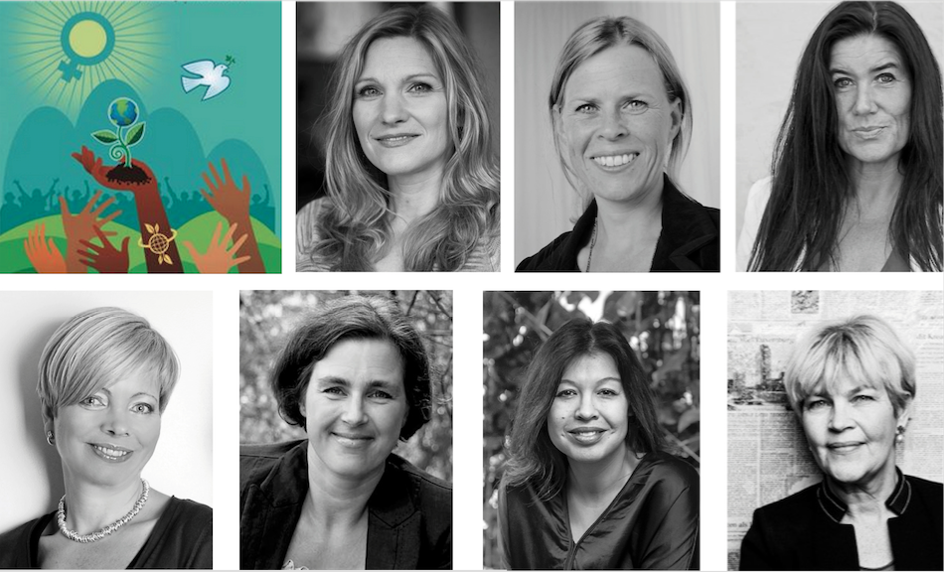  
  
Celebrate International Women's Day 2020 at Ekskäret Klustret on Monday! Join us for a climate-smart vegan breakfast and discussions on how women lead and create change for an equal and more sustainable society and world. Meet Dr. Åsa Lundquist Coey, Sara Jervfors, Helena Lindemark**, **Tiina Bruno**, **Karolina Palmberg**, **Sanna Rådelius, Caroline Stiernstedt Sahlborn, Annette Ericsdotter. Moderator: Heidi Andersen**.  
  
To address climate change, we must make gender equity a reality. And in the face of a seemingly impossible challenge, women and girls are a fierce source of possibility. Women have shown more commitment and willingness to change both society and their own behavior in order to reach the United Nations (UN) climate goals. Women are a vital resource and their participation is important in solving the climate crisis. UN figures indicate that 80% of people displaced by climate change are women.  
  
**WELCOME to participate and explore** how we can create change in gender equality and a climate-smart future. Gain tools and inspiration to accelerate your own and society’s transformation.*​***WE ARE ALL NEEDED to lead the change**. Our voice is needed. Our wisdom is needed. We hope to see you and gain some clarity on how we together can lead the change towards a better future!​​​Heidi Andersen, Shero Leaders Network*,* Annette Ericsdotter, TGIM-Thank God It´s Mondayand Caroline Stiernstedt Sahlborn, Ekskäret Foundation  
  
**PROGRAM**  
​07:00 - 07:30 Morning "chair yoga"  
​07:30 - 08:15 Breakfast and mingle  
​08:15 - 10:30 Speakers and discussions **Location:** Ekskäret Klustret, Birger Jarlsgatan 58, Stockholm   
 **PRESS**For interviews and press accreditation please contact Annette Ericsdotter, [annette@tgim.se](mailto:annette@tgim.se)   
 **SPEAKERS:  
​SARA JERVFORS** Project Manager at *MatLust* and Dietitian Manager of *Södertälje and Gnesta municipality*. The municipality's work is based on the research-based meal concept *"Diet for a green planet"* and has received broad attention and has positively impacted public meal operations throughout Sweden, Europe, and the world.   
 **​​DR. ÅSA LUNDQUIST COEY,***Doctor of Management and Complexity*, Ph.D., from the University of Hertfordshire (The Complexity Research Center) with a background in law and pedagogy. Åsa is also a coach, author, MSc in Organization and Leadership from Springfield University in the USA.  
  
**HELENA LINDEMARK** Founder and President of the *2022 Initiative Foundation* and *Sustainable Development Sweden AB*. She is passionate about contributing to a positive change for Sweden and for the world. Helena presents a compass, showing that Nature is the basis for our survival and that SDGs related to Education, Economy and innovation can be used as tools for creating Sustainable Societies, Wellbeing of individuals and for solving the damage we've done to Nature.  
  
​​**TIINA BRUNO** Founder of *Parentsmart Employers:* sustainable return on inclusion. Tiina is often referred to as a thought leader, an influencer and “norm breaker” promoting new perspectives, role model examples and concrete methods for increasing gender equality, social sustainability and inclusion in companies and societies.   
  
**ORGANIZERS​​**​:  
​​​**HEIDI ANDERSEN** Founder of *SHERO Leaders*. Speaker, author, mindset mentor, and one of the first to teach mindfulness (MBSR) in Sweden. For the last 14 years, she has lectured, taught individuals, leadership groups and organizations how to incorporate change using positive psychology, and positive neuroscience to create resilience, balance, and meaning. **SHERO Leaders Network** supports women leaders and entrepreneurs to be their own shero, to own their wisdom and cultivate resilience so they can transform themselves and transform society.  
  
**CAROLINE STIERNSTEDT SAHLBORN** Chairman of *Ekskäret Foundation* and consultant at *GRO*. Caroline works with assisting leaders and organizations towards improved leadership and increased responsibility with abilities for co-creation and managing change. **Ekskäret Klustret** - The home for flourishing changemakers. Klustret is a space, a community, and a co-working hub, for people and organizations who are committed to creating a sustainable, flourishing and more conscious society. It’s a place where we can collaborate, grow and thrive together.  
  
**ANNETTE ERICSDOTTER** Founder of *TGIM-Thank God It´s Monday,* an event producer with more than 30 years in the business. A super networker with marketing, sales, and PR skills. Annette is a founding member of the board of *End Ecocide Sweden*, communicator in the network of *Rights Of Nature Sweden*.  
  
**TIME**: Monday March 9, 07:00 – 10:30  
**LOCATION**: Ekskäret Klustret, Birger Jarlsgatan 58, Stockholm [*Find us! Click here.*](http://www.ekskaret-klustret.se/contact-us#contact-us-text) **ADMISSION**: 150 SEK to cover the vegan breakfast and the lovely location, SWISH 070-88 288 91 now with your name, or at the door.  
 **PLEASE, SIGN-UP** to reserve your seat: [*www.tgim.se*](http://www.tgim.se)