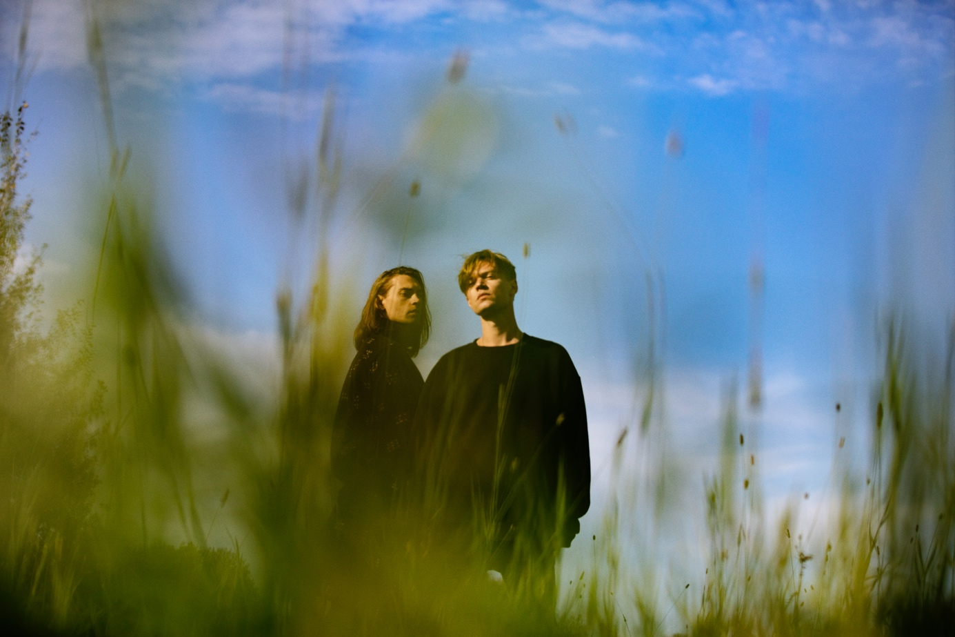

GUSTAF & VIKTOR NORÉN SIGNS WITH RMV GRAMMOFON- NEW MUSIC OUT SPRING 2020
As pop artists, the brothers Gustaf & Viktor Norén has had successful careers with bands such as Mando Diao, Sugarplum Fairy and State Of Sound, but it is only now that they release music together - for the first time ever.
In 2015, Gustaf left Mando Diao and has since lived and worked in Dala-Floda, 4 km west of his hometown Borlänge.
-I haven't been a professional musician for five years, but I play a lot at home with my family and my kids. I don’t think I've ever played as much as when I put the guitar on the shelf, he says.
Together with folk musicians he got to know in the neighborhood of Dala-Floda, Gustaf Norén rediscovered childhood music, and at the same time initiated a collaboration with his five-year younger brother Viktor.
-It opened up as a creative highway when we started playing together. You have a special chemistry with someone you have always had in your life. It made us find a way back to the music, Viktor says, revealing that a new record is in the making.

The new album "Hymns To The Rising Sun" will be the brothers' first release on RMV Grammofon.
The record, which Gustaf & Viktor wrote together with Björn Olsson (Håkan Hellström, Soundtrack Of Our Lives, Mando Diao, etc.) is being recorded in the legendary RMV studio at Skeppsholmen in the fall and will be released in the spring of 2020.
-When we first met Claes & Ludvig and played our songs, we immediately felt that RMV was the perfect home for us. An understanding and a genuine passion for music, like a band member rather than a record label. A sense of the beginning of a long collaboration with blurred boundaries between artist and record company, a harmonious, forward-leaning & lust-filled coexistence with the common drive to jointly create & publish music without creative obstacles. RMV is a vitamin injection right into our musical veins, says Viktor
Claes Uggla at RMV Grammofon continues:

-We have followed Gustaf & Viktor's musical careers for a long time and we are incredibly proud and excited to welcome them to RMV Grammofon! Two exceptional songwriters with a unique sense of melodies, who together with Björn Olsson has written and recorded fantastic pop songs.
We look forward to releasing their first joint album with them this spring.
The duo did an acclaimed summer tour in 2019 and are going on a Christmas tour in December. The planning for the 2020 summer tour is now in full swing

