Kontaktperson:  Magnus Wallin  Malwa Forest AB  Telefon: 0768-439595  Mail: magnus@malwa.se | Fältspatsvägen 1  511 91 Skene  www.malwa.se | Malwa FOREST AB

PressRELEASE

Malwa unveils its next generation harvester

Malwa Forest - Europe's leading manufacturer of compact forestry machines - will show its next generation harvester, the Malwa 560H, on Elmia Wood 2017

Skene 2 juni 2017: The Malwa forestry machines are characterized by being compact and light weight yet effective for first and second thinning.The new harvester has a new casted bogie and optimized frame structure to further enhance handling, strength and longevity. The machine can be equipped with extra diesel tank and 100 l capacity on stump treatment fluid for increased productivity.
- We are proud to present our new harvester who together with our forwarder is a unbeatable team for gentle thinning. Our ambition is to contribute to timber-rich, storm-resistant stands with minimal environmental damage, says Magnus Wallin, founder and Business Development Manager.
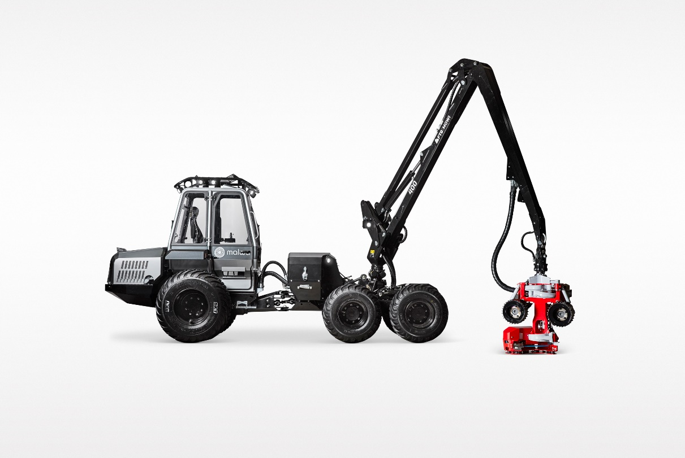
High resolution pictures can be downloaded: https://db.tt/zTKTDJ5hPX

