FOR IMMEDIATE RELEASE

Intellian continues expansion with €6.5m investment in new state-of-the-art European Headquarters

Satellite communications leader reaffirms commitment for operational excellence, streamlined supply and local support with opening of European Headquarters

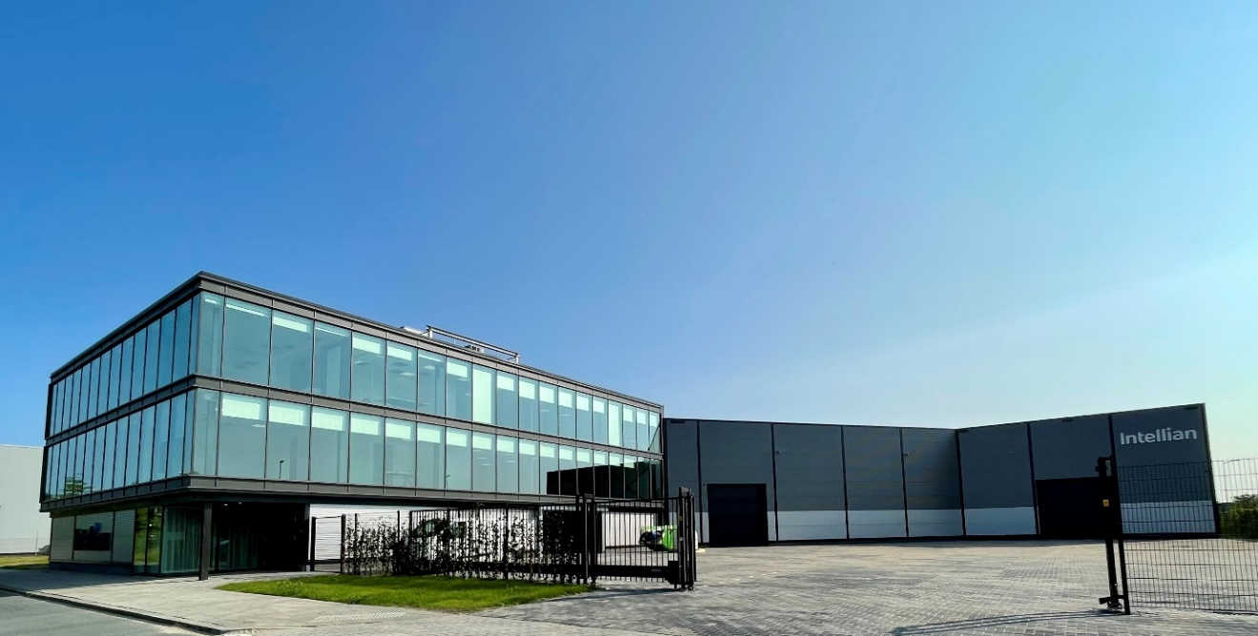
Intellian’s new European Headquarters and Logistics Center in Rotterdam

29 July 2021 – Intellian has announced the opening of its bespoke European Headquarters and Logistics Center in Rotterdam, underpinning a long-term commitment to the region. The new facility will further enhance the service and user experience of Intellian’s partners and customers, both in Europe and beyond.
The €6.5m state-of-the-art facility has been custom-built by the satellite communications solutions and technology leader to achieve operational excellence and efficiency, streamline supply chains and provide fast, cost-effective product delivery to the important European market.
With the landmark investment in major Dutch port city Rotterdam, Korean manufacturer Intellian has secured ownership of a key location within Europe’s center of commerce for maritime, ideally positioning the company to further strengthen its focus on achieving the highest levels of customer service in the years ahead.
The impressive new building offers a high-tech interior which more than triples Intellian’s previous rented business footprint in the city, covering a plot of 3,773m² to include both office and warehouse space. The comprehensive layout encompasses a solution center, customer support center, and a product demonstration and event area on a roof-top veranda, plus multiple loading bays and access to a full line-up of test systems.
Housing the expanding 35-strong local team, the EU Headquarters also includes an extensive training center, providing an ideal environment to ensure an enhanced customer experience for product testing, seminars, workshops, customer meetings and more.
Jon Harrison, Vice President and General Manager, Intellian, said: “We are extremely proud to announce that our new European Headquarters is now open. This significant and worthwhile investment in Europe is crucial to the future success of Intellian and our global partners, meeting increasing product demand and the need to be agile with a new infrastructure and facility. Optimizing operational efficiency, the EU HQ and Global Logistics Center will greatly enhance our customers’ experience, improving training, logistics and system testing. Our continued mission is to streamline the overall supply chain, ensuring faster delivery, increased capacity for stock and additional product lines. This new flagship facility will deliver a polished, higher quality of service, not only for Europe, but for all Intellian partners and customers globally.
“We would particularly like to extend our gratitude to the city for their invaluable assistance. As the biggest maritime address in Europe, we know Rotterdam is the place to be. We first moved to the city 10 years ago as part of a global initiative and our growth was exponential. After making the crucial decision to transition from rented space to investing in the city of Rotterdam several years ago, they welcomed our request to find a site to build our own facility from the beginning. We can now celebrate the establishment of a customized local and regional base which creates the perfect launch pad for future success in Europe and enables us to accommodate increasing demand.
“Our customers thrive on local support, so we know that serving our customers on the spot, and not remotely, is the only option. That is why we are confident that Intellian’s investment in Europe, while major competitors are divesting, will result in long-term business success and customer satisfaction. It is yet another example of how Intellian consistently excels at meeting operational challenges.”
With growth and innovation intrinsic to Intellian’s plans for the future, the Rotterdam project is one of several new premises opening this year. Its new Research and Development Center in Pyeongtaek, South Korea, was recently completed, while the UK team will take up new offices near Heathrow, London, making space for the growing team and offering proximity to many key partners. A new R&D facility focused on emerging technologies will also begin operations in Maryland, USA.
-Ends-

For further enquiries, please contact:
Sadie Brown / Marketing Manager
Intellian Ltd
T +44 2380 019 021 ext. 1612
Sadie.Brown@intelliantech.com
David Pugh
Saltwater Stone
T +44 1202 669 244
d.pugh@saltwater-stone.com

About Intellian Technologies
Intellian is a leading global technology and solutions provider for satellite communications, empowering connectivity for the maritime, government, military, energy, cruise and enterprise sectors. Founded in 2004, Intellian is renowned for its innovative design, future-proofed technologies and outstanding customer support, which combined with continued investment in its partners, logistics network, quality control and low environmental impact production facilities make it a trusted enabler within the satellite communications industry. Its bold, pioneering solutions include the award-winning v240MT – the world’s first tri-band, multi-orbit antenna system – and the future-proof NX series antennas, optimized for high performance and low cost of ownership.
Intellian has a worldwide presence with over 400 employees, 10 global offices and five logistics centers on three continents. Intellian Technologies Inc. is listed on the Korean Stock Exchange, KOSDAQ (189300:KS).

