Britta Marakatt-Labba
Luođđat/Tracks
2023
(embroidery, 175x35 cm)
For the exhibition “Britta Marakatt-Labba. Moving the Needle” at Oslo’s National Museum of Art, Architecture and Design, Britta Marakatt-Labba has created a commissioned work, Luođđat/Tracks.
With this new work, the artist abandons her typical landscape format in favour of a vertical canvas, embroidered both front and back. Here, she explores the different traces left on nature by human industrializing activities, and the ways in which they affect the traditional Sámi way of life. To find their feeding grounds, the Sámi’s reindeer herds roam free in the mountain plains, following the same paths as generations before. With intrusions in the landscape, this sensitive ecosystem is disturbed.
On the backside of the work, in a sparse, wintery landscape, reindeer and other animal tracks slowly merge into the train tracks of the mining industry.
In the front, a number of motifs common to Marakatt-Labba’s works come together. The starry northern sky is connected to the earth by yellow lines representing the noaidi (shaman’s) drum, under the protection of holy white reindeer. Further down, red lines encompass sleeping spaces in connection with a domed lávvu (tent). In Marakatt-Labba’s works, the sleeping spaces represent all that is safe, but here they are being driven out of the safety of the lávvu and disappearing into the sky with smoke from the fire.
At the bottom half of the canvas, we see reindeer herds escaping rows of towering wind turbines, falling deep into mining shafts and the grasp of industrialization.
Luođđat/Tracks addresses ongoing environmental and cultural threats in the North.
In Norway, the conflict between windfarm companies and the reindeer herding Sámi has been a source of controversy in recent years, culminating in the 2021 supreme court ruling that the Norwegian government is violating the Sámi’s human rights in connection with constructions at Fosen. This has united Sámi and environmental activists in powerful and relentless protests, echoing the late 1970s and early 1980s’ massive protests against the damming of the Alta River.
Meanwhile, in Marakatt-Labba’s home county of Kiruna, the entire historic city centre is planned to be moved 3 kilometers east as mining activities are threatening to swallow the town.
To Marakatt-Labba, these interventions represent not only threats to the environment, but to the very existence of Sámi culture.

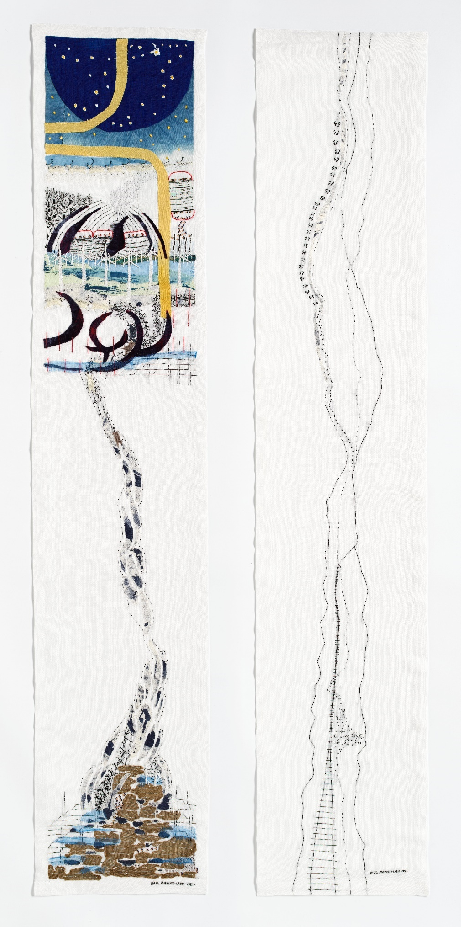
Britta Marakatt-Labba Luođđat/Tracks, 2023. © Britta Marakatt-Labba / BONO.
Photo by The National Museum / Annar Bjørgli

