**COX POWERTRAIN PREVIEWS WORLD’S FIRST PROFESSIONAL 300HP DIESEL OUTBOARD**

*International Workboat Show 2016, New Orleans, 30th November to 2nd December, Booth 3963*

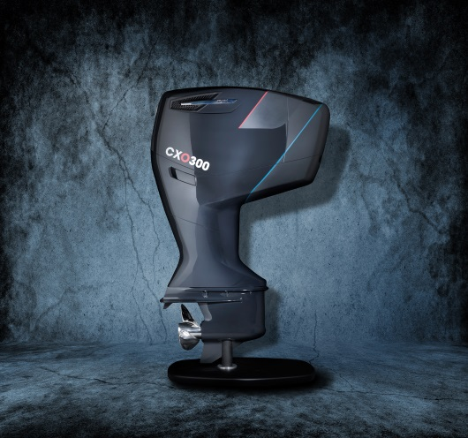

British diesel engine innovator, Cox Powertrain, is previewing its pioneering professional outboard motor, the CXO300, at this year’s International Workboat Show in New Orleans. Cox has brought together highly skilled engineers from Formula 1 racing and premium automotive engine design to develop this completely new concept diesel engine, providing gasoline outboard performance, with diesel economy and reliability.

Cox is displaying a full sized model of the CXO300, which is a revolutionary opposed-piston, diesel outboard designed specifically for professional marine users. Delivering 300hp and weighing only 300kg, it is targeted at commercial, government and military applications, where performance, durability and fuel efficiency are paramount.

Cox Powertrain is led by former Cosworth CEO Tim Routsis who commented, “International Workboat is an important venue for us to showcase our technology to the commercial workboat market. The development of the CXO300 is now entering the final stages of a five year development programme so we are excited at the prospect of introducing this game-changing technology to the market ahead of its launch. We have brought together some of the UK’s foremost experts in engine design to turn this concept into a reality. Owners can be confident that this new diesel outboard is ready for the tough and demanding environment in which it will operate. ”

Cox is currently finalising a highly qualified US dealer network, which will be announced early 2017. “It is imperative for us to deliver an engine that is supported by a professional sales and servicing operation throughout the US. For this reason we are working with long-established and trusted businesses that understand the market and are able to offer an exceptional through-life service,” said Cox Powertrain’s Business Development Manager, Joel Reid.

Cox Powertrain is a British company based in West Sussex, dedicated to answering the demands of commercial, government and military marine operators, for a reliable and powerful diesel outboard. With petrol now not permitted on-board military ships, in addition to many commercial vessels and superyachts, the development of a viable diesel outboard for RIBs and tenders, offering the comparable power and weight of a gasoline engine, has been an important factor in the rapid expansion of Cox Powertrain.

For further information, visit [www.coxmarine.com](http://www.coxmarine.com)

ENDS

**About Cox Powertrain**

Cox Powertrain is a world-leading British designer and builder of diesel engines developed for worldwide and multi-market applications.

Based on the South Coast of England, Cox Powertrain is backed by the Ministry of Defence and a solid shareholder base of private and institutional investors. As a result, the company has been able to implement a long-term development programme of ground-breaking new products.

Led by ex-Cosworth CEO, Tim Routsis, whose background lies in engine development in global automotive, aerospace and marine markets, the company’s mission is to deliver a completely new concept in diesel engines that has the potential to revolutionise the marine market.

With a strong pedigree in Formula 1 racing and premium automotive design, Cox’s highly skilled team of engineers has decades of experience in combustion engines and understand the many difficulties customers are challenged with.

Cox’s first ground-breaking diesel outboard engine, the CXO300, is the highest power density diesel outboard engine ever developed. As a low weight, high power, single fuel engine, the CXO300 delivers the same performance and efficiency of an inboard but with the convenience and flexibility of an outboard.

For further information, visit www.coxmarine.com

**Media contacts:**

Reena Bayley, Marketing Manager

Cox Powertrain Limited

Tel: +44 (0) 1273 454 424

E: reena.bayley@coxpowertrain.com

**Media information & images:**

Karen Bartlett

Saltwater Stone

Tel: +44 (0) 1202 669 244

E: k.bartlett@saltwater-stone.com